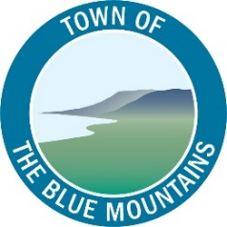

Committee Agenda

Grey County – The Blue Mountains Task Force
Meeting Date: October 24, 2019
Meeting Time: 1:30 p.m.
Location: Heritage Room – Grey County Administration Building
595 9th Avenue East Owen Sound, ON
Prepared by Krista Royal, Deputy Clerk

Call to Order
- Approval of Agenda
Recommended (Move, second)
THAT the Agenda of October 24, 2019, be approved as circulated, including any items added to the Agenda.
- Declaration of Pecuniary Interest and general nature thereof
- Minutes
Recommended (Move, second)
THAT the Grey County – The Blue Mountains Task Force minutes of September 19, 2019 be adopted as circulated, including any revisions to be made.

Agenda Topics
B.1 MTAG Report – Re-Assessment Impacts and Tax Burden Shifts
B.2 Tax Situation – Now and in 4 Years
B.3 Potential for a Co-ordinated Effort for Tax Deferral or Other Mitigation for People on Fixed Incomes and Seniors
B.4 County Revenues and Expenditures Report

B.5 County Service Delivery and Effectiveness
a) Transit Project
b) Planning
c) Attainable Housing and Community Improvement Plan

New Business

Notice of Meeting Dates
November meeting date – to be determined

Adjournment
Recommended (Move, second)
THAT this Committee does now adjourn at (time) p.m.

