Committee Report
To: | Warden and Members of Grey County Council
Committee Date: | June 9th, 2022
Subject / Report No: | PDR-CW-21-22
Title: | Flato Glenelg/Southgate Meadows Subdivision Phase 2 – 42T-2020-09
Prepared by: | Randy Scherzer
Reviewed by: | Kim Wingrove
Lower Tier(s) Affected: | Township of Southgate
Status:

Recommendation
- That Report PDR-CW-21-22 be received; and
- That all written and oral submissions received on plan of subdivision 42T-2020-09, known as the Flato Glenelg/Southgate Meadows Phase 2 subdivision, were considered; the effect of which changed the draft plan of subdivision and helped to make an informed recommendation and decision; and
- That in consideration of the draft plan of subdivision application 42T-2020-09, for lands described as Part of Lots 225 and 226, Concession 2 SWTSR, and Blocks 131 and 132, RP 16M-85, geographic Township of Proton, now in the Township of Southgate, the Grey County Committee of the Whole approves this plan of subdivision to create a total of one hundred and fifty five (155) residential units consisting of ninety-three (93) single detached lots, sixty-two (62) townhouse units, in addition to parkland, walkway/trail, stormwater management, open space, future right-of-way and road blocks, subject to the conditions set out in the Notice of Decision.

Executive Summary
The County and the Township of Southgate received development applications in 2020 for the Flato Glenelg/Southgate Meadows Phase 2 development. The applications submitted included a County official plan amendment, a local official plan amendment, a plan of subdivision, and a zoning amendment. The County official plan amendment and local official plan amendment have been approved. The Township has also recently passed the zoning by-law amendment. The only application pending approval is the proposed subdivision which proposes to create a total of 155 residential units, consisting of 93 single detached units and 62 townhouse units, as well as blocks for parkland, stormwater management, walkways/trails, open space, future rights-of-way and internal roads, on the northwest end of the settlement area of Dundalk. The subdivision will be serviced by municipal water and sewer services. This subdivision was modified from the original submission to reflect comments received from agencies, the Township, and the County. The Township has recently supported the proposed plan of subdivision through recommended conditions of draft approval. County Planning staff are recommending approval of the plan of subdivision, subject to the conditions of draft approval attached to this report.

Background and Discussion
The County and the Township received applications for a proposed development known as Flato Glenelg/Southgate Meadows Phase 2. The applications included a County official plan amendment, a local official plan amendment, a zoning amendment and proposed plan of subdivision. County Official Plan Amendment 6 was approved by the County on October 28, 2021 and the subsequent local official plan amendment (LOPA 31) was adopted by the Township of Southgate and approved by the County on January 24, 2022. The Township of Southgate recently passed the zoning by-law amendment associated with the proposed development. The application that remains outstanding is the proposed plan of subdivision.
The subject lands are located in the northwest corner of the settlement area of Dundalk and are described as Part of Lots 225 and 226, Concession 2 SWTSR, geographic Township of Proton, Township of Southgate (See Map 1).
The subject lands are approximately 18.4 hectares in size; however, the actual area proposed for development is less than half the size of the subject lands. The subject lands are currently vacant with a portion of the subject lands used for agricultural purposes and a portion currently containing woodlands and hazard lands. Northeast of the subject lands is the County CP Rail Trail and some vacant agricultural lands. East and south of the subject lands are residential uses including the approved Phase 1 for this overall planned development. West of the subject lands include agricultural uses, residential uses and some vacant lands.
The plan of subdivision application proposes to create a total of 155 residential units consisting of 93 single detached units and 62 townhouse units (see Map 2). Access to the proposed residential units would be through an existing draft approved plan of subdivision known as Southgate Meadows/Flato Glenelg Phase 1 – 42T-2018-12 which is currently under construction. The proposed plan would connect to Corbett Street and Aitchison Avenue as part of Southgate Meadows/Flato Glenelg Phase 1. Additional internal roads would be constructed to provide access to the proposed lots. Servicing to the proposed lots would be via municipal water and sewer services.
Map 1: Airphoto of Subject Lands
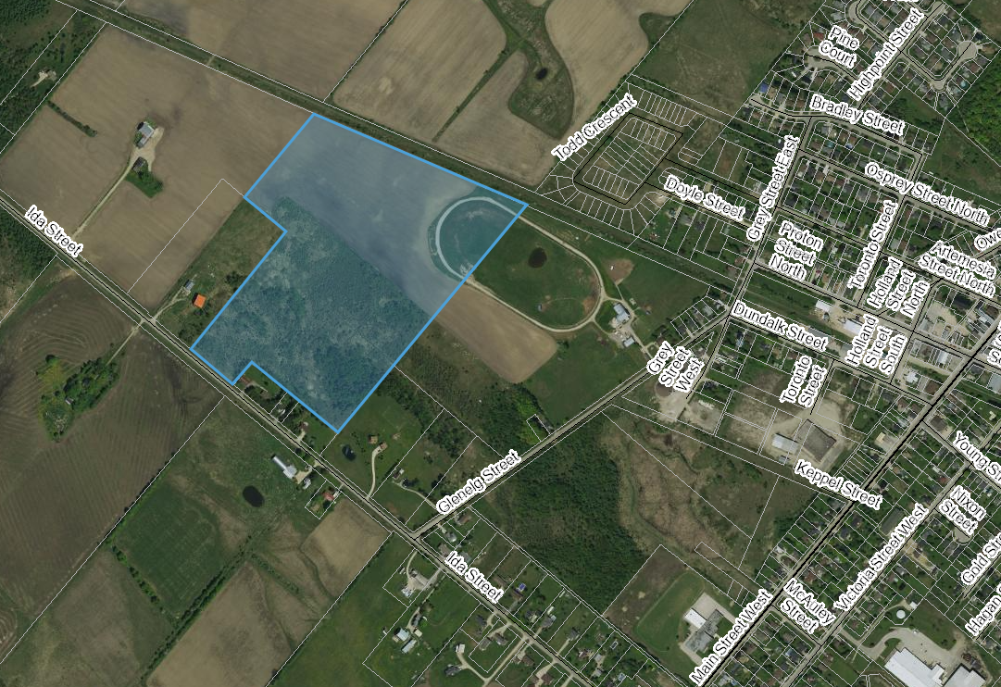
The proposed development also required a local official plan amendment and a zoning by-law amendment from the Township of Southgate, both of which have been approved. Copies of all background reports and plans can be found at this link.
A joint public meeting between the Township and the County was held for all the proposed applications on January 27, 2021. Minutes from that meeting can be found here: Public Meeting Minutes – January 27, 2021.

Map 2: Proposed Plan of Subdivision - (Courtesy of MHBC Planning.)
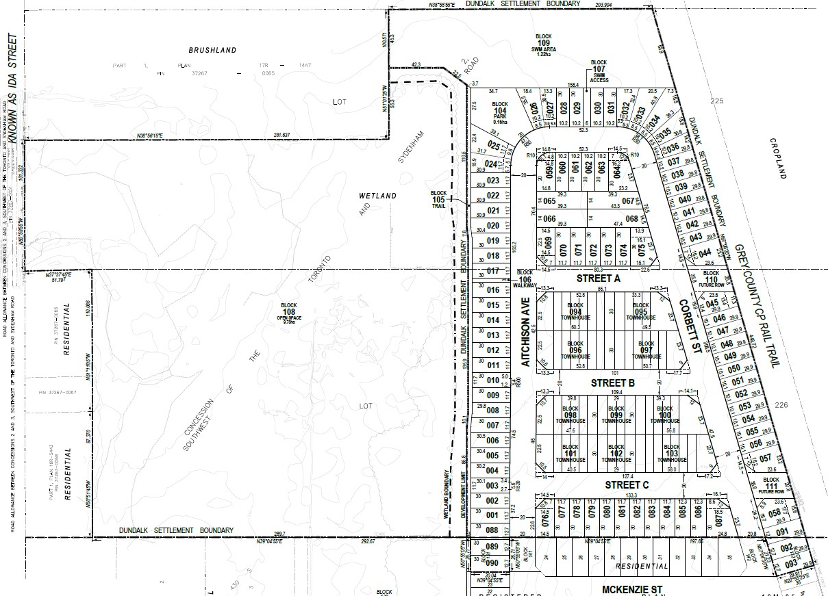

Agency Comments Received

Enbridge Gas, dated November 19, 2020 and April 26, 2022
Enbridge Gas Inc. request that as a condition of final approval that the owner/developer provide to Union Gas the necessary easements and/or agreements required by Union Gas for the provision of gas services for this project, in a form satisfactory to Enbridge.

Bruce Telecom, dated November 19, 2020
Bruce Telecom have no concerns or issues with the work being done at this location.

Canada Post, dated November 19, 2020
Canada Post will provide mail delivery service through centralized Community Mailboxes; and will work with the developer to determine a suitable permanent location for them. Once the development is approved, they require notification of the new civic addresses.

Eastlink, dated November 20, 2020
Once the subdivision is approved, Eastlink staff will require the detailed Hydro plans for their planning.

Township of Southgate Public Works Department, dated November 20, 2020
The subdivision will need to be on municipal water, sanitary sewer and storm water service connections. No road widening is required.
The property is located in a Well Head Protected Area “D”; applicable to Dense Non-Aqueous Phase Liquid (DNAPL) products managed by education and outreach programs.

Bell Canada, dated November 24, 2020
Bell Canada requests conditions of draft approval to ensure that there are necessary easements provided to Bell Canada to service this new development and that the Owner will be responsible to provide entrance and service ducts from Bell Canada’s existing network infrastructure to service this development.

Hydro One, dated November 27, 2020
Hydro One has no comments or concerns at this time.

Grand River Conservation Authority (GRCA), dated November 27, 2020
The subject lands fall completely under the Saugeen Valley Conservation Authority (SVCA) jurisdiction, therefore GRCA staff defer commenting to the SVCA.

Historic Saugeen Metis, dated November 27, 2020
The Historic Saugeen Métis (HSM) Lands, Resources and Consultation Department has reviewed the relevant documents including the Environmental Impact Study and Archaeological Assessment and have no objection or opposition to the proposed Southgate Meadows/Flato Glenelg Phase 2 Plan of Subdivision Application as presented.

Saugeen Valley Conservation Authority (SVCA), dated January 8, 2021 and May 13, 2022
SVCA staff has reviewed the applications in accordance with the SVCA’s Memorandum of Agreement with the Township of Southgate, and as per their mandated responsibilities for natural hazard management, including their regulatory role under the Conservation Authorities Act.
It is the opinion of the SVCA staff that:
- Consistency with Section 3.1, Natural Hazard policies of the PPS, 2020 has been demonstrated.
- Consistency with Section 2.1, Natural Heritage policies of the PPS, 2020 has been demonstrated; and
- Consistency with local planning policies for natural hazards and natural heritage has been demonstrated.
SVCA staff note that the proposed Draft Plan of Subdivision is generally acceptable to SVCA staff, provided that recommended conditions of draft approval are included in the draft Plan of Subdivision approval. SVCA also reviewed the most recent proposed plan and noted that they do not have any additional comments or objections to the proposed plan of subdivision. The following are the conditions recommended by SVCA which have been incorporated into the recommended conditions of draft approval:
- That prior to any grading or construction on site, and prior to Final Approval of the subdivision by the County of Grey, the owner shall prepare the following studies/reports/documents, completed to the satisfaction of the Saugeen Valley Conservation Authority;
a) Final Lot Grading and Drainage Plan;
b) Final Functional Servicing & Stormwater Management Report;
c) Final Hydrologic/Hydrogeologic Assessment (water balance) demonstrating no net loss of surface and groundwater to the receiving wetland feature;
c) Final Sediment and Erosion Control Plan;
d) A letter provided to SVCA from the applicant’s ecologist advising that proposed stormwater management and grading plans are in conformance with the recommendations of the EIS; and
e) Landscaping Plan for the 10 metre wetland buffer, and Stormwater Management Pond.
- That the Subdivision Agreement between the Owner and the Municipality contain provisions with wording acceptable to the Saugeen Valley Conservation Authority relating to the Final Lot Grading and Drainage Plan, Final Functional Servicing & Stormwater Management Report; Hydrologic/Hydrogeologic Assessment detailing water balance to the receiving wetland feature; Final Sediment and Erosion Control Plan; and Landscaping Plan. We note that the above plans shall include all recommendations of the Environmental Impact Study, including recommendations found in the EIS Section 8.0.

Bluewater District School Board (BWDSB), dated May 13, 2022
The BWDSB has no objection to the proposed development. BWDSB recommends that sidewalks be included through the proposed development to facilitate heavy foot traffic areas and to promote walkability. The BWDSB requests the following conditions be included as part of the draft plan approval which have been included in the recommended conditions:
- “That the owner(s) agree in the Subdivision Agreement to include in all Offers of Purchase and Sale a statement advising prospective purchasers that accommodation within a public school operated by Bluewater District School Board in the community is not guaranteed and students may be accommodated in temporary facilities; including but not limited to accommodation in a portable classroom, a “holding school”, or in an alternate school within or outside of the community.”
- “That the owner(s) shall agree in the Subdivision Agreement to include in all Offers of Purchase and Sale a statement advising prospective purchasers that student busing is at discretion of the Student Transportation Service Consortium of Grey-Bruce.”
- “That the owners(s) agree in the Subdivision Agreement to include in all Offers of Purchase and Sale a statement advising prospective purchasers that if school buses are required within the Subdivision in accordance with Board Transportation policies, as may be amended from time to time, school bus pick up points will generally be located on the through street at a location as determined by the Student Transportation Service Consortium of Grey Bruce.”

Public Comments Received
There were verbal comments provided by Shan Elliot to Township of Southgate staff, 356 Glenelg St, indicating that she supports both Phases 1 and 2 of Southgate Meadows/Flato Glenelg and is hopeful that sewer services will be extended all the way down Glenelg Street in the future so that their property can connect to municipal sewer services.
Another individual at the public meeting asked if the proposed development would have any impact on the existing residents on Doyle Street. It was noted at the public meeting that the County CP Rail Trail acts a divider between the homes on Doyle Street and the planned development and therefore impact on the owners on the east side of the rail trail from the proposed development should be minimal.
There were no further comments provided by the public.

Analysis of Planning Issues
When rendering a land use planning decision, planning authorities must have regard to matters of Provincial Interest under the Planning Act, be consistent with the Provincial Policy Statement (PPS) 2020 and conform to any Provincial Plans or Municipal Official Plans that govern the subject lands. In this case, the County of Grey Official Plan and the Township of Southgate Official Plan have jurisdiction over the subject property. There are no Provincial Plans in this area of the County.

Provincial Policy and Legislation
Most notable to this proposed official plan amendment are the following clauses from the Planning Act, which will need to be considered.
- the protection of ecological systems, including natural areas, features and functions,
An Environmental Impact Study (EIS) was provided as part of the application submissions. SVCA has reviewed the EIS and recommended some mapping revisions to the Hazard Lands and to add ‘Other Wetlands’ identified on the subject lands as part of Appendix B to the County Official Plan. The mapping revisions recommended by SVCA have been incorporated into the schedules for proposed OPA 6. The SVCA also identified some recommended draft plan conditions which have been incorporated into the recommended conditions of draft approval.
- the conservation of features of significant architectural, cultural, historical, archaeological, or scientific interest,
A Stage 1 and 2 Archaeological Assessment was submitted with the applications. The Archaeological Assessment noted that as part of the assessment of the study area, physical evidence of human activity was observed but it was too recent to qualify as an archaeological resource and is of no cultural heritage value or interest. Accordingly, no archaeological resources were documented. The Archaeological Assessment concludes that:
- no further archaeological assessment of the study area is warranted,
- the provincial interest in archaeological resources with respect to the proposed undertaking has been addressed, and
- the proposed undertaking is clear of any archaeological concern.
- the adequate provision and efficient use of communication, transportation, sewage and water services and waste management systems;
The proposed development will be serviced by municipal water and sewer services from the Township of Southgate. The subject lands are located within the settlement area of Dundalk and would be considered the second phase of a planned development known as Southgate Meadows/Flato Glenelg. Services would be extended to the subject lands from Phase 1 of the development which is currently under construction. The Township is actively working on environmental assessments and approvals to expand and/or upgrade the services to be able to accommodate the projected growth for the settlement area of Dundalk. Conditions have been included in the recommended conditions of draft approval with respect to servicing provisions.

Provincial Policy Statement
The PPS speaks to the efficient use of land within settlement areas. The subject lands are within the settlement area of Dundalk.
The supply of an adequate range and distribution of residential housing types is required by the PPS. In this case, the proposed plan of subdivision is proposing single detached residential units and townhouse units.
Other policies in the PPS speak to connected, walkable communities, with provisions for public parkland and open space. The proposed subdivision will provide connections to adjacent planned roads and connections to the CP Rail Trail. A trail along the southwest boundary of the proposed subdivision is also being proposed which would connect to the trail block identified in Southgate Meadows/Flato Glenelg Phase 1. Sidewalks within the development will also be required.
Parts of the subject lands are designated as Hazard Lands. Both the PPS and the County Official Plan discourages development within hazard lands. The application and supporting documents have been circulated to both the Saugeen Valley Conservation Authority and the Grand River Conservation Authority. They have reviewed the supporting documents and SVCA has no objections to the proposed development subject to recommended conditions of draft approval which have been included.
The protection of significant environmental features is also required through the legislation and policy. Appendix A of the County Official Plan identifies a small portion of the subject lands as being within the Wellhead Protection Area (WHPA). Comments were received from the Risk Management Official (RMO) noting that the Source Protection Plan regulates the use of Dense Non-Aqueous Phase Liquids (DNAPL’s) within the WHPA and the RMO notes that these products will be managed by education and outreach.

County of Grey Official Plan
The subject property is designated as ‘Primary Settlement Area’ on Schedule A of the County Official Plan as per County Official Plan Amendment 6. The Primary Settlement Area designation permits a wide range of industrial, residential, institutional, and commercial development. Within this designation the County Plan generally defers to the detailed development standards of the Township of Southgate.
The proposed residential density for this development exceeds the County’s minimum target of 20 units per net hectare as stated in section 3.5(5) of the County Plan. Excluding the undevelopable areas, the developable portion of the lands is approximately 4.85 hectares and the total units proposed is 155 units, which is approximately 32 units per net hectare.
Section 8.9 of the County Plan speaks to servicing and ensuring that infrastructure such as water, sewers, natural, gas, and hydro are considered when new development is proposed. The subject development will be serviced via municipal water and sewer services with appropriate utility connections available.
Section 9.13 of the County Plan speaks to a list of requirements to be considered for new plans of subdivision. Table 1 below offers some responses to how those criteria have been addressed.

Table 1: Plan of Subdivision Criteria Analysis
Plan of Subdivision Criteria | Staff Response
1a) Access and connections to public transportation (where applicable) and access to existing trails, | The Saugeen Mobility and Regional Transit (SMART) service is operating in Southgate currently. The residents of this future subdivision would also be able to access the Grey Transit Route which passes through Dundalk.  Sidewalk connections and trails are being added throughout this development.
1b) The layout of the subdivision should be designed such that the lots back onto the Provincial Highway or County Road and front onto a local internal street, | There are no Provincial Highways or County Roads abutting this development. All new units will have direct access onto Municipal Roads.
1c) Improving and promoting walkability/cyclability within the proposed plan through sidewalks, bike lanes, bicycle parking/racks, and/or other active transportation infrastructure with consideration for existing walking and cycling conditions, | Sidewalks, trails and connections to existing/planned trails are being planned with this development.
1d) Accessibility needs, | Sidewalk and park facilities would need to be designed to meet all required accessibility standards. Homes in this development would be required to meet the Ontario Building Code (OBC), and any future builder or homeowner may choose to exceed the OBC requirements.
1e) The street pattern of the proposed plan and how it fits with the surrounding neighbourhood. Plans which utilize a grid pattern or a modified grid pattern must be considered more favourably than those with curvy street patterns or cul-de-sacs, | Cul-de-sacs are not being used in this development. A modified grid system is proposed.
1f) Energy conservation and efficiency design measures such as LEED (Neighbourhood) and Low Impact Development, | County staff are not aware of any specific considerations in this regard, beyond the subdivision being proposed at a reasonable density.
1g) Impact on the natural environment, as defined in Section 6 of this Plan. | Discussed earlier in this report.
1h) Consideration of the design of street lighting to minimize impact on dark skies, | Street lighting will need to meet municipal standards.
1i) The provision of usable parkland and green space, | A park is being provided for recreational purposes along with trails.
1j) Public access to waterfront or beach (where applicable), | Not applicable as there is no waterfront or beach here.
1k) Snow removal and emergency vehicle access, | The Municipality will be responsible for snow removal and has not flagged any concerns regarding emergency vehicle access.
1l) Compatibility with the Ministry of the Environment, Conservation and Parks’ (MECP) D-Series Guidelines or its successor document(s), | The development will be municipally serviced, and the stormwater management facility will require MECP approval.
1m) Accessible, age-friendly design features, and | County staff are not aware of any specific age-friendly design considerations being built into the future homes; however, the developer could consider options in that regard.
1n) Healthy environment development provisions outlined in Section 4.3(1) | GBPHU was circulated on this development. In the absence of GBPHU comments, County staff have utilized the Healthy Development Checklist in reviewing this subdivision.
2) A range of housing and employment densities. | There is a range of housing types being provided here, but no employment is proposed in this subdivision.
3) A mix of housing types including homes for the aged and assisted living facilities. | While a mix of housing is provided there is no assisted living facilities being proposed at this time.
4) The provision of affordable housing. | The final selling prices of the homes has not yet been determined; however, the developer has made no promises of providing affordable housing and there are currently no tools/mechanisms available to the Township or the County to require that a portion of the units are affordable.
5) Consistency with Provincial Policy and Local Official Plan provisions. | See the planning analysis sections of this report. Staff are satisfied that consistency and conformity have been achieved.
6) The information requirements listed under Section 9.17 Complete Applications which will be identified through pre-submission consultation with the County or local municipality as applicable. | Pre-submission consultation between the proponent, the Township of Southgate, and the County identified the submission requirements for this development. Copies of all background reports and plans can be found at this link.
The proposed plan of subdivision conforms to the County Official Plan with the recommended conditions of draft plan approval.

Township of Southgate Official Plan
The subject lands are designated as ‘Neighbourhood Area’ in the Township of Southgate Official Plan. The Official Plan policies in the Township Plan mimic those in the County Plan and the PPS. Township of Southgate staff completed a detailed review of the development applications. A copy of this staff report can be found at the following link: Municipal Planning Report
Overall, County staff would concur with the Township staff analysis as it relates to conformity to the goals and objectives of the Southgate Official Plan.
With the attached conditions of draft plan approval County staff are satisfied that the proposed subdivision;
- has regard for matters of Provincial interest under the Planning Act including the criteria under section 51(24) of the Act,
- is consistent with the Provincial Policy Statement,
- conforms to the County Official Plan, and
- conforms to the Southgate Official Plan.

Legal and Legislated Requirements
The application has been processed in accordance with the Planning Act.

Financial and Resource Implications
There are no anticipated financial, staffing or legal considerations associated with the proposed subdivision, beyond those normally encountered in processing a plan of subdivision application.

Relevant Consultation
☒ Internal: Planning
☒ External: The public, Township of Southgate, Saugeen Valley Conservation Authority, and required agencies under the Planning Act.

Appendices and Attachments
Recommended Conditions of Draft Plan Approval

NOTICE OF DECISION
On Application for Approval of Draft Plan of Subdivision
under Subsection 51(37) of the Planning Act
Draft Plan Approval is hereby given by the County of Grey for the application regarding the above noted lands. A copy of the Decision is attached.

PUBLIC AND AGENCY COMMENTS RECEIVED ON THE FILE
All written and oral submissions received on the application were considered; the effect of which helped to make an informed recommendation and decision.

WHEN AND HOW TO FILE A NOTICE OF APPEAL
Notice to appeal the decision to the Ontario Land Tribunal must be filed with the County of Grey no later than 20 days from the date of this notice, as shown above.
The notice of appeal should be sent to the attention of the Director of Planning and Development of the County, at the address shown below and it must,
(1) set out the reasons for the appeal,
(2) be accompanied by the fee required by the Tribunal as prescribed under the Ontario Land Tribunal Act, and
(3) Include the completed appeal forms from the Tribunal’s website.

WHO CAN FILE A NOTICE OF APPEAL
Only individuals, corporations or public bodies may appeal decisions in respect of a proposed plan of subdivision to the Ontario Land Tribunal. A notice of appeal may not be filed by an unincorporated association or group. However, a notice of appeal may be filed in the name of an individual who is a member of the association or group on its behalf.
No person* or public body shall be added as a party to the hearing of the appeal of the decision of the approval authority, including the lapsing provisions of the conditions, unless the person or public body, before the decision of the approval authority, made oral submissions at a public meeting or written submissions to the council, or made a written request to be notified of changes to the conditions or, in the Ontario Land Tribunal’s opinion, there are reasonable grounds to add the person or public body as a party.
*Notwithstanding the above, only a ‘person’ listed in subsection 51(48.3) of the Planning Act may appeal the decision of the County of Grey to the Ontario Land Tribunal (OLT) as it relates to the proposed plan of subdivision. Below is the prescribed list of ‘persons’ eligible to appeal a decision of the County of Grey related to the proposed plan of subdivision as per subsection 51(48.3) of the Planning Act. These are recent changes that have been made to the Planning Act by the province. A link to the revised Planning Act can be found here - https://www.ontario.ca/laws/statute/90p13. For more information about these recent changes, please visit the OLT website or contact OLT - https://olt.gov.on.ca/about-olt/
The prescribed list of ‘persons’ eligible to appeal a decision of the County on the proposed plan of subdivision as per subsection 51(48.3) of the Planning Act is as follows:
- A corporation operating an electric utility in the local municipality or planning area to which the plan of subdivision would apply.
- Ontario Power Generation Inc.
- Hydro One Inc.
- A company operating a natural gas utility in the local municipality or planning area to which the plan of subdivision would apply.
- A company operating an oil or natural gas pipeline in the local municipality or planning area to which the plan of subdivision would apply.
- A person required to prepare a risk and safety management plan in respect of an operation under Ontario Regulation 211/01 (Propane Storage and Handling) made under the Technical Standards and Safety Act, 2000, if any part of the distance established as the hazard distance applicable to the operation and referenced in the risk and safety management plan is within the area to which the plan of subdivision would apply.
- A company operating a railway line any part of which is located within 300 metres of any part of the area to which the plan of subdivision would apply.
- A company operating as a telecommunication infrastructure provider in the area to which the plan of subdivision would apply.
RIGHT OF APPLICANT OR PUBLIC BODY TO APPEAL CONDITIONS
The following may, at any time before the approval of the final plan of subdivision, appeal any of the conditions imposed by the approval authority to the Tribunal by filing a notice of appeal with the approval authority: the applicant; any public body that, before the approval authority made its decision, made oral submissions at a public meeting or written submissions to the approval authority; the Minister; or the municipality in which the subject land is located.
HOW TO RECEIVE NOTICE OF CHANGED CONDITIONS
The conditions of an approval of draft plan of subdivision may be changed at any time before the final approval is given.

You will be entitled to receive notice of any changes to the conditions of the approval of draft plan of subdivision if you have made a written request to be notified of changes to the conditions.

RELATED APPLICATIONS
County Official Plan Amendment No. 6
Southgate Official Plan Amendment No. 31
Township of Southgate Zoning By-law Amendment – C21-20

GETTING ADDITIONAL INFORMATION
Additional information about the application is available for public inspection during regular office hours in the Planning & Development Office at the address noted below. Please contact the Planning Office at 519-376-2205 or 1-800-567-GREY to schedule an appointment to review the information.

ADDRESS FOR NOTICE OF APPEAL
County of Grey
595-9th Avenue East
OWEN SOUND, Ontario N4K 3E3
Attention: Mr. Scott Taylor MCIP RPP
Director of Planning and Development

Plan of Subdivision File No. 42T-2020-09 has been granted draft approval. The County’s conditions of final approval for registration of this draft plan of subdivision are as follows:
- That the final plan shall conform to the Draft Plan of Subdivision File No. 15184H prepared by MHBC Planning and surveyed by Schaeffer Dzaldov Bennett Ltd. dated March 25, 2022
  - 93 single detached lots (Lots 1 to 93)
  - 62 townhouse units located within Blocks 94 to 103
  - Park block (Block 104)
  - Walkway/trail blocks (Blocks 105 to 107)
  - Open space block (Block 108)
  - Stormwater Management block (Block 109)
  - Future right of way blocks (Blocks 110 and 111)
The legal description of the subject lands is Part of Lots 225 and 226, Concession 2, Southwest of the Toronto and Sydenham Road and Blocks 131 and 132, Registered Plan 16M-85, geographic Township of Proton, Township of Southgate, County of Grey.
- That a subdivision agreement be entered into to the satisfaction of the Township of Southgate and registered on title.
- That Blocks 104 to 109 (Park, Walkway/Trail, Open Space, Stormwater Management), and Blocks 110 & 111 (Future Right of Way blocks) be deeded to the Township of Southgate.
- That the road allowances included in this draft plan shall be shown and dedicated as public highways to the Township of Southgate.
- That the streets shall be named, subject to final approval of Township Council, and provided that such new street names are not duplicates of street names or phonetic sounding street names elsewhere in the County of Grey.
- That any dead ends, daylighting triangles at street intersections and open sides of road allowances created by this draft plan shall be terminated in 0.3m reserves to be conveyed to, and held in trust, by the Township of Southgate.
- That the Owner agrees to satisfy the requirements of the Township of Southgate in reference to parkland dedication in a manner satisfactory to the Township of Southgate and pursuant to the provisions of the Planning Act. R.S.O. 1990 as amended.
- That the proposed subdivision is zoned appropriately. This zoning shall have a holding provision for all the lands requiring access to municipal services. The holding provision may be removed in phases, upon entering into a subdivision agreement and when adequate municipal water and sewer capacity are available and allocated by by-law.
- That the owner agrees in writing to satisfy all the requirements, financial and otherwise, of the Township of Southgate and without limiting the generality of the foregoing, the provision of roads, installation of services, installation of sidewalks and trails and drainage.
- The Owner shall develop a phasing plan to the satisfaction of the Township. The phasing plan shall address matters including but not limited to the allocation of servicing, any necessary temporary works such as turning circles, sidewalk and trail connections, or temporary easements. The phasing plan shall also identify any lots which may be temporarily constrained by development as a result of the phasing. The subdivision agreement between the Owner and the Township shall contain provisions satisfactory to the Township to address phasing arrangements acceptable to the Township, including that servicing shall only be allocated to phases which are being registered and for which securities are provided.
- That such conveyances and easements as may be required by an appropriate authority for municipal servicing, utility or drainage purposes shall be granted to the appropriate authority.
- The Owner and the Township shall acknowledge in the Subdivision Agreement that sewage and water allocation is not available to service the entire subdivision. The Township is undertaking the necessary approvals to provide the required servicing. Final approval shall only be given to each phase of the development where sanitary and water services are available and constructed to the subdivision or financially secured.
- That prior to the final approval and registration of the phases of the plan, the Township of Southgate allocate by by-law water supply capacity and sewage treatment plant capacity.
- That the developer prepares and submits a Native Tree planting and landscaping plan for approval by the Township. The plan will specifically provide for additional tree planting in the park and open space areas as well as the provision of trees for individual lots. The plan will also include details regarding the 10 metre wetlands buffer as well as landscaping associated with the Stormwater Management Pond. A treed buffer is to be planted on the backs of Lots 34 to 58, and 91 to 93 adjacent to the CP Rail Trail. These plans will form part of the approved plans in the subdivision agreement and will be to the satisfaction of the Saugeen Valley Conservation Authority and the Township.
- That prior to any grading or construction on the site and prior to registration of the plan, the owners or their agents submit the following plans and reports to the satisfaction of the Saugeen Valley Conservation Authority (SVCA) and the Township.
- A final Stormwater Management Report in accordance with the 2003 Ministry of Environment Report entitled “Stormwater Management Practices Planning and Design Manual” and in keeping with the Functional Servicing and Stormwater Management Report (September 2020 and the updated December 2021 Report, C.F. Crozier and Associates as well as the addendum letter dated March 14, 2022).
- Completion of a feature-based water balance demonstrating no net loss of surface and groundwater to the receiving wetland feature, evaluation of downstream stormwater receivers, and mitigation of any negative impacts completed to the satisfaction of the SVCA and Township and its Engineers.
- Detailed lot grading and drainage plans showing existing and proposed grades.
- An Erosion and Siltation Control Plan in accordance with the Saugeen Valley Conservation Authority’s Guidelines for sediment and erosion control, indicating the means whereby erosion will be minimized, and silt maintained on-site throughout all phases of grading and construction.
- The submission and approval of the necessary permit(s) from the SVCA and/or GRCA prior to any grading within the regulated area.
- That the above matters be incorporated into the subdivision agreement between the Owner and the Township and contain provisions with wording acceptable to the SVCA and the Township.
- That the Owner as part of the subdivision agreement, shall agree in writing acceptable to the Township of Southgate
- To undertake all works according to the plans and reports approved under Condition No. 14 and 15 above.
- To maintain all stormwater management and erosion and sedimentation control structures in good repair and operating order throughout all phases of construction until Final Acceptance of services has been granted by the Township of Southgate. The Owner is responsible to satisfy all requirements of the Environmental Compliance Approval until Final Acceptance has been granted.
- To investigate any well interference complaints received by the Developer, Developers Agents, Ministry of the Environment, Conservation and Parks (MECP) or the Township, from the start of construction until final acceptance of the first phase of the subdivision. The results of each investigation shall be submitted for review to the Township and the MECP within 60 days of the complaint being received. The owner shall be required to pay for any well interference assessment, completed to the satisfaction of the Township. If determined to be a valid complaint, acceptable well interference mitigation to a complaint may include well deepening and or pump lowering. The owner agrees to reimburse the cost of any mitigation.
- To erect a subdivision sign on the property containing the following information:
- Identifying all proposed uses within the draft approved plan of subdivision and adjacent uses.
- Identifying off street parking restriction to be imposed by the Township upon Final Acceptance of the subdivision.
- Illustrating the location of proposed sidewalks, public walkways, trails, parks, fences and community mailbox locations. With respect to fences, a fence shall be installed at the backs of Lots 34 to 58, and 91 to 93 adjacent to the CP Rail Trail.
- That the subdivision Agreement between the Owner and the Township shall contain provisions whereby the Owner shall make satisfactory arrangements with the appropriate providers for the provision of permanent and /or temporary hydro, telephone, natural gas, internet and cable television services to this plan.
- That the subdivision agreement between the Owner and the Township of Southgate contain wording to the effect that all agreements of purchase and sale shall ensure that all persons who make first purchases of land within the plan of subdivision after final approval of the subdivision plan, are informed when land is transferred, of all the development charges related to this development, including the County’s Development Charges.
- That the developer shall include in the subdivision agreement and insert in all agreements of purchase and sale or lease for each lot/dwelling in the subdivision “servicing capacity currently does not exist for the entire development. This could lead to a delay in the timing of final approval and the construction of any given dwelling within the subdivision”. This clause is no longer required when sufficient servicing capacity exists for the entire development.
- That the subdivision agreement between the Owner and the Township of Southgate address servicing financing in order to ensure the construction and financing of all external services which are necessary to provide appropriate levels of service to this plan of subdivision. Details of these external services are to be confirmed as part of detailed design.
- That the Owner pays the cost of supplying and erecting street name and traffic control signs in the subdivision to the satisfaction of the Township.
- That any domestic wells and boreholes drilled for hydrogeological or geotechnical investigations within the limits of the draft plan of subdivision be properly abandoned by the Owner, when no longer required, in accordance with the Ministry of Environment, Conservation and Parks Regulations and Guidelines to the satisfaction of the Township.
- That the subdivision agreement includes provisions that requires the developer to submit a report prepared by a Professional Engineer to the satisfaction of the Chief Building Official certifying all structural fill placed below proposed building locations. This report shall include the following information: lot number, depth of fill, top elevation of fill and the area approved for building construction from the street line.
- All imported fill is to meet Ministry of Environment, Conservation and Parks Table 2 criteria for development lands.
- That the developer shall submit a report prepared by a professional engineer to the satisfaction of the chief building official providing an opinion on the presence of soil gases (radon and methane) in the plan of subdivision in accordance with applicable provisions contained in the Ontario Building Code.
- That the developer shall include in the subdivision agreement and insert in all agreements of purchase and sale or lease for each dwelling in the subdivision “The lands to the North of the subdivision are being utilized for normal agricultural operations that may result in noise, dust, odour and other potential nuisances associated with livestock or agricultural uses. These normal agricultural practices may occasionally affect the living environment of residents in close proximity to agricultural operations.” The agreements of purchase and sale or lease for Lots 34 to 58, and 91 to 93 shall include a clause to indicate that “ATV’s and snowmobiles use the CP Rail Trail located adjacent to the lot and these uses generate noise.”
- The Owner shall make satisfactory arrangements with Canada Post and the Township, for the installation of Canada Post Community Mailboxes and shall indicate these locations on the appropriate servicing plans. The applicant shall further provide the following for the Community Mailboxes:
- An appropriately sized sidewalk section (concrete pad), per Canada Post standards, to place the mailbox on, plus any required vehicle lay-bys, walkway access and/or curb depressions for wheelchair access.
- A suitable temporary Community Mailbox location which may be utilized by Canada Post until the curbs, sidewalks and final grading have been completed at the permanent Community Mailbox Site locations to enable Canada Post to provide mail service to new residences as soon as homes are occupied.
- That the Owner shall agree in the Subdivision Agreement that the Recommendations and Mitigation measures identified in the Environmental Impact Statement Update (EIS), dated September 2020 and updated in December 2021 (including the EIS Addendum Letter dated March 30, 2022) prepared by SLR Global Environmental Solutions to be implemented to the satisfaction of the Township and the Saugeen Valley Conservation Authority.
- The Owner shall agree in the Subdivision Agreement to the following:
  - Should previously unknown or unassessed deeply buried archaeological resources be uncovered during development, such resources may be a new archaeological site and therefore subject to Section 48 (1) of the Ontario Heritage Act. The proponent or person discovering the archaeological resources must cease alteration of the site immediately and engage a licensed archaeologist to carry out archaeological fieldwork, in compliance with sec. 48 (1) of the Ontario Heritage Act;
  - That anyone working on the subject lands who uncovers a burial site containing human remains shall cease fieldwork or construction activities and immediately report the discovery to the police or coroner in accordance with the Funeral, Burial and Cremation Services Act.
- That the owner(s) agree in the Subdivision Agreement to include in all Offers of Purchase and Sale a statement advising prospective purchasers that accommodation within a public school operated by Bluewater District School Board in the community is not guaranteed and students may be accommodated in temporary facilities; including but not limited to accommodation in a portable classroom, a “holding school”, or in an alternate school within or outside of the community.
- That the owner(s) shall agree in the Subdivision Agreement to include in all Offers of Purchase and Sale a statement advising prospective purchasers that student busing is at discretion of the Student Transportation Service Consortium of Grey-Bruce.
- That the owners(s) agree in the Subdivision Agreement to include in all Offers of Purchase and Sale a statement advising prospective purchasers that if school buses are required within the Subdivision in accordance with Board Transportation policies, as may be amended from time to time, school bus pick up points will generally be located on the through street at a location as determined by the Student Transportation Service Consortium of Grey Bruce.
- Prior to the signing of the final plan by the County of Grey, the applicant is to provide to the County written correspondence from the Saugeen Valley Conservation Authority how draft plan conditions 14, 15 and 28 have been addressed to SVCA’s satisfaction.
- Prior to the signing of the final plan by the County of Grey, the County is to be advised by the applicant in writing from Canada Post how draft plan condition 27 has been addressed to the Canada Post’s satisfaction.
- Prior to the signing of the final plan by the County of Grey, the applicant is to provide to the County written correspondence from the Township of Southgate indicating that all the draft plan conditions have been carried out to the Township’s satisfaction.
- If final approval is not given to this plan within three (3) years of the draft approval date, and no extensions have been granted, draft approval shall lapse under Subsection 51(32) of the Planning Act, RSO 1990, as amended. If the owner wishes to request an extension to draft approval, a written explanation along with the applicable application fee and a resolution from the Township must be received.
- That the Owner shall provide the Township of Southgate and County of Grey with digital copies of the Final Plan in a format acceptable to the Township and the County.

NOTES TO DRAFT APPROVAL
- It is the applicant's responsibility to fulfil the conditions of draft approval and to ensure that the required clearance letters are forwarded by the appropriate agencies to the County of Grey, quoting the County file number 42T-2020-09.

- An electrical distribution line operating at below 50,000 volts might be located within the area affected by this development or abutting this development. Section 186 - Proximity - of the Regulations for Construction Projects in the Occupational Health and Safety Act, requires that no object be brought closer than 3 metres (10 feet) to the energized conductor. It is proponent’s responsibility to be aware, and to make all personnel on site aware, that all equipment and personnel must come no closer than the distance specified in the Act. They should also be aware that the electrical conductors can raise and lower without warning, depending on the electrical demand placed on the line. Warning signs should be posted on the wood poles supporting the conductors stating “DANGER - Overhead Electrical Wires” in all locations where personnel and construction vehicles might come in close proximity to the conductors.

- Clearances or consultations are required from the following agencies, as well as the appropriate agency or authority providing utilities or services:

Township of Southgate
185667 Grey Road 9
Dundalk, ON, N0C 1B0

Saugeen Valley Conservation Authority
1078 Bruce Road 12, Box 150
Formosa, ON, N0G 1W0

Canada Post Corporation
300 Wellington Street
London, ON, N6B 3P2

- We suggest you make yourself aware of the following subsections of the Land Titles Act:
    - subsection 144(1) requires all new plans to be registered in a Land Titles system if the land is situated in a land titles division; and
    - subsection 144(2) allows certain exceptions.

The subdivision plan for Registration must be in conformity with the applicable Ontario Regulation under The Registry Act.
- Inauguration or extension of a piped water supply, a sewage system, or a storm drainage system, is subject to the approval of the Ministry of the Environment Conservation and Parks under the Ontario Water Resources Act, RSO 1990, as amended.

- That any tree removal on-site shall be done only in accordance with approved vegetation preservation or tree management plans, as well as the County’s Forest Management By-law.

- All measurements in subdivision final plans must be presented in metric units.

- The final plan approved by the County must be registered within thirty (30) days or the County may withdraw its approval under subsection 51(32) of the Planning Act RSO 1990, as amended.

