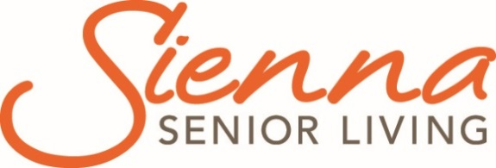

Rockwood Terrace

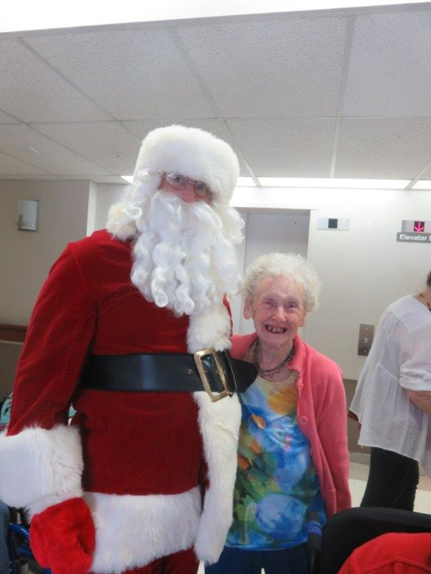
  - Grey County Operations Report to Committee of Management
  - Open Session

  - Submission Date: February 12, 2019
  - Information for the Month of: December 15, 2018-January 31, 2019

Financials
Financial analysis will be transitioned to Sienna in 2019.

Scorecard: Quality
Publicly reported indicators – Q2 2018 (July – Sept 2018)

Indicates Better than Ontario Average
Indicates Worse than Ontario Average
Indicates Ontario Best Practice Target Reached
Indicates Sienna Target Reached

Indicator | HQO Best Practice | Ontario | Sienna Target | Sienna Average | Rockwood Terrace
Worsened ADL | 25% | 33% |  | 29.4% | 31.2%
Worsened behavioural symptoms | 8% | 12.7% |  | 11% | 13.9%
Worsened mood from symptoms of depression | 13% | 23% |  | 17.4% | 33.9%
Has fallen | 9% | 16.4% | 13.5% | 16.6% | 13.7%
Worsened stage 2 to 4 pressure ulcer | 1% | 2.7% | 2% | 2.2% | 3.8%
Has a new stage 2 to 4 pressure ulcer | 1% | 2.2% |  | 1.8% | 3.5%
Daily physical restraints | 3% | 4.3% |  | 0.9% | 2.5%
Worsened bladder continence | 12% | 17.8% |  | 15.7% | 15.1%
Worsened pain | 6% | 9.9% | 8% | 7% | 17.8%
Taken antipsychotics without a diagnosis of psychosis | 25.3% | 19.5% | 20% | 17.4% | 10.4%
Improved or remained independent in mid-loss ADL | 30.4% | 29.2% |  | 27.5% | 42.6%
Has pain | 7% | 5.8% |  | 2.4% | 4.5%

We will continue with the action plan that was developed in March 2018 to address performance and meet targets.

Ministry of Health and Long-Term Care (MOHLTC) Compliance Orders /Inspection Findings Summary
No visits in this reporting period.

Scorecard: People
We are pleased to announce the promotion of Karen Pink to the position of RAI Coordinator. Karen commenced her career with the County of Grey at Grey Owen Lodge, then transferred to Rockwood Terrace when this building closed. Originally, she worked as a Health Care Aide and then returned to school to become an RPN. Karen has strong leadership and analytical skills, and along with her compassion we feel she is a great fit and will do well in this position.
We are also excited to announce that Andrea Watson has accepted the promotion to Associate Director of Care. Andrea began working at Rockwood Terrace as a student. Upon graduation, she immediately stepped into an RN role where she has been very involved in many committees including Health and Safety and Infection Control. In this new role she will support the delivery of resident focused care. Andrea’s normal hours of work will be 1:30-7:00 pm to provide support over the supper and early evening hours. This position will provide direct supervision of all nursing staff, complete quality improvement activities such as audits and the creation and implementation of action plans, performance management including hiring, investigations, discipline and completing performance appraisals. Andrea will also be part of the weekend on-call coverage for the three homes.
We are pleased to again welcome PSW and RPN students from Georgian College for clinical placement.

Sienna Partner Visits
- Quality & Informatics Partner- December 19 visit
- Dietary and Nutritional Care Partner- January 10 teleconference
- CARF-January 11 teleconference
- Quality & Informatics Partner- January 15 visit
- Housekeeping/Laundry Partner- January 22 visit
- Clinical Care Partner- January 22 visit
- Region 7 Executive Directors/Administrator- Jan 24 monthly meeting
- Volunteer Services- January 30 teleconference

Projects, Location Events and Other
- Security Cameras- installation of 21 security cameras and 2 monitors was completed in December
- Hall project Restoration- New handrails, wall protection and painting was completed in December
- Christmas Festivities- Several local choirs entertained during the Christmas season, the kindergarten class presented their Christmas Concert, and Santa Clause and his elf visited on December 25.
- Java Club- For over a year, groups of residents have been participating in the Java Music Club Program. The vision of the Java Music Club is “Thriving communities in which all citizens have a voice and abundant opportunities to appreciate and help one another.” The primary purpose is to share experience, strength and hope to support one another and to have fun. This program plays an important role in our Cultural Competency Plan as the program encourages sharing and listening with an open mind.
- The Annual Robbie Burns day luncheon was held January 25 complete with haggis and piped music performed by Bill McMeekin.

Occupancy
Occupancy in 2018 was maintained at 97.33% with 43 move ins and 46 discharges.
2019 Occupancy Data | Reporting Month | Year to Date
Occupancy | 99.7% | 99.7%
Move-Ins | 3 | 3
Discharges | 2 | 2

Regulatory visits i.e. Ministry of Labour, Public Health
There were no regulatory visits during this time period.

Occupational Health and Safety Issues
An internal WHMIS Audit was completed as a proactive measure. The Home is currently addressing items from this audit.

Emergency Preparedness and Environmental concerns (including emergency codes practiced)
Fire drills held for December and January.
During a regular inspection of the generator fuel tank, the third-party company issued a warning tag for the generator fuel tank as it no longer complies to CSA B139 Ontario Installation code. We are currently working to have the situation rectified.

Written and Verbal Complaints Summary
Type of Compliant | Summary | Outcome (s)
Verbal | Some family members upset that they were not called when a resident was palliative. | Meeting held, clarified policy to notify the Power of Attorney which had occurred.  Remains Unresolved
Verbal | Resident unhappy with roommate. | Resident is on list for an internal move.  Ongoing
Verbal | Resident upset regarding conversation with staff. | Issue addressed with staff.  Resolved
Verbal | Family upset as were not contacted related to an incident between residents. | Discussed with family, Point Click Care updated with families wishes  Resolved
Verbal | Family complaint regarding medication and communication with staff. | Medication discontinued, issue addressed with staff.  Resolved.

Compliments Summary
Numerous cards and treats were received over the Holiday Season from families expressing their thanks for care of loved ones.

Resident and Family Satisfaction Survey
Resident and Family Surveys completed, results will be shared at an upcoming Committee of Management meeting.

Resident/Family Council Updates
A Resident Council meeting was held on January 18, 2019. The Mission Statement and Resident’s Rights were reviewed at the meeting and the Director of Care reviewed the Quality Improvement Plan with the council attendees. Resident’s are requesting a smoking “hut,” and expressed concern about PSW shortages.
There was no Family Council meeting held during this time.

