Committee Report
To: | Chair McQueen and Members of the Affordable Housing Task Force
Committee Date: | July 19, 2021
Subject / Report No: | Rental Housing Update / PDR-AF-19-21
Title: | Rental Housing Update and Next Steps
Prepared by: | Randy Scherzer and Scott Taylor
Reviewed by: | Kim Wingrove
Lower Tier(s) Affected: | All local municipalities
Status:

Recommendation
- That Addendum to Report PDR-AF-19-21 regarding a rental housing update be received; and
- That staff continue to consult with rental housing developers and providers on future opportunities and challenges to providing additional market and affordable rental housing; and
- That staff be directed to incorporate the follow-up items identified in this report as part of the Housing Action Plan and to provide a status update on these actions at a future Task Force meeting; and
- That this report be shared with member municipal staff within Grey County.

Executive Summary
Through the continued work on the Housing Action Plan staff have consulted with developers and providers of rental housing to examine their challenges and opportunities. This report provides a summary of the feedback received through the rental housing interviews. Next steps and action items are also identified to further examine and address some of the comments received. While not all of the comments can be addressed at the County or municipal levels; there are further opportunities for the County to make a positive impact to assist in the further development of rental housing.

Background and Discussion
On March 3, 2021 staff presented Addendum to Report PDR-AF-01-20 to the Affordable Housing Task Force (Task Force). There were a number of action items in this report, many of which are underway by the County’s Housing, Economic Development, and Planning departments. Further reports will be presented to the Task Force as a follow-up to this Report.
Recently staff have conducted interviews with three large scale rental housing owners and developers. Staff hope to conduct similar interviews with other developers in the near future. All three of these developers have projects currently underway in Grey County, and two of them have large rental portfolios already built and rented. The developers spoken to have developments in a number of Grey’s municipalities including some larger and smaller settlement areas. The majority of their developments are on full municipal services, but there are some on partial or private services in some of the smaller settlements. Through these interviews, staff sought to better understand their opportunities and challenges both as developers and landlords. The interviews conducted were all for-profit developers and did not include any not-for-profit housing operators at this time.
To guide these interviews and start discussions, the following questions were posed to the interviewees.
- Do the County’s programs and policies assist you in this regard?
- Are changes needed to the above programs?
- Are any changes needed to County or Municipal planning policies?
- Are their barriers to being a landlord we should be aware of?
- Are there further barriers the County could help you overcome, which would assist in seeing more rental units?
- Do you have any future development plans for additional rental units?
- Is there anything further we should know on this topic?
The interviews turned into more ‘free-form’ discussions versus specifically answering the above questions one-by-one.

Feedback Received from Developers
Below is a brief summary of the feedback received from these developers and landlords. Many of the below comments were common to all three developers, while some were specific to a single developer. County staff have kept the feedback anonymous at this time, to ensure honest input could be given.

Incentive Programs, Rebates, Taxes, and Fees
- The recent changes to the County’s Development Charges (DC) By-law for DC deferrals and exemptions were appreciated and can have a large impact on the pro forma of a new rental development.
- Similar updates and changes should be considered to municipal DC by-laws for rental housing.
- One developer noted that Canadian Mortgage and Housing Corporation (CMHC) funding is onerous to apply for, however it is worth the effort in utilizing for some rental developments. Another developer noted that CMHC funding was not overly beneficial and not worth the paperwork.
- Municipal Community Improvement Plans (CIPs) which waive or rebate application/permit fees, offer tax incentives, parkland rebates, or brownfield redevelopment incentives can be very beneficial. Municipalities that have not updated the CIPs to offer such programs should place a priority on getting such plans in place.
- Often municipal fees and taxes can be the second largest cost in developing land, while property taxes are one of the largest operating expenses. As such, any rebates or incentives here can have a large impact on the ‘bottom line’ and the ultimate affordability of a rental unit. Ten-year tax waivers or tax increment incentives are very beneficial to seeing new rental developments built (See Figure 1 below).
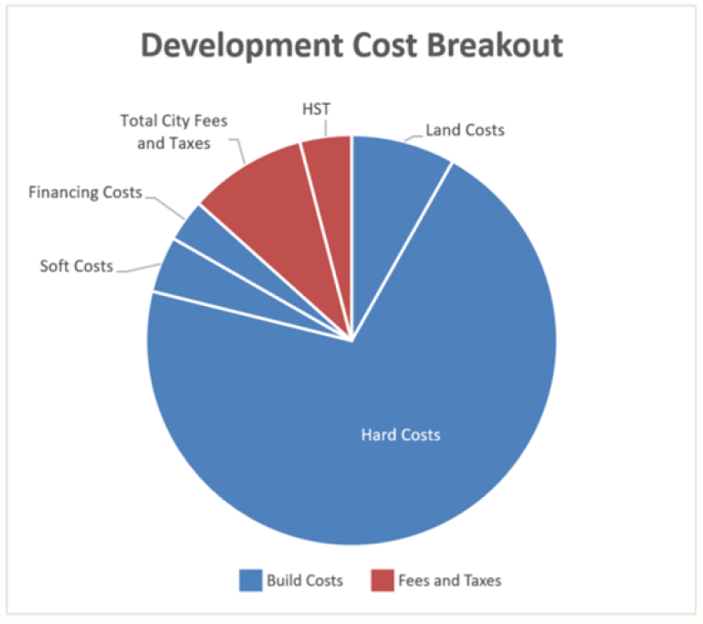

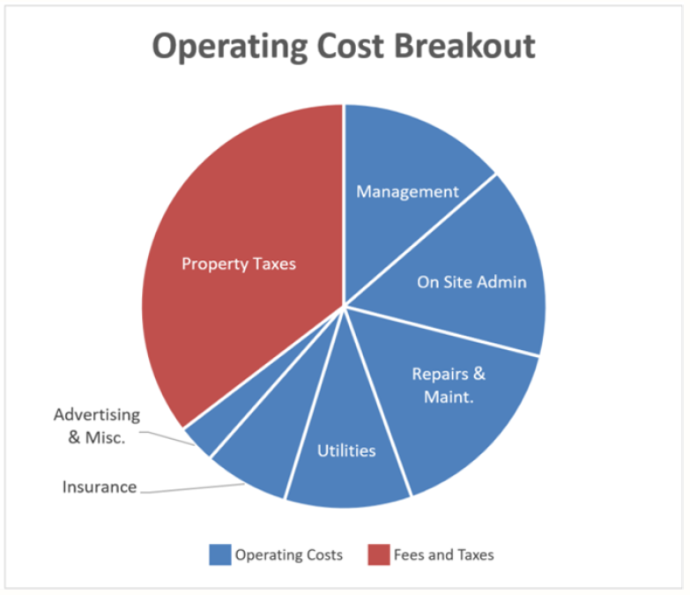

Figure 1: Developer ‘A’ Sample Development and Operating Cost Breakouts
- Flat or capped municipal fees are preferred to escalating or per square metre charges.
- There are big differences between a developer that develops and builds a rental building to sell, versus a developer that builds to own as a long-term asset. The approach to financing, development, and community impression are very different between the two. For example, developers that build and sell have little incentive from a property tax rebate, versus someone looking at a long-term asset may see great value in such a program.

Planning and Development Process
- Time is money. Delays in the planning or approvals process can have huge impacts on the bottom line of a development. With the current increases in land and construction material costs, the ability to get things done quickly is more important than ever. One developer shared an anecdote of a two-week delay, that had they not been able to address with the municipality ahead of time, would have cost them an additional $2.5 million dollars.
- Counties and municipalities should seek to cut as much ‘red-tape’ as possible, including allowing for staff delegated approvals where appropriate.
- Rental housing needs champions at the council and staff levels of both the County and member municipalities. Community opposition without such champions can be difficult for a private developer to overcome.
- Clear policies allowing for density and intensification are beneficial.
- Pre-zoning lands for density and rental developments would assist to seeing future rental housing developed.
- One developer noted the peer review process can be challenging anything that can be done to speed this up would be appreciated.
- The need for reliable infrastructure with capacity for new construction is key. Developers will go to other communities if forced to wait for servicing capacity upgrades.
- One developer noted that design guidelines would not be a barrier as they already build a high-quality attractive product. They ‘bank on’ their reputation and as such do not want to build an inferior product.
- One developer noted that official plans and population projections need to keep pace with development pressures, so that communities can continue to grow and not be held up by dated projections that do not accurately reflect growth needs.

Operational and Landlord Challenges and Opportunities
- The operating costs versus the ability to increase rents to pay for those costs are not always weighed evenly. In some cases, landlords get creative with their rent versus other add-on costs to recoup some of this imbalance.
- Organics pick-up across Grey and standard waste management services would be appreciated.
- Most tenants are well meaning and great to deal with. Although problem tenants are not frequent, they can be difficult to deal with and evict in extreme circumstances.
- COVID has created challenges for both landlords and tenants with respect to affordability, management, and evictions.
- Having your own internal property management and property management on-site is a big benefit, and not something that some smaller operators can offer.
- The ability to build more green and sustainable development is a future opportunity that some developers are actively seeking partners on.

Market and Demand
- The current rental housing market has very low supply with high demand. This lack of supply is contributing to the affordability crisis. Increasing the rental supply, even without specifically targeting new affordable rental housing should help ease the affordability problems.
- Developers are open to a ‘pitch’ if communities in Grey are seeking more rental housing and have property available for such housing. In some cases, a specific community was not on a developers’ radar, until such a pitch was presented, but with outreach from the municipality the development followed.
- Mixing market rate and affordable housing in a single building is something that can be done where incentives would support that.
- Interest rates are fairly low right now for established developers, making it a good time to invest in rental development.
- Short term accommodations are driving up rental prices in some markets.

Items for Follow-up
County staff have identified the need for further work between the County and member municipalities on the following items. It is recommended that these action items be incorporated into the Housing Action Plan if currently not identified. County staff will provide a status update on the various action items at a future Task Force meeting.
- Working with municipalities on municipal development charge updates related to rental housing.
- Ensuring CIP programs are up to date and in place across Grey. Currently most, but not all, of Grey’s municipalities have a recently passed CIP in place. County staff can assist those remaining municipalities on getting their CIP approved.
- Exploring refinements to the planning process at both the County and municipal levels to streamline approvals. This may include recommending some staff delegated approvals, updated official plans or zoning by-laws, and refinements to the County/municipal peer review process.
- Consideration of pre-zoning land at the municipal level for density and rental housing.
- Exploring surplus County/municipal lands to offer up for new affordable and market rate rental housing.
- Exploring potential for new green rental developments and partnerships. Staff would note that this would fit nicely with the draft recommendations of the Climate Change Action Plan.
- Consider ‘pitching’ communities within Grey as an ideal location for new rental developments.
- Demonstrating leadership at the Council and staff on the need for rental housing.
- Promoting funding sources, such as CMHC funding, where applicable.

Legal and Legislated Requirements
There are no further specific legislative requirements beyond those already being considered by County departments stemming from this report. Various pieces of legislation such as the Planning Act, Municipal Act, Development Charges Act, Residential Tenancies Act, etc. all impact housing in Ontario.

Financial and Resource Implications
The action items identified in the Housing Action Plan will primarily be funded from the Affordable Housing Fund established by County Council as part of the 2021 Budget. Other programs and initiatives would be funded from existing budgets and implemented using existing staff resources. For future/new initiatives, additional expenses may be required which will be considered either through future budgets or through separate staff reports to Council.

Relevant Consultation
☒ Internal (Housing, Planning, Economic Development, and CAO)
☒ External (Member municipalities, non-profit organizations, developers)

Appendices and Attachments
Addendum to Report PDR-AF-01-20

