Committee Report
To: | Warden and Members of Grey County Council
Committee Date: | December 8, 2022
Subject / Report No: | EDTC-CW-01-23
Title: | Grey County Gallery Design Services Award
Prepared by: | Jill Paterson
Reviewed by: | Savanna Myers
Lower Tier(s) Affected: | All
Status: | Recommendation adopted by Committee as presented per Resolution CW03-23; Endorsed by County Council January 12, 2023, per Resolution CC09-23.

Recommendation
- That report EDTC-CW-01-23 regarding the Grey Roots Gallery Design Services Award be received; and
- That the complete design services for the remaining three sections of the gallery be awarded to Origin Studios on a single source contract for $100,400 net HST; and
- That staff be directed to proceed with awarding the single source contract to Origin Studios ahead of the approved 2023 budget and prior to County Council approval as per Section 26.6 b) of the Procedural By-law to meet timelines required for further application towards fabrication and installation.

Executive Summary
The five-year Grey County Gallery Update is entering phase three, following the Voices launch in 2020 and the installation of the Abundance in November of 2022. Three theme areas (Connection, Permanence and Hope) remain, which includes design, fabrication, and installation for each.
Funding has been received towards design work for the remaining three theme areas. Following a successful experience with Origin Studios and to maintain a consistent approach to the space, staff wish to complete the remaining design work with Origin Studios.

Background and Discussion
Gallery Overview: Connection, Permanence and Hope
When complete, the Grey County Gallery will include five theme areas. Voices (People) and Abundance (Agriculture) were the first two sections approved. Hope (Forest), Permanence (Stone), and Connection (Water) are proposed for the 2023 design and 2024 fabrication and installation.
The concept of Hope allows us to bring in a discussion of the work that needs to be done and the truths that need to be understood on our journey to reconciliation.
Permanence explores the origin story of Grey County – how the land was shaped by glaciers whose retreat left Grey County with stunning escarpment outcrops and cobbled slopes. It is also the origin story of human habitation – the Indigenous people who lived here before the settlers.
On the surface, Connection will be tied to Grey County’s waterways, waterfalls, and watersheds and people’s relationship with it – transportation, navigation, and shipping; mills and power generation; boating and recreation. From the idea of transportation stems other physical connections – railroads and roadways; phone lines, hydro-electric lines, and the internet. On a deeper level, the stories include personal connections – friendships, love stories, communities found or begun; and finally, broken connections –strained relationships, broken bonds, and lost communities.
Connection, Permanence and Hope explore presents artefacts, photographs, archival records, and play-based interactives relating to the above stories.
Design Work
Origin Studios was hired to complete the design work for Abundance, including specifications completed in 2021. The design work for the remaining three sections will require a rendering walk-through, complete CAD technical and graphic styling packages for each theme.
Given the relationship and knowledge built with Origin Studios, staff believe it will be most effective and efficient to complete the remaining sections of the Gallery Redesign, maintaining a continuous look and feel throughout. Furthermore, the timeline required through the funding agreement is conducive to maintaining the relationship.
Project Funding
Staff successfully applied to the Canada Cultural Spaces Fund from Canadian Heritage, which awarded 47% of the total project cost for this redesign work of the three remaining sections. Origin Studio estimates for the remaining design work and technical packages were used to inform the application to Canada Cultural Spaces Fund. As such, staff are confident in the contract award and funding figures.
Staff intend to pursue Canada Cultural Spaces funding for the fabrication and installation of the three sections in 2024. As such, the design work, including full technical drawings are required to be completed by the fall. Pre-budget approval to award the design contract will ensure enough time to complete this necessary first step and prepare for further funding applications.

Legal and Legislated Requirements
None.

Financial and Resource Implications
The estimate received from Origin Studio for the design of the remaining design work is $100,400 net HST. The Canada Cultural Spaces Grant will cover up to $47,300 of these costs, with the remaining costs being funded from the Grey Roots Gallery Reserve in the amount of $39,900 and the balance of $13,200 coming from the 2023 Grey Roots Capital budget pending Council approval.
Staff recommend Origin Studio be awarded a single source contract to produce rendering walk-through, complete CAD technical and graphic styling packages for Permanence, Connection and Hope section of the Gallery Redesign. The company has provided a reasonable estimate for the design work for the remaining 1033 sq. ft of gallery space.

Relevant Consultation
☒ Internal - Grey Roots staff, Financial Analyst, Purchasing, Director
EDTC, Deputy CAO
☒ External –Origin Studios, Canadian Heritage

Appendices and Attachments

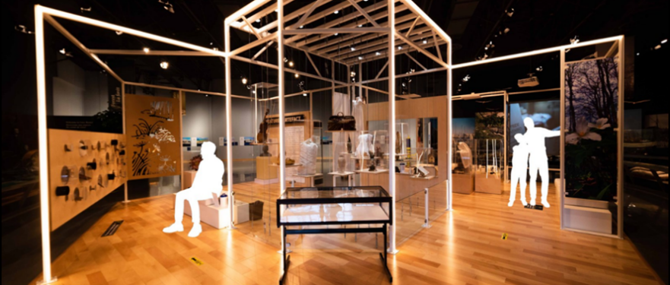
Current Grey County Gallery with Voices Exhibit in forefront
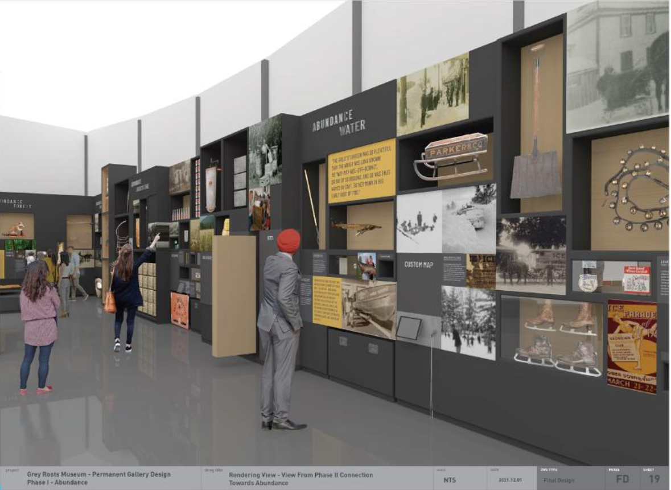
Concept for Abundance by Origin Studios
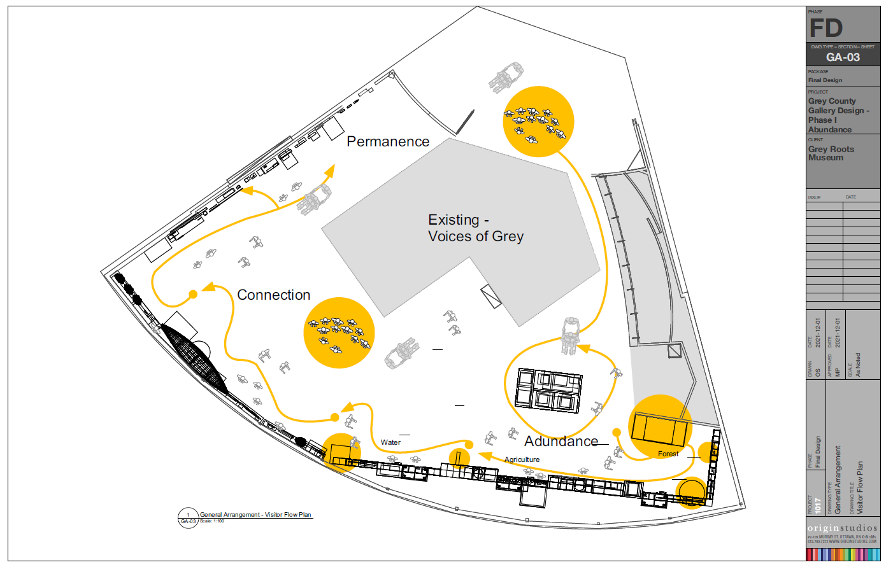
Grey County Gallery Redesign Visitor Flow and Floor Plan

