BOUNDARY ROAD AGREEMENT
THIS AGREEMENT made this day of , 2018.
BETWEEN:
THE CORPORATION OF THE COUNTY OF DUFFERIN
Hereinafter referred to as “Dufferin County”
- and -
THE CORPORATION OF THE COUNTY OF GREY
Hereinafter referred to as “Grey County”
WHEREAS Sections 20, 29, 29.1 and 52 of the Municipal Act, 2001, (the “Act”) make provision for agreements between adjoining municipalities for the maintenance and repair of any highway forming the boundary between such municipalities, including the culverts thereon;
AND WHEREAS portions of a highway as particularly described herein comprise a shared boundary road between Dufferin County and Grey County (the “Road”);
AND WHEREAS both parties wish for Grey County to provide year-round oversight, maintenance, and repair on the Road;
AND WHEREAS the parties wish to agree on a manner in which capital upgrades of the Road shall be completed;
AND WHEREAS the parties wish to share the costs equally for both maintenance and capital projects;
NOW, THEREFORE, THIS AGREEMENT WITNESSTH THAT, in consideration of the mutual covenants set out below together with other good and valuable consideration (the receipt of which is acknowledged), the parties agree as follows:
- Definitions
1.1 “Agreement” means this Agreement and all instruments amending it;
1.2 “Road” means the portion of the highway forming the boundary between Grey County and Dufferin County, described as that portion of the County Boundary Line between the Municipality of Grey Highlands (on the north side) in the County of Grey and the Township of Melancthon (on the south side), in the County of Dufferin, which will be known as Grey Road 9, a total distance of approximately 3.2 kilometres. More specifically, it begins at the easterly limit of lot 230, concession 9 of Melancthon Township, running easterly to the intersection with the Township of Melancthon 5th Line.
1.3 “Road Maintenance” means all road maintenance budgeted work activities pertaining to the counties’ responsibility in meeting the Minimum Maintenance Standards as set out in Ontario Regulation 239/02 of the Highway Traffic Act. (Programs exercised normally 365 days of the year in order to maintain the right of ways and infrastructure in a “state of repair”).
1.4 “Schedule A” means a map showing the geographical location of the Road, attached hereto.
1.5 “Schedule B” means a document indicating the lump sum payable by Dufferin County in 2019 for the Annual Maintenance Costs of the Road, attached hereto.
1.6 “Winter Maintenance” means all winter-based budgeted work activities pertaining to the counties’ responsibility in meeting the Minimum Maintenance Standards as set out in Ontario Regulation 239/02 of the Highway Traffic Act.
1.7 “Winter Maintenance Season” means the continuous period of time between the fifteenth (15th) day of November and the first (1st) day of April.

- Term and Termination
2.1 This Agreement shall be effective on the date that it is signed by both parties and shall continue until September 30, 2023 (the “Term”).
2.2 The parties acknowledge that since the previous boundary road agreement expired, which was September 30, 2018, both have continued to act in good faith according to the operating terms of the previous boundary road agreement as if it had been in effect, pending the execution of this Agreement.
2.3 Either party may terminate this Agreement by providing the other with one hundred and twenty (120) days’ written Notice of its intent to terminate, pursuant to Section 15. However, such Notice may only be provided between April 15 and August 15 of any year throughout the Term of the Agreement.
- Obligations of Grey County
3.1 Grey County shall undertake all Winter Maintenance activities with respect to the Road, including but not limited to the patrolling, plowing and spreading of materials for winter road conditions, during each Winter Maintenance Season throughout the Term of the Agreement.
3.2 In addition to the requirements set out in 3 (a) above, Grey County shall attend to winter events that occur prior to November 15th and after April 1st until winter events have subsided at the end of each season throughout the Term of this Agreement. Both parties acknowledge that the level of service provided outside of the Winter Maintenance Season may be at a lower level than during the Winter Maintenance Season, but that it shall meet the minimum standards set forth in regulations made by the Minister of Transportation as contemplated in section 44(4) of the Act (the “Minimum Maintenance Standards for Municipal Highways”) where such standards apply and, in the event that there is no applicable Minimum Maintenance Standard, shall meet the standard of what is reasonable in the circumstances.
3.3 Grey County shall be responsible for all removal of snow beyond the width of the Road and shoulders if required.
3.4 Grey County shall be responsible to provide snow blowing services required within the right of way, if deemed necessary by Grey County.
3.5 Grey County shall undertake all Road Maintenance activities with respect to the Road, including all routine patrolling and maintenance activities throughout the Term of this Agreement.
3.4 The Parties acknowledge that the level of service to be provided by Grey County on the Road may change throughout the Term of the Agreement. Any changes to the level of service shall meet the minimum standards set forth in the Minimum Maintenance Standards for Municipal Highways, Ontario Regulation 239/02 of the Act where such standards apply and, in the event that there is no applicable Minimum Maintenance Standard, shall meet the standard of what is reasonable in the circumstances.
3.5 Grey County shall be responsible for the drainage maintenance of the Road, including the clearing of ditches, curbs and gutters, catch basins, and storm drains.
3.6 Grey County shall be responsible for the surface maintenance of the Road, including the repair of potholes, cracks and depressions.
- Reimbursement
4.1 Dufferin County and Grey County shall each be responsible for one half of the total maintenance costs of the Road.
4.2 On or about December 31, 2018, Grey County will invoice Dufferin County for the lump sum amount for 2018 maintenance costs for the entire period of January 1, 2018 – December 31, 2018. The lump sum amount to be invoiced was previously established within the Boundary Road agreement between the two parties which expired on September 30, 2018. Dufferin County shall provide payment to Grey County no later than 30 days from receipt of such invoice.

4.3 On or about December 31 of each remaining year throughout the Term beginning in 2019, Grey County shall invoice Dufferin County annually for all maintenance intended to be undertaken during that calendar year. Dufferin County shall provide payment to Grey County no later than 30 days from receipt of any such invoice throughout the Term of the Agreement.
4.4 The invoices will be in the form of a lump sum that represents a five year average of the cost to complete the maintenance on the Road. The lump sum amount invoiced shall be equal to the total as indicated in Schedule “B” as attached hereto. The lump sum amount invoiced on December 31, 2019 shall increase by 2 percent per year in each subsequent year of the Agreement.
- Capital Costs
5.1 Subject to the further terms set out in this section, Dufferin County and Grey County shall each be responsible for one-half of all capital improvements on the Road, including but not limited to items such as road construction, hot mix asphalt resurfacing, and the shoulder gravelling associated with this resurfacing, culvert repairs and replacement, and surface treatment.
5.2 Prior to completing any capital improvements Grey County will identify the required work to Dufferin County.
5.3 Except in the case of emergencies, Grey County shall notify Dufferin County two years in advance of any such capital improvement work proposed and the extent and cost of the capital improvement work shall be mutually agreed upon prior to proceeding with the work.
5.4 If Dufferin County and Grey County agree that the work is required, Dufferin County and Grey County will mutually agree how the work will be completed and whether Dufferin County or Grey County will administer the work in each case.
5.5 The party who administers the work as determined in Section 5.5 shall invoice the other party for one half of the capital costs no later than the 31st of December in the year in which the work was undertaken. The invoiced party shall pay the invoice no later than 30 days from receipt of the invoice.
5.6 All capital improvements on the Road including road construction, hot mix asphalt resurfacing, the shoulder graveling associated with this resurfacing, and the mid-life shoulder graveling application shall be apportioned between and paid by both parties on a 50/50 basis.
5.7 Despite Section 5.6, the capital expenditures by either party in any one year within the Term shall not exceed the sum of $10,000 for work under Section 5.7. unless it has been approved pursuant to Section 5.8 below.
5.8 If a party identifies the need for capital expenditures to exceed the sum of $10,000 for such work, it shall first advise the other party prior to the budget being set for the applicable budget year (not later than June 30th), or as soon as the need is identified where the work required is of a more urgent nature. The party making the request shall not proceed with the work without first receiving confirmation in writing from the other party that it has been included in the applicable budget year and has therefore been approved by its Council; or without first receiving the consent of the Council of the other party to the expenditure of any amount in excess of the said sum. If the Council does not provide approval, the party which has identified the need for the work to be completed may elect to proceed with the work without cost-sharing with the other party.
- Indemnification
6.1 Grey County agrees to defend, indemnify and save and hold harmless Dufferin County from all claims, lawsuits, losses, expenses and costs, or any other liability imposed by statute or common law in any way connected to or in any way arising out of any actual or alleged breach, default or neglect of duty in respect of obligations imposed on Grey County under the terms of this Agreement.
6.2 Dufferin County agrees to defend, indemnify and save and hold harmless Grey County from all claims, lawsuits, losses, expenses and costs, or any other liability imposed by statute or common law in any way connected to or in any way arising out of any actual or alleged breach, default or neglect of duty in respect of obligations imposed on Dufferin County under the terms of this Agreement.
- Insurance
7.1 Each party shall, at its own expense, obtain and keep in force during the Term of this Agreement, Municipal General Liability insurance satisfactory to the other party, including the following terms and minimum coverage and underwritten by an insurer licensed to conduct business in the Province of Ontario:
a) Written on an occurrence basis for limits not less than Fifteen Million Dollars ($15,000,000);
b) Inclusion of the other party as an Additional Insured with respect to the operations of the named insured, and including Cross liability and severability of Interest clauses;
c) Non-owned automobile coverage including contractual non-owned coverage;
d) Products and completed operation coverage with a limit of at least Fifteen Million Dollars ($15,000,000); and
e) Policies shall not be invalidated as respects the interests of the Additional Insured by reason of any breach or violation on any warranties, representations, declarations or conditions.
7.2 Automobile liability insurance for limits not less than Ten Million Dollars ($10,000,000) on forms meeting statutory requirements covering all licensed vehicles used in any manner in connection with the performance of the terms of this Agreement;
7.3 A thirty day written notice of cancellation, termination or material change.
7.4 Each party shall provide the other party proof of insurance, each year, in the form of an insurance certificate.
7.5 Both parties agree to immediately notify the other party of any occurrence, incident or event which may reasonably be expected to expose either party to material liability of any kind in relation to the Road.
- Force Majeure
8.1 Neither Grey County nor Dufferin County shall be held responsible for any damage or delays as a result of war, invasions, insurrection, demonstrations, or as a result of decisions by civilian or military authorities, fire, flood, human health emergency, strikes and generally as a result of any event that is beyond the reasonable control of Grey County or Dufferin County.
8.2 Grey County and Dufferin County agree that in the event of a disaster or FORCE MAJEURE the parties will co-operate and Grey County will make all reasonable efforts to provide temporary replacement service until permanent service is completely restored.
- Governing Law
9.1 This Agreement shall be governed by and construed and interpreted in accordance with the laws of the Province of Ontario and the laws of Canada applicable therein. The parties hereby irrevocably attorn to the exclusive jurisdiction of the courts of Ontario with respect to any matter arising under or related to this Agreement.
- Enforcement of Individual Municipal By-Laws Dealing with the Road
10.1 Except for the provisions of this Agreement respecting maintenance of the Road, it is specifically acknowledged in accordance with Section 28 of the Act, that the by-laws passed by each of Grey County and Dufferin County relating to their respective portions of a Road, such as, but not limited to, entrances, setbacks and parking shall remain in force and effect unless a bylaw passed by the Councils of both Grey County and Dufferin County shall designate otherwise.
- Severability
11.1 Each of the provisions contained in this Agreement is distinct and severable and a declaration of invalidity or unenforceability of any such provision or part thereof by a court of competent jurisdiction shall not affect the validity or enforceability of any other provision hereof.

- Entire Agreement
12.1 This Agreement constitutes the entire agreement between the parties with respect to the year round maintenance and capital improvement projects for the Road and supersedes all prior agreements, understandings, negotiations and discussions, whether written or oral. There are no conditions, covenants, agreements, representations, warranties or other provisions, express or implied, collateral, statutory or otherwise, relating to year round maintenance and capital improvement projects for the Road except as provided in this Agreement, and the attached Schedules “A” and “B”.
- Waiver and Amendment
13.1 Except as expressly provided in this Agreement no amendment or waiver of this Agreement shall be binding unless executed in writing by the party to be bound. No waiver of any provision of this Agreement shall constitute a waiver of any other provision, nor shall any waiver of any provision of this Agreement constitute a continuing waiver, even if similar in nature, unless otherwise expressly provided.
- Successors and Assigns
14.1 This Agreement shall enure to the benefit of and be binding upon the parties hereto and their respective successors and permitted assigns. Neither party may assign all or any part of this Agreement without the written approval of the other party.
- Notice
15.1 Any notice required to be given, served or delivered must be in writing and sent to the other party at the address indicated below, or to such other address as may be designated by notice provided by either party to the other.
For Grey County:
County Clerk
County of Grey Administration Building
595 9th Ave East
Owen Sound, ON N4K 3E3
Fax: 519-376-8998
Email: countyclerk@grey.ca
For Dufferin County:
County of Dufferin
55 Zina Street
Orangeville, ON L9W 1E5
Fax: 519-941-4565
Email: clerk@dufferincounty.ca
15.2 Any notice to be given by either party to the other shall, in the absence of proof to the contrary, be deemed to have been received by the addressee if:
a) Delivered personally on a business day, then on the day of delivery;
b) Sent by prepaid registered post, then on the second day following the registration thereof;
c) Sent by ordinary mail, then on the third business day following the date on which it was mailed; or
d) Sent by facsimile or email, upon confirmation of successful transmission of the notice.
- Dispute Resolution
16.1 A dispute between the parties relating to the interpretation or implementation of this Agreement will be addressed though good faith negotiation, with or without the assistance of a mediator. The parties agree that in the event that they are not able to reach a resolution of all the matters in dispute after mediation, then the matters remaining in dispute will be finally determined by arbitration in accordance with the provisions of the Ontario Arbitrations Act, 1991.

IN WITNESS WHEREOF the parties hereto have executed this Agreement as of the day and year set out above:
THE CORPORATION OF THE COUNTY OF DUFFERIN:

PAUL MILLS, WARDEN

PAM HILLOCK, CLERK
I/we have the authority to bind the Corporation.
THE CORPORATION OF THE COUNTY OF GREY:

STEWART HALLIDAY, WARDEN, COUNTY OF GREY

HEATHER MORRISON, CLERK, COUNTY OF GREY
We have the authority to bind the Corporation.

Schedule "A"
Geographical Location Map
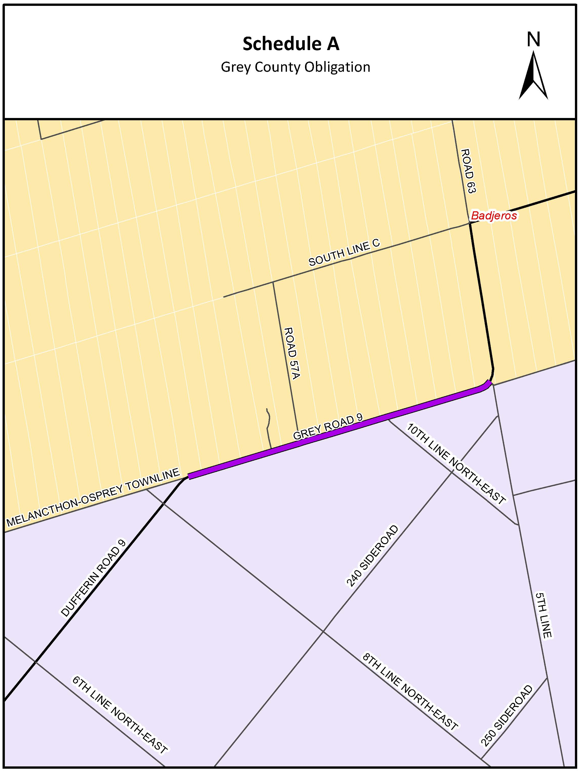

Schedule “B”
Grey Road 9 Annual Maintenance Costs Payable by Dufferin County
Lump sum amount for Winter Maintenance $8,984.19
Lump sum amount for Summer Maintenance $ 897.35
Total lump sum amount payable by Dufferin County: $9,881.54
The total lump sum amount shall be invoiced on or about December 31, 2018.
That amount shall increase by 2% per year in each subsequent year of this Agreement.
See Section 4 of the Agreement for other details on the invoicing.

