Committee Report
To: | Warden Hicks and Members of Grey County Council
Committee Date: | November 12, 2021
Subject / Report No: | HRR-CW-10-21
Title: | Employee Assistance Program (EAP) plan for Members of County Council
Prepared by: | Sandra Shipley
Reviewed by: | Jennifer Moreau
Lower Tier(s) Affected: | None
Status: | Recommendation adopted by Committee as presented per Resolution CW178-21; Endorsed by County Council November 25, 2021 per Resolution CC87-21

Recommendation
- That Report HRR-CW-10-21 regarding the Employee Assistance Program (EAP) for Members of County Council be received; and
- That the Employee Assistance Program be provided to the eighteen members of County Council effective December 1, 2021.

Executive Summary
During the October 14, 2021 Committee of the Whole meeting, Council directed staff to bring back a report outlining the costs associated with including Grey County Council in the County’s Employee Assistance Program (EAP).

Background and Discussion
In 2009, a committee comprised of employees and managers from the Non Union group of employees met to review compensation, benefits and human resources policies. The group then met with the CAO, Warden, Chair of the Finance & Personnel Committee, and the Director of Human Resources to discuss their findings. The group recommended that Council consider providing an employee assistance program to staff. Council agreed and on October 1, 2009, the EAP benefit was provided to permanent Non Union employees who have a minimum guarantee of seven hours per week. After seeing the benefits of the program, the EAP plan was provided to the unionized employees effective July 1, 2011.
The EAP program is a confidential, 24/7 service that is available to covered employees, their spouse and dependent children. The program can be accessed by telephone (toll-free) or online. Counselling sessions are short term, solution focused and cover many issues:
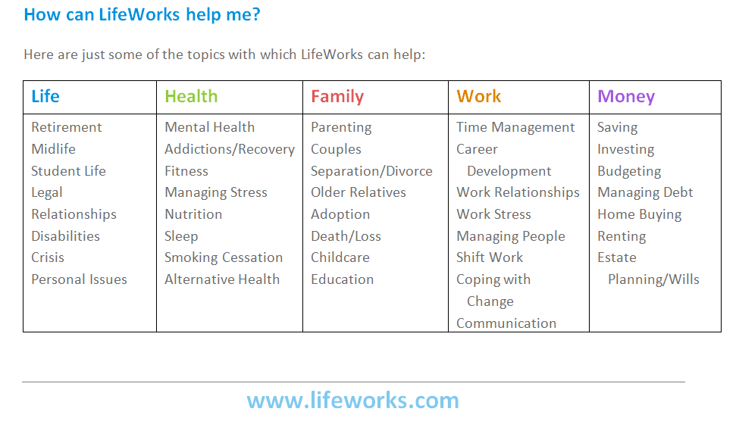
Members of Council already receive the benefit of an OMERS pension. In addition, they are covered for accidental death and dismemberment under the County’s liability policy.
Should County Council decide to provide the EAP benefit to members of Council, it is recommended that Council provide it to the 18 elected members, in order to be consistent with how the program is provided to staff.
Annual premium for this benefit is $48.60 plus HST per insured member. This rate is guaranteed to December 31, 2022.

Legal and Legislated Requirements
Not applicable

Financial and Resource Implications
The annual cost to provide this benefit to the 18 full time members of County Council and their eligible dependents is $890.28 net of HST rebate.

Relevant Consultation
☐ Internal
☐ External-LifeWorks

Appendices and Attachments
N/A

