Committee Report
To: | Deputy Warden McQueen and Members of Grey County Council
Committee Date: | May 12, 2022
Subject / Report No: | EDTC-CW-11-22
Title: | Grey Roots Gallery Redesign
Prepared by: | Jill Paterson, Manager Museum & Archives  Sim Salata, Curator
Reviewed by: | Savanna Myers, Director, Economic Development Tourism and Culture
Lower Tier(s) Affected: | All
Status: | Recommendation adopted by Committee as presented per Resolution CW74-22; Endorsed by County Council May 26, 2022 per Resolution CC47-22

Recommendation
- That Report EDTC-CW-11-22 regarding the Grey Roots Gallery Redesign be received; and
- That the fabrication and installation of the Abundance gallery be awarded to Wood & Wallworks on a single source contract for $145,000 + HST; and
- That the project deficit be funded from the Canada Cultural Spaces Fund if the application is successful and from any surplus realized in 2022, or if no surplus is realized, the funds be transferred from the Grey Roots General Reserve.

Executive Summary
The five-year Grey County Gallery Update is entering phase two of construction, following the Voices of Grey launch in 2020. In January of 2022, staff received the final design package from Origin Studios for the Abundance section, covering approximately 1500 sq. ft of the gallery. An evolving project vision coupled with soaring construction costs mean additional funds are required to proceed with the project. Staff have applied to the Canada Cultural Spaces Fund to fully offset the overage but are seeking approval of Council to use reserve funds if unsuccessful to allow the project to proceed on schedule.

Background and Discussion
Gallery Overview: The Grey’t Abundance
You are standing in a place that is marked with natural richness - its lands, forests and waters have sustained and protected people who have called this region home and continues to do so. Indigenous land use, and later settler industries such as forestry, agriculture and industry, allowed countless generations to take advantage of the natural world around them to carve out their lives and new opportunities. Grey County continues to enjoy and sustain the natural abundance found here.
Abundance explores the above using artefacts, photographs, archival records and play-based interactives relating to the subthemes of Forests, Agriculture, and Water.
Design Work
The design work, including complete specifications was completed in 2021 with Origin Studios. Staff looked for a design that could structurally and aesthetically stand the test of time, while providing space for regular updates with new objects, images and text panels.
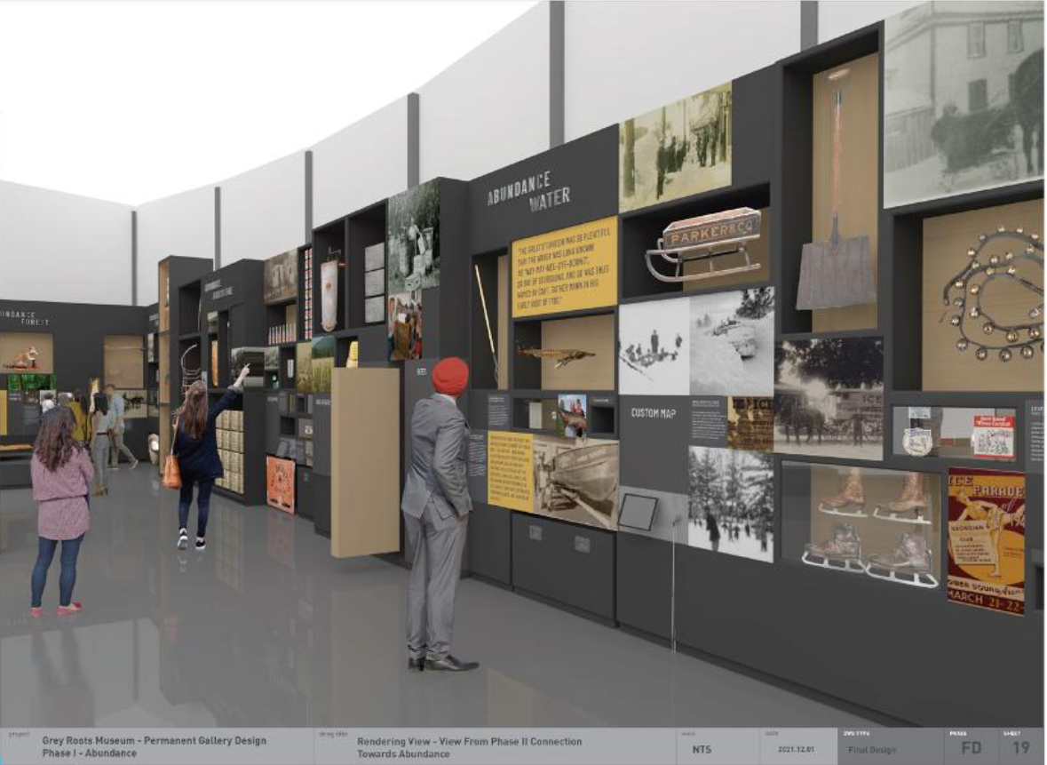
The exhibit casework is designed to age and can simply be refreshed to reflect contemporary aesthetics and thematic priorities, which will help break the cycle of complete gallery reconstruction every 10 to 15 years.
Project Funding
The phased redesign, endorsed through CAOR-CW-13-18 continues to evolve as staff consider best use of resources and exhibit longevity. Realizing the importance of professionally designed, fabricated and installed casework to carry the vision forward, the 10-year capital estimates are undervalued. Estimates have also not kept up with inflation or accounted for the rise in construction costs resulting from the pandemic. Staff also recently learned about updated industry standards, which note, most museum exhibit builds start at about $200/sq.ft. and can go up to $1000/sq.ft. The estimate noted for the Abundance build (approx. 1,500 sq.ft.) is approximately $97/sq.ft.
Staff pursued an opportunity to apply to the Canada Cultural Spaces Fund from Canadian Heritage, seeking up to 50% of the total project cost. Staff were encouraged by the program officer who saw the project as a good candidate for the funding, as replacement of long-term exhibits are eligible projects under the program. Full schematic plans and cost estimates are required as part of the application, which were also completed. Staff were also proactive including design technical packages for the next two sections, Connection and Permanence, in the application to reduce future budget requirements.
Staff will adjust capital budgets beginning in 2022 for better future planning, and intends to also pursue continued support from the Canada Cultural Spaces Fund and develop an appeal for sponsorship and philanthropic donation for the remaining sections of the Gallery Redesign. The intent is to use Abundance to demonstrate the proof of concept and to build excitement, encouraging private sector partnership to complete the remaining sections. Naming opportunities may be available for potential sponsors and legacy building donors will be engaged and stewarded through a fundraising strategy focused on the Grey County Gallery Redesign project.
Accessibility
As the gallery redesign and fabrication is occurring over multiple years, the modular design offers the museum an opportunity to showcase which stories and artefacts will be coming in future installations. This approach also offers known and aspirational communities the opportunity for self-representation and to work with the museum’s curatorial team to develop collaborative approaches where communities are empowered to tell their own stories. Contemporary museology focuses on the importance of establishing and maintaining a two-way dialogue with visitors and supporters and will lead to repeat visitation and support from local communities.
The new Grey County Gallery Design was also presented at the Grey County Accessibility Committee. The exhibit designers, Origin Studios, have taken their approach from the Smithsonian Guidelines for Accessible Design, the Accessibility Standards for Exhibitions from Ingenium, and the Canadian Museum for Human Rights Inclusive Design and Accessibility Guidelines. Accessibility considerations have been included in all aspects of the design from the layout and floor plan to colour scheme and text panels, to object placement, lighting requirements and more.

Legal and Legislated Requirements
None.

Financial and Resource Implications
The 2022 budget, operating and capital, included $88,600 for fabrication and installation of Abundance. Estimates received ranged from $145,000 to $266,560, exceeding the approved budget amounts. To proceed, Council approval is required to ensure funds for the 39% deficiency of $56,400. If staff are unsuccessful receiving the grant, staff recommend funding for the fabrication and installation be taken from any surplus realized in 2022 or if no surplus is realized, the funds be transferred from the Grey Roots General Reserve. The 2022 year-end balance, including the $56,400 to cover the budget shortfall, is estimated at $348,120.
Staff recommend Wood & Wallworks be awarded a single source contract to fabricate and install the exhibit casework for $145,000 + HST. The company has provided a reasonable estimate for the work to be completed as specified. Staff wish to proceed with an award to ensure costing is not further impacted by supply shortages and continued inflation.

Relevant Consultation
☒ Internal - Grey Roots staff, Financial Analyst, Purchasing, Director
EDTC, Deputy CAO, CAO
☒ External –Wood & Wallworks, Origin Studios, Holman Inc, Canadian Heritage

Appendices and Attachments
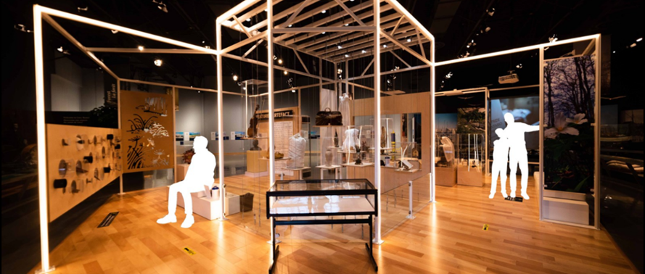
Current Grey County Gallery with Voices Exhibit in forefront

