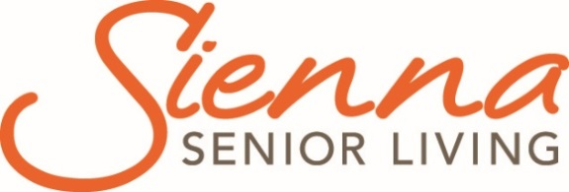

Grey Gables
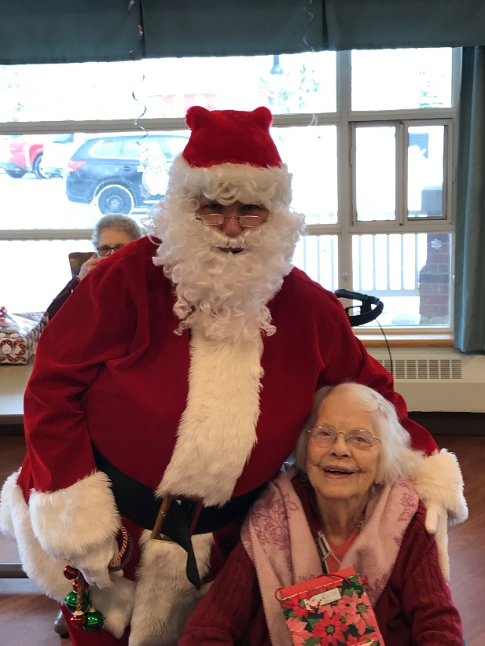

  - Grey County Operations Report to Committee of Management
  - Open Session

  - Submission Date: February 12, 2019
  - Information for the Month of: December 15, 2018-January 31, 2019

Financials
Financial analysis and updates will be transitioned to Sienna in 2019.

Scorecard: Quality
Publicly reported indicators- Q2 2018 (July- Sept 2018)
Indicates Better than Ontario Average
Indicates Worse than Ontario Average
Indicates Ontario Best Practice Target Reached
Indicates Sienna Target Reached

Indicator | HQO Best Practice | Ontario | Sienna Target | Sienna Average | Grey Gables
Worsened ADL | 25% | 33% |  | 29.4% | 41.7%
Worsened behavioural symptoms | 8% | 12.7% |  | 11% | 19.1%
Worsened mood from symptoms of depression | 13% | 23% |  | 17.4% | 33%
Has fallen | 9% | 16.4% | 13.5% | 16.6% | 12.8%
Worsened stage 2 to 4 pressure ulcer | 1% | 2.7% | 2% | 2.2% | 3.3%
Has a new stage 2 to 4 pressure ulcer | 1% | 2.2% |  | 1.8% | 2.6%
Daily physical restraints | 3% | 4.3% |  | 0.9% | 3.8%
Worsened bladder continence | 12% | 17.8% |  | 15.7% | 27.6%
Worsened pain | 6% | 9.9% | 8% | 7% | 14.9%
Taken antipsychotics without a diagnosis of psychosis | 25.3% | 19.5% | 20% | 17.4% | 25.6%
Improved or remained independent in mid-loss ADL | 30.4% | 29.2% |  | 27.5% | 37.1%
Has pain | 7% | 5.8% |  | 2.4% | 3.1%

We will continue with the action plan that was developed in March 2018 to address performance and meet targets.

Ministry of Health and Long-Term Care (MOHLTC) Compliance Orders /Inspection Findings Summary
Details provided in report LTCR-CM-14-19

Scorecard: People
Winter weather brings all sorts of interesting challenges and the Grey Gables staff handle them like rock stars! During the recent snowy weather that brought road closures and dangerous driving conditions many staff stayed in town over night to ensure they were able to get back into work and others came in early or on their day off to help. Through strong communication and teamwork, they strategized a contingency plan and everyone was well looked after.
We are proud of so many of our staff and would like to recognize a couple who recently demonstrated their commitment to Colour It in a special way. To better communicate with a resident during mealtimes, a cook taught himself some words in polish. Another cook dedicated her Christmas morning and arrived in the home as Santa’s helper to distribute gifts and share Christmas joy. This was a wonderful surprise to the residents.
Debi Hughson, an RN with Grey Gables since 2011, has accepted the position of Associate Director of Care at Grey Gables. With the implementation of this new role, additional resources and leadership will be available into the evening hours to support resident care needs and provide direct supervision of staff. The ADOC responsibilities and range of duties include completing quality improvement activities, auditing, creating and monitoring action plans and supporting performance management through counseling, discipline and the completion of investigations. Debi will also be part of the weekend on-call coverage for the three homes.
Grey Gables hosted 6 Personal Support Worker students and 8 Practical Nurse students from Georgian College for their placement experience.

Sienna Support Services Updates
- Quality and Informatics Partner- Dec 17, Jan 17 visits
- Clinical Partner- Dec 17, Jan 10 visits
- Housekeeping/’Laundry Partner- Dec 18, 2018 teleconference
- CARF- Jan 11 teleconference
- Nutrition Partner- Jan 15 teleconference
- Resident Experience Partner- Jan 18 visit
- Region 7 Executive Directors/Administrators- Jan 22 teleconference, Jan 24, Jan 29 meetings

Projects, Location Events and Other
There were many special moments and events over the Christmas season, some highlights include:
- 18 couples enjoyed a traditional Christmas meal together on Dec 20
- Residents made Christmas crackers and included a thank you magnet and chocolates that were handed out as a thank you to all staff
- 21 volunteers were recognized at an Appreciation Lunch on Jan 17
- A memorial service was held in memory of 8 residents who passed away in the in the previous three months was held on Jan 26

Long Term Care

Occupancy
Occupancy in 2018 was maintained at 99.33% with 19 move ins and19 discharges.
2019 Occupancy Data | Reporting Month | Year to Date
Occupancy | 99.2% | 99.2%
Move-Ins | 2 | 2
Discharges | 1 | 1

Regulatory Visits i.e. Ministry of Labour, Public Health
There were no regulatory visits during this reporting period.

Occupational Health and Safety Issues
There were two outbreaks that took place during the reporting period:
- December 21 – 24, 2018: Enteric outbreak affecting one home area
- January 1 – 8, 2019: Respiratory outbreak affecting one home area

Emergency Preparedness and Environmental concerns (including emergency codes practiced)
The annual Fire Inspection was completed on January 7, 2019 with no orders issued.
In the early hours of January 25, 2019 staff declared a Code Brown (hazardous situation) in response to a potential natural gas leak. Policies and procedures were followed as required and the issue was resolved with no harm to residents or staff.
Code Red was practiced on all three shifts in December and January.
Code White was practiced on all three shifts in January.

Written and Verbal Complaints Summary
Type of Compliant | Summary | Outcome (s)
Verbal | Family complaint related to loss or damage of residents clothing | Meeting held with family member and appropriate team members. Resolution is still in progress.

Compliments Summary
Verbal- numerous resident and visitor comments on the Christmas decorations and events throughout the home.
Numerous thank you cards and gifts of chocolate, cookies and fruit brought in for staff from residents and their family members. These gifts are placed in the staff room for all staff to enjoy.
Thank you card from a spouse of a resident to a member of the leadership team for supporting the resident’s physiotherapy program.

Resident and Family Satisfaction Survey
Resident and Family Surveys completed, results will be shared at an upcoming meeting of Committee of Management.

Resident/Family Council Updates
Resident Council meetings held January 29, 2019. Administrator was invited and provided an update on the MOHLTC Inspection Report. There were no areas of concern raised.
Family Council meeting held on January 15, 2019. No areas of concern raised.

