Grey County Logo Committee Report

| **To**: | Warden and Members of Grey County Council |
| --- | --- |
| **Committee Date:** | December 8th, 2022 |
| **Subject / Report No:** | PDR-CW-05-23 Information Report |
| **Title:** | Delbrook Plan of Subdivision Information Report 42T-2022-04 |
| **Prepared by:** | Hiba Hussain |
| **Reviewed by:** | Scott Taylor |
| **Lower Tier(s) Affected:** | Municipality of Grey Highlands |
| **Status:** | Recommendation adopted by Committee as presented per Resolution CW04-23; Endorsed by County Council January 12, 2023, per Resolution CC09-23. |

## Recommendation

1. **That report PDR-CW-05-23 regarding an overview of plan of subdivision application 42T-2022-04 on lands described as** Part of Lot 101, Concession 1, Northeast of Toronto and Sydenham Road, Geographic Township of Artemesia, Municipality of Grey Highlands, County of Grey, **be received for information.**

## Executive Summary

The County has received a plan of subdivision application known as Delbrook subdivision (County file number 42T-2022-04). The proposed plan of subdivision would create 154 residential lots which would comprise of 24 semi-detached dwellings and 130 townhouse dwelling units. In addition to the residential units, the proposal will create a stormwater management block, future development blocks and new municipal roads.

The applicant has chosen not to submit a zoning by-law amendment application along with the plan of subdivision application. A zoning by-law amendment application will be required in the future.

The application and supporting studies have been circulated to prescribed agencies and the public for comment. Following the public and agency review processes, a thorough analysis and staff recommendation will be provided.

## Background and Discussion

The proposed plan of subdivision application, known as Delbrook subdivision (County file 42T-2022-04), would create blocks of land for residential development consisting of:

* 24 semi-detached residential units,
* 130 townhouse dwelling units,
* drainage block for stormwater management and environmental lands,
* 3 future development blocks (approximately 1.64 hectares), and
* 3 unnamed municipal roads (Street A, Street B and Street C).

Access to the site is proposed through a future municipal street (Street C) which will connect to Grey County Road 12 (Main Street East) and will align with Lawler Drive. The proposed subdivision will have two (2) internal connections through the extension of unnamed municipal roads (Street A and Street B).

Municipal water and sewer services are proposed to be extended to the proposed development. A Functional Servicing and Stormwater Report was also submitted to demonstrate the planned expansion of municipal services. Various other technical reports were prepared as part of the application submission package.

This site is approximately 8.48 hectares in size and has approximately 430 metres of frontage on Grey Road 12 (Main Street East). The lands are legally described as Part of Lot 101, Concession 1, Northeast of Toronto and Sydenham Road, geographic township of Artemesia, Municipality of Grey Highlands, County of Grey.

The subject site is in the northeast section of Markdale. The parcel has historically been utilized for agricultural uses but currently is vacant and has no farming-related activity occurring. Surrounding this site are a mixture of residential, future residential lands, and Agricultural lands. More specifically the subject property is bounded by:

* agricultural lands to the north,
* future residential lands to the east that are subject to plan of subdivision application 42T-2017-06 (Centre Point South), and
* residential lands within the Markdale Primary Settlement Area to the south and west.

Map 1 below shows the subject lands highlighted in red and the surrounding area, while Map 2 shows the proposed Delbrook plan of subdivision concept plan. The draft concept plan submitted is currently under review. Future changes to the draft concept plan might be proposed once comments have been received from various commenting agencies.

A public meeting for the application will be scheduled at a later date.

Pre-submission consultation between the proponent, the Municipality of Grey Highlands and the County identified the submission requirements for the proposed plan of subdivision. Copies of all background reports and plans can be found at [this link](https://www.grey.ca/planning-development/planning-applications).

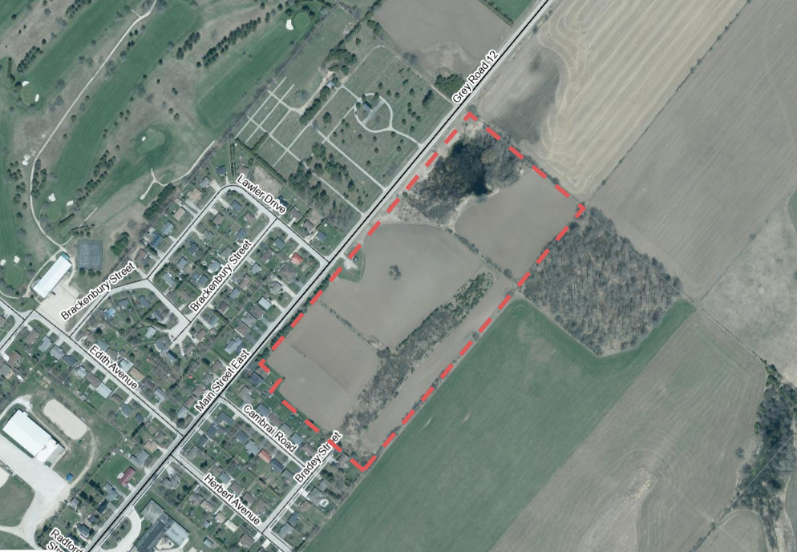

Map 1: Location of the Subject Lands

#### Map 2: Proposed Delbrook Plan of subdivision Concept Plan

### Map 2: Proposed Delbrook Subdivision Concept Plan

(Map 2 Courtesy of Delbrook Group)

#### Analysis of Planning Issues

When rendering a land use planning decision, planning authorities must have regard to matters of Provincial Interest under the *Planning Act*, be consistent with the Provincial Policy Statement (PPS), and conform to any Provincial Plans or County/Municipal Official Plans that govern the subject lands. In this case, the County of Grey Official Plan and Municipality of Grey Highlands Official Plan have jurisdiction over the subject property. The lands are outside of the Niagara Escarpment Plan area.

#### Provincial Policy and Legislation

Both the *Planning Act* and the Provincial Policy Statement (PPS) speak to promoting development and redevelopment within settlement areas. The proposed plan of subdivision is within the settlement area of Markdale. The proposed development will offer a mix of higher density residential dwelling types. The legislation and policy also speak to the provision of affordable housing. County and Municipal staff will work with the proponent moving forward to determine if there will be any affordable housing provided through this proposed subdivision.

The PPS indicates that municipal services are the preferred form of servicing for settlement areas, which is what will be utilized for this development.

Other policies in the PPS speak to the protection of natural, cultural, and archaeological resources. There are some environmental features on-site. An Environmental Impact Study (EIS) was submitted in support to the proposed development. An Archaeological Assessment was also submitted in support of this development.

Following the public and agency review periods, staff will provide a more fulsome analysis of the Provincial legislation and policy.

#### County of Grey Official Plan

The proposed plan of subdivision is on lands designated as ‘Primary Settlement Area’ and ‘Hazard Lands’ in the County Official Plan. The Primary Settlement Area designation permits a range of residential dwelling types on full municipal services.

Section 3.5(5) of the County Plan requires new residential development to achieve a minimum density of 20 units per net hectare, as per the below-quoted policy.

*“For the City of Owen Sound and the Town of Hanover, it is recommended that a minimum development density of 25 units per net hectare will be achieved for new development. For all other Primary Settlement areas, a minimum development density of 20 units per net hectare will be achieved for new development. The County encourages new development to be of a form and density which is supportive of future transit needs in accordance with the Province’s Transit Supportive Guidelines, or to develop similar municipal guidelines that achieve the same objective;”*

Similar to the legislation and PPS, the County Plan also speaks to a range of housing types, including affordable housing. As per above, County staff will explore this matter further as part of the development review process to determine if there will be any affordable housing in this development.

Appendix A to the County Plan maps the lands as being within an ‘Wellhead Protection Area’.

The County Plan also provides policies that govern roads, transportation, and stormwater management.

#### Municipality of Grey Highlands Official Plan

The subject lands are designated as ‘Neighbourhood Area’ and ‘Hazard Lands’ in the Municipality of Grey Highlands Official Plan. The proposed residential uses are permitted within this designation.

A more thorough analysis of the *Planning Act*, PPS, County and Municipality of Grey Highlands policies will follow the agency review and the public process.

## Legal and Legislated Requirements

The application will be processed in accordance with the *Planning Act.*

## Financial and Resource Implications

There are no anticipated financial, staffing, or legal considerations associated with the proposed subdivision, beyond those normally encountered in processing a subdivision application. The County has collected the requisite fee and peer review deposit for this application.

## Relevant Consultation

Internal: Planning, Transportation Services

External: The public, Municipality of Grey Highlands, Saugeen Valley Conservation Authority, and required agencies under the *Planning Act*.

### Appendices and Attachments

None