**Jeff Smith, By-law Coordinator** Telephone: (519) 376-4440 ext. 1241

blackCity of Owen Sound Facsimile: (519) 371-0511

808 2nd Ave East E-mail: jsmith@owensound.ca

Owen Sound ON N4K 2H4 Website: www.owensound.ca

January 28, 2014

VIA EMAIL

Sharon Vokes,

County Clerk / Director of Council Services

595 9th Avenue East

Owen Sound ON N4K 3E3

Sharon.Vokes@grey.ca

Dear Ms. Vokes,

**Re: Request to Review Traffic Signals**

At their meeting on January 2, 2014, the By-law Committee recommended that City Council pass the following motion:

**That the By-law Committee recommend to City Council that Grey County be requested to review the pedestrian phasing and timing of the traffic signals at the intersection of 9th Avenue East and 8th Street East to ensure the traffic signals meet pedestrian crossing needs.**

City Council approved the above motion by Resolution R-140113-016 at their meeting on January 13, 2014.

Please direct this request as required for a response.

If you have any questions or require any further information please feel free to contact me.

Sincerely,

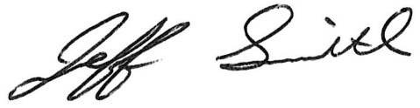

Jeff Smith, B.A., M.A.

By-law Coordinator

c C. Webb, Manager of Engineering Services, City of Owen Sound