Grey County Logo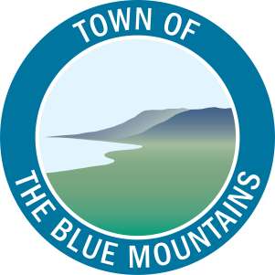

Committee Agenda

# Grey County – The Blue Mountains Task Force June 28, 2017 – 1:00 PM

Seminar Room, Grey County Administration Building

1. **Call to Order**
2. **Adoption of the Agenda**
3. **Declaration of Pecuniary Interest**
4. **Items for Direction and Discussion**
   1. Task Force Terms of Reference

**That the Grey County / The Blue Mountains Task Force Terms of Reference be adopted as presented.**

* 1. Areas of Interest to Explore
  2. Facilitation Services

1. **Other Business**
2. **Next Meeting Dates**
   1. To Be Determined
3. **Adjournment**