Grey County Logo Committee Report

# Report TR-TAPS-41-15

**To**: Chair Barfoot and Members of the Transportation and Public Safety Committee

**From**: M.J. Kelly, Director of Transportation Services

**Meeting Date:** April 23, 2015

**Subject: Agreement for Land Exchange between Grey County and Blue Mountain Resorts – Grey Road 119**

**Status**: Recommendation adopted by Committee as presented per Resolution TAPS60-15; Endorsed by County Council per Resolution CC67-15;

## Recommendation(s)

**WHEREAS Grey County will be completing tender RFT-TS-16-15 for reconstruction of Grey Road 119 beginning as early as May 1, 2015;**

**AND WHEREAS tender RFT-TS-16-15 includes the realignment of a curve that will require a parcel of property owned by the Blue Mountain Resorts;**

**AND WHEREAS the Blue Mountain Resorts wishes to acquire a parcel of land from the Grey Road 119 right-of-way that is not required for road purposes;**

**AND WHEREAS the Blue Mountain Resorts and Grey County Transportation Services Department are agreeable to exchange these lands;**

**NOW THEREFORE BE IT RESOLVED THAT Report TR-TAPS-41-15 be received;**

**AND That the Warden and Clerk be authorized to execute the agreement for a land exchange between the Corporation of the County of Grey and Blue Mountain Resorts that includes:**

1. **The Blue Mountain Resorts transferring land it owns described as part of PIN 37148-0207 being Part of Lot 15, Concession 2, Town of Blue Mountains (formerly Township of Collingwood), County of Grey and more particularly described in the draft reference plan attached hereto as Schedule “A” to Grey County and ,**
2. **Grey County transferring its land it owns described as of part of PIN 37148-0214 (LT) being Part of Lot 15, Concession 2, Town of Blue Mountains (formerly Township of Collingwood), County of Grey and more particularly described in the draft reference plan attached hereto as Schedule “B” to the Blue Mountain Resorts .**

## Background

In 2015, Grey County will be reconstructing Grey Road 119 from Banks to Grey Road 19. This project includes reconstructing the road, making revisions to the alignment and improving the shoulders.

The reconstruction of Grey Road 119 (RFT-TS-16-15) includes a curve correction that requires the acquisition of land currently owned by Blue Mountain Resorts. The curve correction will improve the radius of the curve and, as a result, increase the overall safety of motorists.

The Blue Mountain Resorts wish to obtain a section of Grey Road 119 that will assist with its operation. This property is excessive of the normal 30.2 metres the County normally owns for Grey Roads and this property will not be required for future Grey Road purposes.

The properties to be exchanged are relatively small; approximately 1350 square metres transferred from Blue Mountains Resorts and 950 square metres transferred from Grey County.

Both parties, Grey County and Blue Mountain Resorts, are agreeable to a land exchange.

## Financial / Staffing / Legal / Information Technology Considerations

The County has incurred costs for the legal surveying and solicitor services. With the County obtaining the property from the Blue Mountains Resorts it will be able to make the improvements to the road and improve safety.

## Link to Strategic Goals / Priorities

5.3 Explore innovative ways to more efficiently and effectively deliver services and programs, including consideration of partnerships.

## Attachments

Land Exchange Agreement for Grey Road 119 between Grey County and Blue Mountain Resorts GP Inc.

Respectfully submitted by,

M.K. Kelly

Director of Transportation Services

THIS AGREEMENT made this_________ day of March, 2015

B E T W E E N

**THE CORPORATION OF THE COUNTY OF GREY**

(Hereinafter called “the County”)

OF THE FIRST PART

A N D

**BLUE MOUNTAIN RESORTS GP INC. as general partner for and on behalf of BLUE MOUNTAIN RESORTS LIMITED PARTNERSHIP**

(Hereinafter called “BMR”)

OF THE SECOND PART

**WHEREAS** BMR is the owner of part of PIN 37148-0207 being Part of Lot 15, Concession 2, Town of Blue Mountains (formerly Township of Collingwood), County of Grey and more particularly described in the draft reference plan attached hereto as Schedule “A” (the “BMR Parcel”).

**AND WHEREAS** the County is the owner of part of PIN 37148-0214 (LT) being Part of Lot 15, Concession 2, Town of Blue Mountains (formerly Township of Collingwood), County of Grey and more particularly described in the draft reference plan attached hereto as Schedule “B” (the “County Parcel”).

**AND WHEREAS** BMR has agreed to convey the BMR Parcel to the County to facilitate certain county road improvements to be undertaken by the County with respect to Grey Road No. 119

**AND WHEREAS** the County in turn has agreed to convey to BMR the County Parcel which is currently occupied and utilized by BMR as part of its resort operations.

**NOW THEREFORE** in consideration of the mutual covenants hereinafter contained and the payment of the sum of $1.00 by each of the parties to the other (the receipt and sufficiency of which is hereby acknowledged) the parties hereto agree as follows:

1. Interpretation

1.1 In this agreement, the following terms shall have the meanings ascribed to them.

“**BMR**” means Blue Mountain Resorts Limited Partnership;

“**BMR Parcel**” means the lands described in Schedule “A”;

“**County**” means The Corporation of the County of Grey;

“**County Parcel**” means the lands described in Schedule “B”;

“**Closing Date**” means ______________, 2015;

2. Closing Date Transfers

2.1 On the Closing Date, BMR shall transfer to the County the BMR Parcel free of all monetary encumbrances but subject to all covenants or restrictions and encumbrances of record.

2.2 On the Closing Date, the County shall convey to BMR the County Parcel free of all monetary encumbrances but subject to all covenants or restrictions and encumbrances of record.

2.3 Each party shall pay applicable land transfer tax on the value of the parcel acquired by such party.

3. Conditions

3.1 The obligations of the parties to complete the transactions contemplated by this agreement shall be conditional upon:

(a) Passage of a by-law by County council approving the acquisition of the BMR Parcel;

(b) Passage of a by-law by County council removing the right of passage by public and authorizing transfer of the County Parcel to BMR.

In the event that these conditions have not been satisfied on or before the day of __________, 2015, this agreement shall be null and void, and the parties shall be released of their obligations hereunder with the exception of the obligation to contribute toward costs as provided in section 5.4 hereof.

4. Representations and Warranties

4.1 BMR’s Representations and Warranties

BMR represents and warrants to the County that as of the date of this agreement and as at the Closing Date,

(a) Blue Mountain Resorts Limited Partnership is the beneficial owner of the the BMR Parcel and Blue Mountain Resorts GP Inc. holds registered title for and on behalf of Blue Mountain Resorts Limited Partnership;

(b) BMR is a validly existing limited partnership duly constituted under the laws of the Province of Ontario and has now and will have on closing the necessary authority, power and capacity to enter into this agreement and to carry out the transactions contemplated herein upon the terms and conditions contained herein;

(c) BMR is a Canadian resident for the purposes of determining its liability for the payment of income tax pursuant to the Income Tax Act of Canada.

(d) Blue Mountain Resorts Limited Partnership is or will be at the Closing Date a registrant for the purposes of harmonized sales tax (“HST”) under the Excise Tax Act (Canada).

4.2 County’s Representations and Warranties

The County hereby represents and warrants to BMR that as of the date of this agreement and as of the Closing Date,

(a) It is or will be at the Closing Date a registrant for the purposes of harmonized sales tax (“HST”) under the Excise Tax Act (Canada).

5. Miscellaneous

5.1 On the Closing Date the County shall deliver to BMR for registration a transfer of the County Parcel duly completed and signed in electronic format pursuant to Part 3 of the Land Registration Reform Act, RSO, 1990, Ch.L.4 and the Electronic Registration Act, S.O., 1991 C.44.

5.2 On the Closing Date, BMR shall deliver to the County for registration a transfer of the BMR Parcel duly completed and signed in electronic format pursuant to Part 3 of the Land Registration Reform Act, RSO, 1990, Ch.L.4 and the Electronic Registration Act, S.O., 1991 C.44.

5.3 On the Closing Date each party shall deliver to the other such ancillary documentation as may be necessary to confirm the representations and warranties contained herein.

5.4 The parties agree to share equally in the expenses relating to the completion of this transaction including the survey preparation and registration costs, the legal fees and disbursements related to the preparation of this agreement and the preparation and registration of the ultimate transfers of the BMR Parcel and the County Parcel and any other reasonable costs necessarily associated with the transactions contemplated herein. BMR shall initially pay such costs and shall subsequently invoice the County for its one-half share of the costs and the County shall reimburse BMR within thirty (30) days after receipt of such invoice.

5.5 On the Closing Date the parties shall self assess for HST relating to the BMR Parcel and the County Parcel and shall provide to the other a declaration confirming the party’s HST registration number together with an indemnity to save the other party harmless from any HST, penalty, interest or other amounts which may be payable by or assessed against such other party as a result of our connection with the other party’s failure to remit any HST applicable on the property transfers contemplated herein.

5.6 This agreement including any schedules attached hereto shall constitute the entire agreement between the County and BMR.

5.7 There is no representation, warranty, collateral agreement or condition, either direct or collateral or expressed or implied which induced any party to enter into this agreement on which reliance is placed by such party, which affects this agreement or the County Parcel or the BMR Parcel, other than as expressed herein.

5.8 This agreement shall be governed in accordance with the laws of the Province of Ontario.

5.9 This agreement may be executed in counterparts, each of which shall be deemed to be an original and all of which taken together shall be deemed to constitute one and the same instrument. This agreement or counterparts may be executed either in original in form or through facsimile transmission or electronic transmission or the parties adopt any signatures received by receiving facsimile machine or electronic transmission as original signatures of the parties.

5.10 This agreement shall enure to the benefit of and be binding upon the parties, their respective successors and permitted assigns.

IN WITNESS WHEREOF the parties hereto have set their hands the day and year first above written.

[signing page follows]

**THE CORPORATION OF THE**

**COUNTY OF GREY**

Per:

_________________________

Name:

Title:

Per:

_________________________

Name:

Title:

I/We have authority to bind the Corporation

**BLUE MOUNTAIN RESORTS GP INC. as General Partner for and on behalf of**

**BLUE MOUNTAIN RESORTS**

**LIMITED PARTNERSHIP**

Per:

_________________________

Name:

Title:

Per:

_________________________

Name:

Title:

I/We have authority to bind the Corporation

SCHEDULE “A”

The County of Grey will be obtaining the parcel of land shown on the unregistered plan as Part 1.

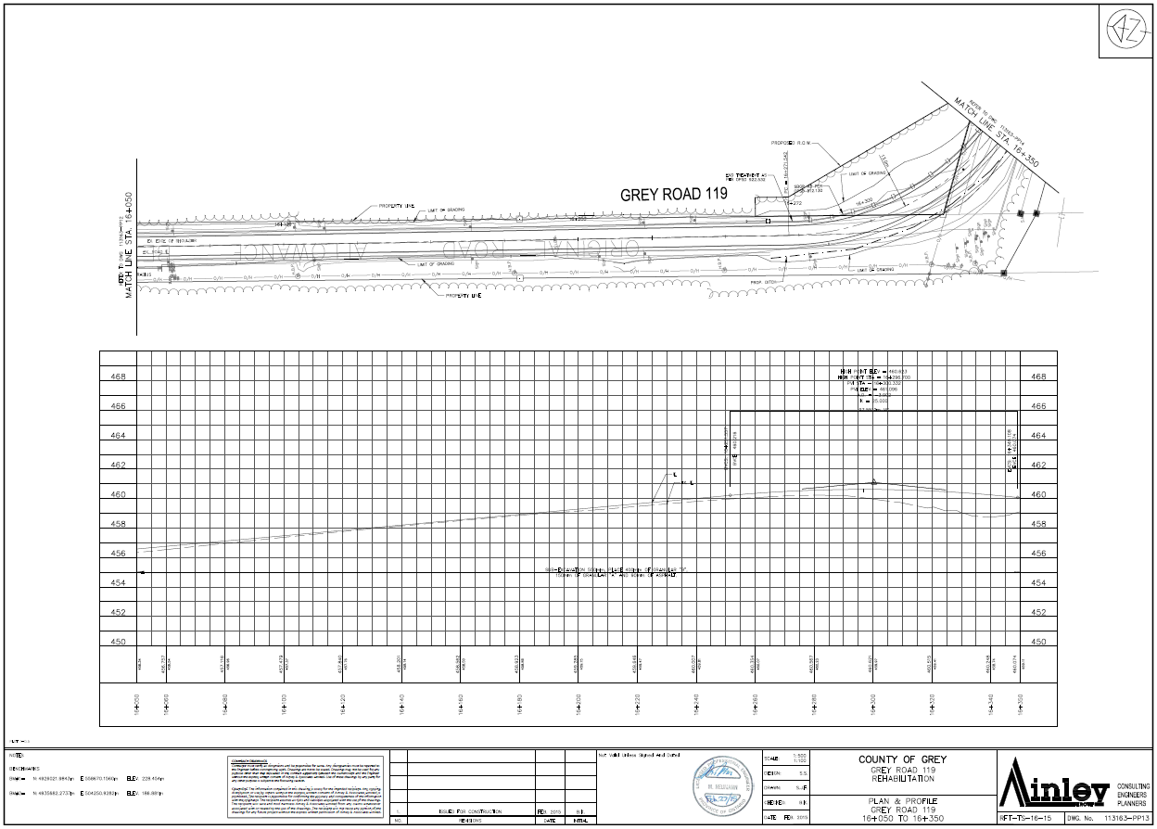

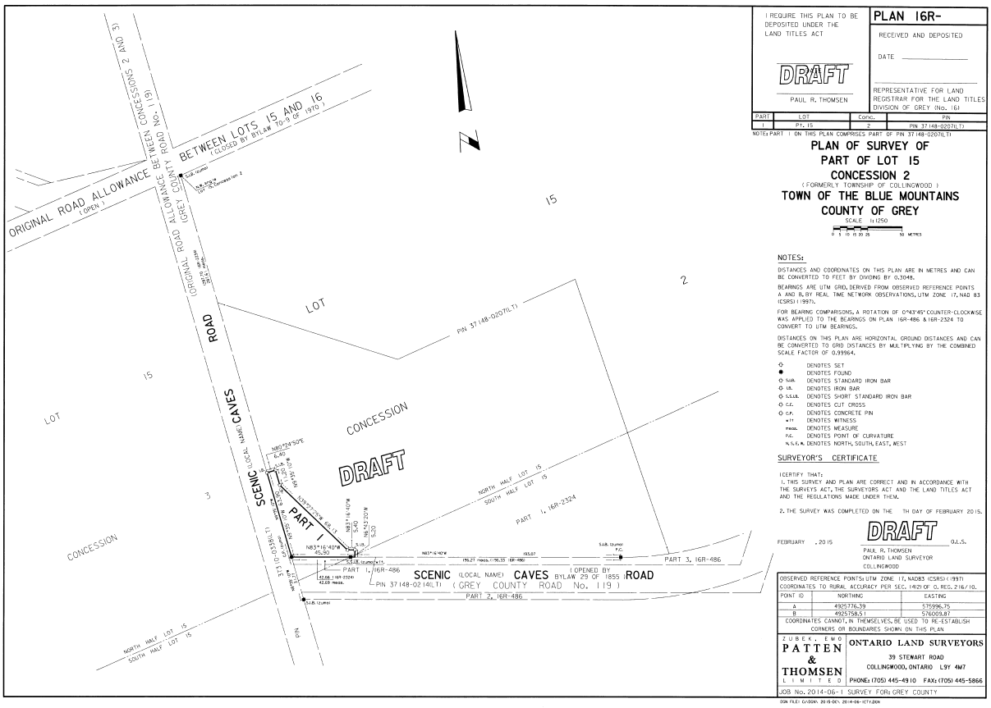

SCHEDULE “B”

Blue Mountain Resort will be obtaining the parcel of land shown on the unregistered plan as Part 1 below.

