Grey County Logo Committee Report

| **To**: | Warden McQueen and Members of Grey County Council |
| --- | --- |
| **Committee Date:** | November 26, 2020 |
| **Subject / Report No:** | PDR-CW-40-20 Information Report |
| **Title:** | McCullough Plan of Condominium 42CDM-2020-08 |
| **Prepared by:** | Scott Taylor |
| **Reviewed by:** | Randy Scherzer |
| **Lower Tier(s) Affected:** | Municipality of Meaford |
| **Status:** | Recommendation adopted by Committee as presented per Resolution CW206-20; Endorsed by County Council December 10, 2020 per Resolution CC05-21; |

## Recommendation

1. **That Report PDR-CW-40-20 regarding an overview of proposed plan of condominium application 42CDM-2020-06, that proposes to create a condominium road for five (5) residential units on lands described as Part of Lots 23 and 24, Broken Front Concession, in the geographic Township of Sydenham, Municipality of Meaford, be received for information.**

## Executive Summary

The County has received a plan of condominium application known as the McCullough Condominium (County file number 42CDM-2020-08), that proposes to create a condominium road to service five proposed residential lots. Access to new homes would be through the condominium road, which would connect out to Sideroad 23. Consent and zoning by-law amendment applications have also been submitted to the Municipality of Meaford for this proposed development. The subject lands are in a designated settlement area in both the County and Meaford Official Plans. Servicing to the proposed condominium will be via private wells and septic systems. Various technical reports were prepared as part of the application submission packages. The applications and supporting studies have been circulated to prescribed agencies and the public for comment. Following the public process, and agency review process, a thorough analysis and staff recommendation will be provided.

## Background and Discussion

The proposed plan of condominium application, known as the McCullough condominium (County file 42CDM-2020-08), would create a private condominium road for five residential lots to be created via consent applications. A zoning by-law amendment application is also required for the proposed development. The subject lands are designated as ‘Inland Lakes and Shoreline’ and ‘Hazard Lands’ in the County Official Plan. The Inland Lakes and Shoreline designation is a designated settlement area under the County Plan.

Although the subject lands have frontage onto Bayshore Road, the proposed lots will not be utilizing this frontage to provide access. Topography along Bayshore Road and the front of the lot makes individual accesses to the five proposed lots unfeasible. Instead, the development proposes a condominium road with a connection to Sideroad 23 to provide access to the lots. Servicing to the proposed condominium will be via private wells and septic systems.

The subject lands are approximately 4 kilometres north of Leith. These lands are 4.9 hectares in size and are legally described as Lots 23 and 24, Broken Front Concession, in the geographic Township of Sydenham, Municipality of Meaford.

Surrounding this site are a mixture of residential lands and farmland. Lands to the north and west are generally residential, while the lands to the east and south are primarily farmlands. Georgian Bay is located approximately 350 metres to the west.

Map 1 below shows the subject lands highlighted in blue and the surrounding area, while Map 2 shows the proposed McCullough development.

Consent and zoning by-law amendment applications have also been submitted to the Municipality of Meaford as part of this development submission. A public meeting for the applications has not yet been scheduled.

Pre-submission consultation between the proponent, the Municipality of Meaford, the Grey Sauble Conservation Authority, and the County identified the submission requirements for the proposed plan of condominium. Copies of all background reports and plans can be found at [this link](https://www.grey.ca/planning-development/planning-applications).

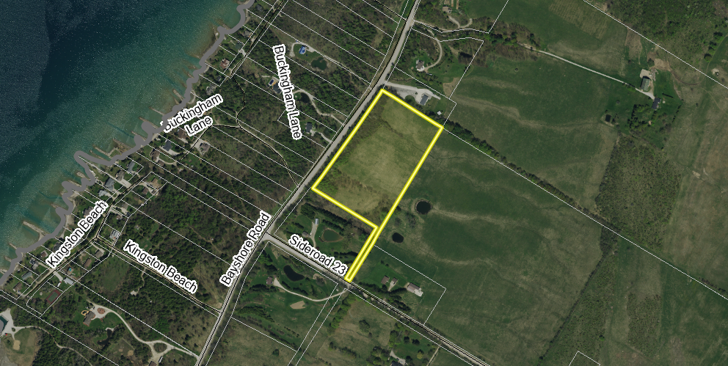

Map 1: Location of Subject Lands

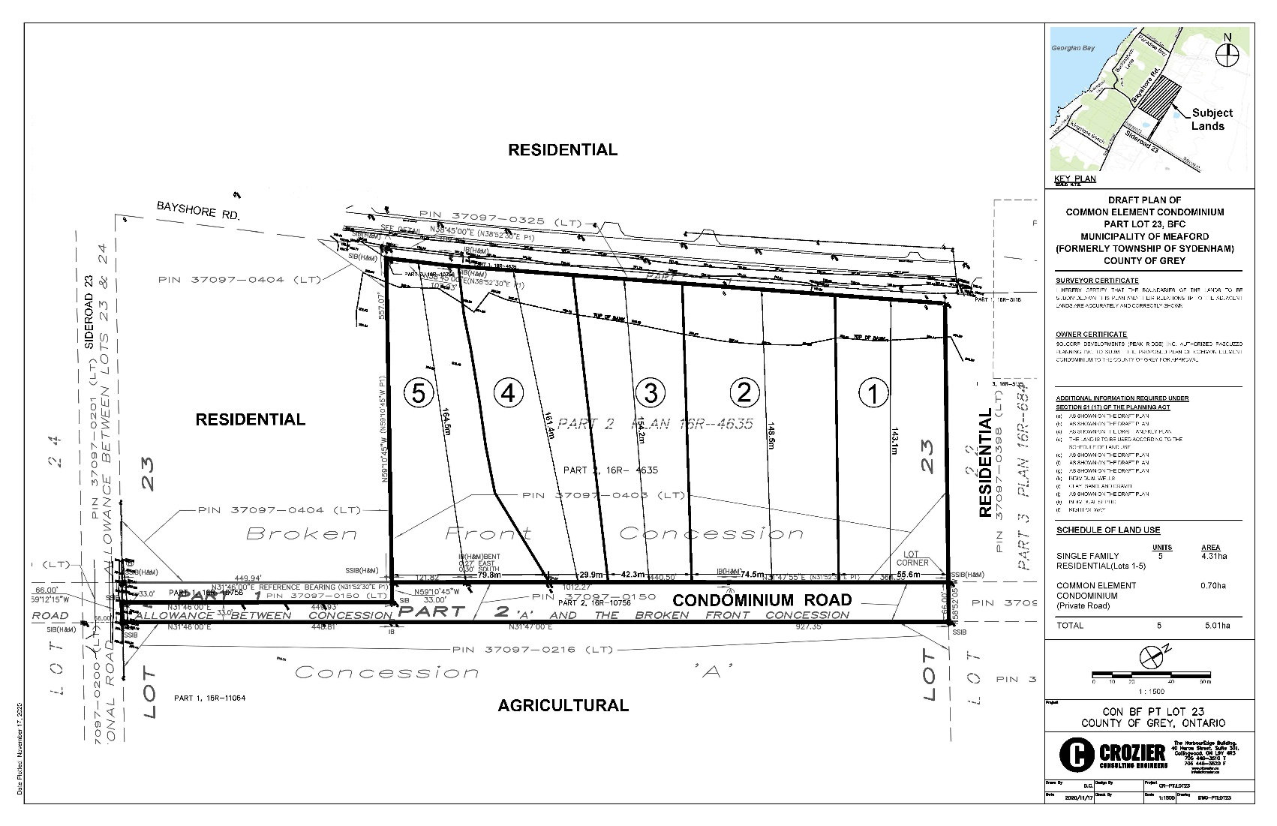

### Map 2: Proposed Plan of Condominium

(Map 2 Courtesy of C.F. Croziers)

#### Analysis of Planning Issues

When rendering a land use planning decision, planning authorities must have regard to matters of Provincial Interest under the *Planning Act*, be consistent with the Provincial Policy Statement (PPS) 2020, and conform to any Provincial Plans or Municipal Official Plans that govern the subject lands. In this case, the County of Grey Official Plan and the Municipality of Meaford Official Plan have jurisdiction over the subject property. The subject lands are located outside of the Niagara Escarpment Plan area.

#### Provincial Policy and Legislation

Both the *Planning Act* and the PPS speak to the efficient use of land within settlement areas. The proposed plan of condominium is within an existing settlement area. The PPS indicates that municipal services are the preferred form of servicing for settlement areas, however neither municipal water nor sewer services exist within proximity to this development. As such, the proposed form of servicing is private wells and septic systems.

Other policies in the PPS speak to the protection of natural, water, cultural and archaeological resources. An environmental impact study (EIS), hydrogeological assessment, and an archaeological assessment were submitted in support of this development.

Following the public and agency review periods, staff will provide a more fulsome analysis of the Provincial legislation and policy.

#### County of Grey Official Plan

The proposed plan of condominium is on lands designated as ‘Inland Lakes and Shoreline’ and ‘Hazard Lands’ in the County Official Plan. Development in Inland Lakes and Shorelines is generally characterized by lower density residential development on private services. Development is proposed to remain outside of the mapped Hazard Lands on-site.

The County Plan does not map any significant natural heritage features on-site, but as noted earlier, an EIS was completed and this will be reviewed by Meaford, the County, and the Grey Sauble Conservation Authority.

The County Plan provides policies which govern roads, transportation, and stormwater management.

#### Municipality of Meaford Official Plan

The subject lands are designated as ‘Shoreline’ and ‘Environmental Protection’ in the Municipality of Meaford Official Plan. Similar to the County Official Plan, this property is within a designated settlement area in the Municipal Plan.

As noted above, a rezoning application has also been submitted to the Municipality and will be processed simultaneously with the condominium and consents.

A more thorough analysis of the County and Meaford Official Plan policies will follow the agency review and the public process.

## Legal and Legislated Requirements

The application will be processed in accordance with the *Planning Act.*

## Financial and Resource Implications

There are no anticipated financial, staffing or legal considerations associated with the proposed condominium, beyond those normally encountered in processing a condominium application. The County has collected the requisite fee and peer review deposit for this application.

## Relevant Consultation

Internal: Planning

External: The public, Municipality of Meaford, Grey Sauble Conservation Authority, and required agencies under the *Planning Act*.

### Appendices and Attachments

None