Committee Report
To: | Warden and Members of Grey County Council
Committee Date: | December 8, 2022
Subject / Report No: | Addendum to PDR-CW-12-22
Title: | Loon Call Grey Highlands Final Report – County Official Plan Amendment No. 12
Prepared by: | Scott Taylor
Reviewed by: | Randy Scherzer
Lower Tier(s) Affected: | Municipality of Grey Highlands
Status: | Recommendation adopted by Committee as presented per Resolution CW07-23; Endorsed by County Council January 12, 2023, per Resolution CC09-23.

Recommendation
- That Addendum to Report PDR-CW-12-22 regarding proposed County Official Plan Amendment No. 12 be received; and
- That all written and oral submissions received on proposed Official Plan Amendment No. 12 were considered, the effect of which helped to make an informed recommendation and decision; and
- That the Committee support the proposed amendment to the County of Grey Official Plan on lands designated ‘Rural’ to redesignate a portion of the subject lands to ‘Primary Settlement Area’ to allow for the consideration of a future plan of subdivision (42T-2021-08) on lands described as Part of Lot 95, Concession 1 NETSR, geographic Township of Artemesia, Municipality of Grey Highlands; and
- That the appropriate by-law be prepared for consideration by County Council.

Executive Summary
County official plan amendment application 42-08-180-OPA-12 (hereafter referred to as OPA 12) proposes to redesignate a portion of the subject lands from the ‘Rural’ designation to the ‘Primary Settlement Area’ designation to allow for the consideration of a plan of subdivision application (42T-2021-08) known as Loon Call Grey Highlands. The designated Hazard Lands on-site would not be changing through this amendment. The proposed plan of subdivision would create 469 new lots, with 313 detached residential lots and 156 multi-attached residential units. New roads, parks, stormwater facilities, and open space blocks would also be created through the plan of subdivision. The plan of subdivision application will be considered in a future staff report following a decision on the County official plan amendment and the proposed Municipality of Grey Highlands official plan amendment. A proposed zoning amendment application has also been submitted to the Municipality of Grey Highlands. Staff are recommending approval of County official plan amendment 12.

Background and Discussion
The County received an official plan amendment application (County OPA 12) and a plan of subdivision application (42T-2021-08), known as Loon Call Grey Highlands. The proposed County official plan amendment application proposes to redesignate a portion of the subject lands (~5.3 hectares) from the ‘Rural’ designation to the ‘Primary Settlement Area’ designation. The designated Hazard Lands on-site would not be changing through OPA 12. Most of this development property is already designated as Primary Settlement Area. OPA 12, if approved, would redesignate the rest of the lands, exclusive of the Hazard Lands, to Primary Settlement Area.
The proposed plan of subdivision, known as the Loon Call Grey Highlands development, would create 469 new lots, parks, walkways, a stormwater management facility, and open space block on approximately 33.42 hectares of land. The subject lands comprise 32.91 hectares of land owned by the developer and 0.51 hectares of land currently owned by the Municipality of Grey Highlands at the south end of their stormwater management facility (see Map 3). A future staff report will be provided regarding the plan of subdivision application following a decision on the County OPA 12 and the corresponding Municipality of Grey Highlands official plan amendment.
This new development would be serviced via municipal water and sewer services. The proposed lots would gain access from a series of new streets that would connect to Stan Baker Boulevard, Margaret Elizabeth Avenue, and Highway 10.
The Loon Call development lands are legally described as Part of Lots 95, 96, and 97, Concession 1 NETSR, geographic Township of Artemesia, Municipality of Grey Highlands. However, the lands subject to OPA 12 only include Part of Lot 95, Concession 1 NETSR. This development property is in the north end of Markdale and is primarily cleared with some wooded areas. Within the rest of the subject lands (i.e. outside of Part Lot 95) is a separate property, which is an existing stormwater management facility owned by Grey Highlands. This facility will be used to manage some of the stormwater from this development. Surrounding the subject lands are the Rocky Saugeen River, residential development, the golf course, and Chapmans Ice Cream.
Map 1 below shows the subject lands highlighted in yellow and the surrounding area. Map 2 shows the County Official Plan designations where red is the Primary Settlement Area, green is Hazard Lands, and white is Rural. Map 3 shows the proposed draft plan of subdivision.
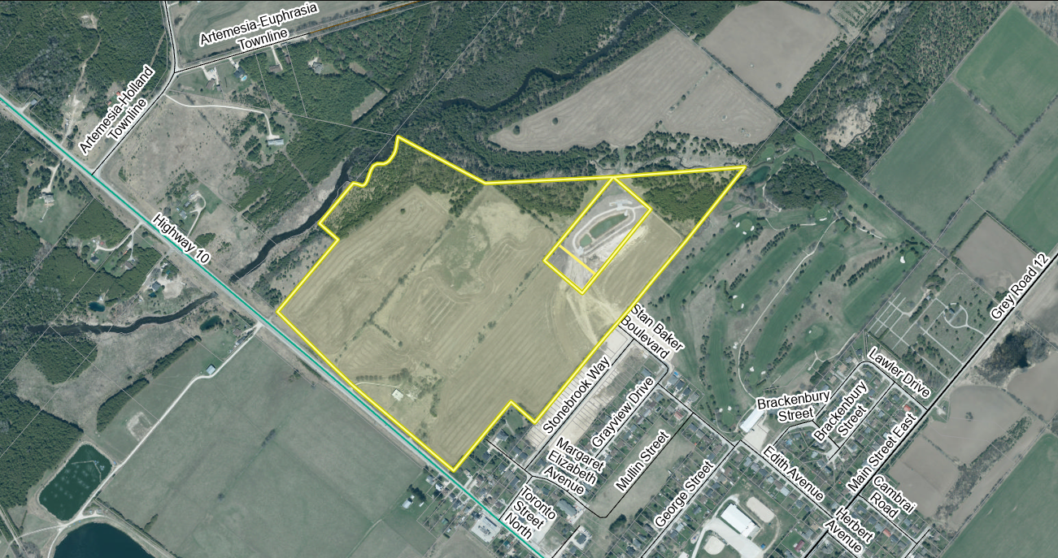
Map 1: Airphoto of Subject Lands
The proposed development also requires a local official plan amendment and a zoning by-law amendment from the Municipality of Grey Highlands. Copies of all background reports and plans can be found at this link.
A joint public meeting between the Municipality and the County was held for all the proposed applications on June 27th, 2022. Most of the written and oral comments received are specific to the proposed plan of subdivision and will be considered as part of the future staff report. Minutes from that meeting can be found here: Public Meeting Minutes – June 27, 2022.

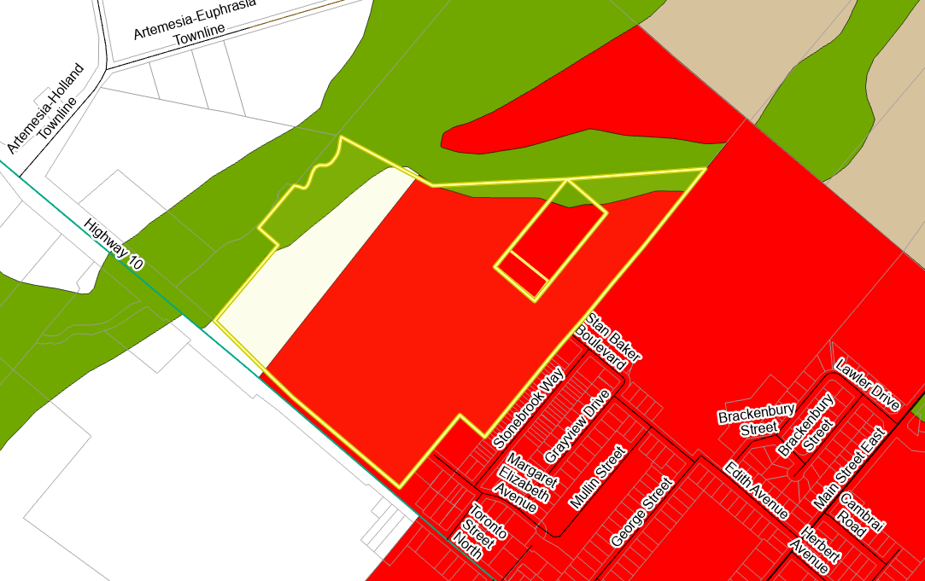
Map 2: Current County Official Plan Designations of the Subject Lands
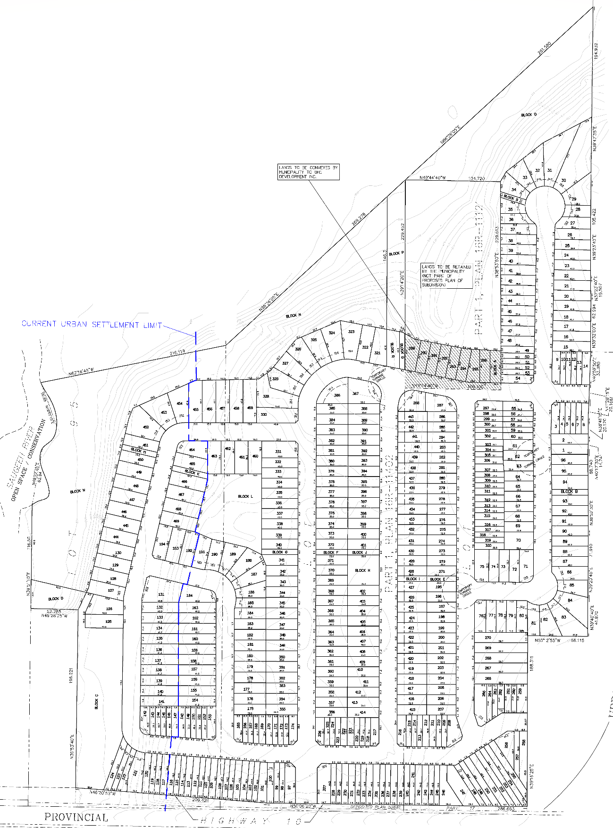

Map 3: Proposed Plan of Subdivision
(Courtesy of T.A. Bunker Surveying Ltd.)

Agency Comments Received
The majority of the comments received from agencies are more applicable to the proposed plan of subdivision application which will be considered in a future staff report.

EPCOR, dated April 12, and May 23, 2022
No comments from EPCOR as this is outside of their service area.

Hydro One, dated May 2, 2022
Hydro One has no comments or concerns at this time.

Bluewater District School Board (BWDSB), dated April 28, 2022
BWDSB has no objections to this development and have provided three conditions of draft plan approval to be considered at the time of a decision on the plan of subdivision application.

Canada Post, dated April 12, 2022
Canada Post has provided a series of conditions of draft plan approval to be considered at the time of a decision on the plan of subdivision application.

EH!tel, dated April 12, 2022
EH!tel had no comments but appreciated being circulated on the applications.

Enbridge Gas, dated April 12, 2022
Enbridge Gas Inc. requests that as a condition of final approval that the owner / developer provide the necessary easements and/or agreements required by Enbridge Gas for the provision of gas services for this project, in a form satisfactory to Enbridge.

Saugeen Ojibway Nation (SON), April 12, and October 18, 2022
The SON recommends the following with respect to this development:
“Revised, complete and comprehensive Stage 1 and Stage 2 HSTCI archaeological re-assessments of the proposed Loon Call Markdale Subdivision will be necessary. These should be produced in consultation with SON, and the Stage 2 conducted with the presence and participation of SON archaeology monitors.”
Additional archaeological fieldwork was undertaken in early November 2022. This field work included both the proponent’s archaeological team, as well as staff from the SON. A stone feature was found which will be preserved without further invasive exploration, based on direction from the SON.

Ministry of Transportation (MTO), dated August 22, September 8, and October 5, 2022
MTO provided a series of comments on the Traffic Impact Study (TIS), speed limit, and the potential for infrastructure upgrades on the Highway. The majority of these comments are more directly applicable to the plan of subdivision application. MTO also noted the following comments:
“MTO were optimistic that MTO may have been able to provide comments to support the OPA and ZBA in advance of Draft Plan of Subdivision comments. However, MTO has now reviewed the TIS and significant revisions are required. MTO must review a revised TIS in advance of being able to support the overall development of the site including the proposed OPA and ZBA.”
Discussions are on-going between the MTO, the developer, Municipality, and County.

Municipality of Grey Highlands, dated September 7, 2022
Grey Highlands offered support for OPA 12, through the following motion:
“That Council received staff report CLS22.26 – GH1 Developments County Official Plan Amendment; and
That Council direct staff to notify the County that the Municipality of Grey Highlands has no concerns with the proposed draft County Official Plan Amendment.”

Grey Bruce Health Unit, dated April 25, 2022
The Grey Bruce Health Unit provided a series of comments on active living, injury prevention, healthy environments, and health equity. These comments are more directly applicable to the decision on the plan of subdivision application.

WSP on behalf of Bell Canada, dated April 13, and May 20, 2022
WSP provided recommended conditions of draft plan approval on the subdivision on behalf of Bell Canada.

Historic Saugeen Metis, dated May 2, 2022
The Historic Saugeen Métis (HSM) Lands, Resources and Consultation Department has reviewed the relevant documents have no objection or opposition to the proposed Loon Call application in Grey Highlands.

Saugeen Valley Conservation Authority (SVCA), dated May 18 and June 29, 2022
SVCA staff provided the following comments on this development:
“SVCA staff has reviewed this application in accordance with our agreement with the County of Grey and as per our mandated responsibilities for natural hazard management, including our regulatory role under the Conservation Authorities Act.
In general, SVCA staff find the proposed plan of subdivision acceptable, provided SVCA’s recommended conditions i. through ix. for draft plan agreement are implemented. See below for a summary of recommended conditions. If SVCA staff’s recommendations are implemented, it is the opinion of the SVCA staff that:
- Consistency with Section 3.1, Natural Hazard policies of the PPS, 2020 will be demonstrated.
- Consistency with Section 2.1, Natural Heritage policies of the PPS, 2020 will be demonstrated.
- Consistency with local planning policies for natural hazards and natural heritage will be demonstrated.”

Public Comments Received
Between the public meeting and written comments, public comments have been received from for the following individuals:
- Shannon Ladinardi,
- Jeromy Campbell, and
- James Norris.
A summary of the public comments received is as follows:
- Clarification on the status of other developments in Grey Highlands,
- Questions about traffic and concern with respect to roads, safety, and intersection capacities,
- Questions about servicing capacity,
- Who pays for upgraded infrastructure,
- Concerns about flooding and drainage,
- Concerns about impacts on the environment, including the Rocky Saugeen River, plants, and wildlife,
- Potential for trespass and litter concerns once this new development is built,
- Concerns over the validity of some of the technical studies (e.g., Geotechnical, Traffic, Environment, Servicing),
- Will the school, hospital, and community facilities such arenas, daycares, recreational facilities, mental health services, etc. be able to accommodate these newly proposed residents,
- Impacts on quality of life of existing Grey Highlands residents,
- Potential for crime to increase,
- Questions about who does what with respect to the County and the Municipality,
- Can green initiatives such as solar panels, rainwater harvesting, or electric vehicle chargers be required as part of this development,
- Concerns about urban sprawl, and
- Concerns about how to participate in a virtual public meeting.
There were no further comments provided by the public.
In addition to the statutory public meeting, the developer also undertook their online open house where they responded to questions, and have submitted responses to some of the public comments submitted.

Analysis of Planning Issues
When rendering a land use planning decision, planning authorities must have regard to matters of Provincial Interest under the Planning Act, be consistent with the Provincial Policy Statement (PPS) 2020 and conform to any Provincial Plans or Municipal Official Plans that govern the subject lands. The Niagara Escarpment Plan does not apply to the subject lands. In this case, the County of Grey Official Plan and the Municipality of Grey Highlands Official Plan have jurisdiction over the subject property.

Provincial Policy and Legislation
Most notable to this proposed official plan amendment are the following clauses from the Planning Act, which will need to be considered.
- the protection of ecological systems, including natural areas, features and functions,
An Environmental Impact Study (EIS) was provided as part of the application submissions. SVCA has reviewed the EIS and recommended some draft plan conditions for the future plan of subdivision decision to implement the findings of the EIS.
- the protection of agricultural resources of the Province,
The subject lands to be redesignated are currently designated ‘Rural’ as per Schedule A of the County Official Plan. An Agricultural Assessment (AA) was submitted with the applications. The ~5.3 hectares to be redesignated are a mixture of Canada Land Inventory (CLI) classes ‘6’ and ‘O’. The AA notes that class 6 soils are “unsuited for cultivation but are capable of use for unimproved permanent pasture.” The class O lands are 100% muck, which is generally not suitable for agricultural purposes. The AA did not identify any Minimum Distance Separation (MDS) conflicts with the proposed redesignation of the Rural lands.
- the conservation of features of significant architectural, cultural, historical, archaeological, or scientific interest,
A Stage 1 and 2 Archaeological Assessment was submitted with the applications. The Archaeological Assessment concludes that:
- no further archaeological assessment of the study area is warranted,
- the provincial interest in archaeological resources with respect to the proposed undertaking has been addressed, and
- the proposed undertaking is clear of any archaeological concern.
The SON raised concerns with the proposed Archaeological Assessment. The proponent, their archaeologist, and SON staff met to discuss these concerns. Subsequently further field work was completed in early November 2022, with both the proponent’s archaeologist as well as SON staff and monitors. The results of this further field work documented a stone feature which resembles a basin with stones mounded along the outer edge all the way round. The site will ultimately be protected by a 10 metre buffer and the lands will be incorporated into the environmental protection lands which are to be conveyed to Grey Highlands. SON has asked that an invasive exploration of this feature not be undertaken.
- the adequate provision and efficient use of communication, transportation, sewage and water services and waste management systems;
The proposed development will be serviced by municipal water and sewer services from the Municipality of Grey Highlands. The subject lands to be redesignated immediately abut the Primary Settlement Area and would be a logical extension of Markdale, given that the remainder of the Loon Call lands are already designated as Primary Settlement Area. Services would be extended through the subject lands and a connection is needed across the Highway to the Grey Highlands wastewater treatment facility in behind Chapmans. As part of the plan of subdivision process, an agreement will be needed between Loon Call, Chapmans, and Grey Highlands to make this connection.
The developer has noted that by expanding Markdale in this location it allows for more efficient servicing and avoids the need for pumping stations, as outlined below:
“The expanded settlement lands will utilize to provide lower cost gravity storm water management and sanitary sewage (rather than expensive pumping stations with back up power together with the maintenance of same). It is noted that these infrastructure works are also necessary to service the lands already within the settlement area limits without the use of pumping stations. This factor alone demonstrates the reason why the expanded lands should have been previously included in the settlement area and will result in optimal infrastructure asset management.
Surface water will be collected and treated through a train of facilities providing quality and quantity control. In this case, the SWM [stormwater management] works for that part of the development currently within the settlement area have been designed to accommodate the additional flows. The expansion to the existing municipal SWM pond and facilities and new SWM pond and facilities are required to be constructed to MOECP [Ministry of the Environment, Conservation and Parks] requirements and SVCA requirements.”
The servicing matters will be dealt with as part of the recommended conditions of draft approval for the proposed plan of subdivision.
(p) the appropriate location of growth and development,
Planning justification, including a scoped comprehensive review, was submitted with the applications in accordance with the PPS, the County Official Plan, and the Grey Highlands Official Plan. The planning analysis notes that the settlement area expansion lands will accommodate approximately 51 of the 469 dwelling units proposed through this development. A large portion of the expansion lands that abut the Hazard Lands will be preserved as open space and valleylands. A new stormwater management facility is also being proposed in the expansion lands, abutting the former landfill site.
The subject applications were submitted prior to the County’s Official Plan Amendment 11, and the revised growth management strategy projections. OPA 11 has the effect of extending the County’s growth horizon to 25 years to the year 2046. With the Municipality of Grey Highlands poised to grow, alongside other Grey County municipalities, the proposed settlement area expansion helps provide lands to accommodate this growth. Municipal staff presented a report to Grey Highlands Council on September 7th, 2022, and Municipal Council passed a motion supporting County OPA 12 to expand the settlement area of Markdale.

Provincial Policy Statement
The PPS speaks to the efficient use of land within settlement areas. County OPA 12 is proposing a small expansion to the settlement area of Markdale. Section 1.1.3.8 of the PPS requires that a comprehensive review be completed to justify an expansion to a settlement area. However, this section also specifies the following:
“In undertaking a comprehensive review, the level of detail of the assessment should correspond with the complexity and scale of the settlement boundary expansion or development proposal.”
In this case a scoped comprehensive review study has been submitted with the applications and this has been reviewed by County and Municipal staff to determine if the proposed settlement area expansion is warranted. Most of the Loon Call lands were added to the Primary Settlement Area of Markdale in 2011 – 2012 when the province and later the Ontario Municipal Board (OMB) approved the County’s five-year review official plan amendment # 80. Prior to the provincial decision on OPA 80, the Municipality of Grey Highlands had requested that the entire Loon Call lands were to be added to the Primary Settlement Area for future residential growth needs. At that time, based on the justification provided, the province approved most of the lands as being added to the settlement area, but left ~5.3 hectares in the Rural designation. It is however worth noting that the planning horizon of the County Official Plan as part of OPA 80 was to the year 2026. Since the 2012 OPA 80 decision, and with subsequent reviews of the County’s growth management strategy, the County Plan is now looking at a longer growth horizon (i.e. OPA 11 provides population projections to the year 2046). Significant growth has been occurring within the settlement area of Markdale over the past few years and this is expected to continue based on the latest Growth Management Study update supported by County Council. Based on the comprehensive review analysis and the projected growth, an expansion to the settlement area can be justified and the logical location for this expansion is the subject lands.
The supply of an adequate range and distribution of residential housing types is required by the PPS. In this case, the proposed plan of subdivision is proposing single detached residential units and multi-attached units. It is further worth noting that this developer specializes in providing attainable housing, which retails for less than many other housing units on the market.
Other policies in the PPS speak to connected, walkable communities, with provisions for public parkland and open space. Trails and parkland are being provided as part of the subdivision, but this will be explored further as part of the staff report on the proposed plan of subdivision application.
Sections 1.6.7 and 1.6.8 of the PPS speak to transportation systems and transportation corridors. The future subdivision is proposed to have three external road accesses, to support the series of new roads being built in the subdivision. Stan Baker Boulevard, Margaret Elizabeth Avenue, and Highway 10 will all be utilized to provide access to this development. An entrance to Highway 10 will be required as part of phase 3 of the development. Discussions are on-going between the MTO, the proponent, the Municipality, and the County with respect to the Highway 10 access. Further details will be needed in an updated Traffic Impact Study prior to a recommendation on the plan of subdivision. Additional discussions and recommendations with respect to Highway improvements can be implemented via draft plan conditions on the subdivision approval, should OPA 12 and the subdivision be approved. The speed limit for this section of Highway is also a key discussion point with the MTO.
The protection of significant environmental features is also required through section 2.1 of the PPS. Appendix B of the County Official Plan identifies portions of Significant Woodlands, Significant Valleylands, and Rocky Saugeen River as being on or adjacent to the subject lands. As noted above, an EIS was conducted in support of this development and reviewed by the SVCA.
Parts of the subject lands are designated as Hazard Lands. Both the PPS (section 3.1) and the County Official Plan (section 7.2) discourage development within Hazard Lands. The application and supporting documents have been reviewed by the Saugeen Valley Conservation Authority. SVCA has signed off on the development subject to recommended draft plan conditions being added to the plan of subdivision approval (should it be approved). It is important to note that the Hazard Lands are not being redesignated or developed.
Section 3.2 of the PPS speaks to avoiding development on or adjacent to human made hazards. The lands proposed to be added to the settlement area are adjacent to a former landfill site. Several years ago, the Municipality of Grey Highlands conducted a Guideline D-4 Study on this landfill site. The developer has also conducted their own assessment of the former landfill site. The D-4 recommends some further field work within 120 metres of the landfill, which notes the following:
“Based on this review, it is reasonable to expect that proposed development plan within the 120 m will not be materially affected by the landfill or the outcomes of the proposed investigations. Even in the event the proposed monitoring finds adverse levels of impact, mitigative measures are available to prevent and mitigate against methane gas migration. Therefore, this D-4 Study supports the general development plans within 120 m of the landfill (as enclosed), subject to further investigation prior to registration of the lot fabric or issuance of the development permits for those lots within the 120 m.”
As per the above recommendation, additional field work is required prior to approval of the plan of subdivision or issuing of building permits.

County of Grey Official Plan
The proposed plan of subdivision is on lands designated as ‘Primary Settlement Area’, ‘Rural’, and ‘Hazard Lands’ in the County Official Plan. OPA 12 only deals with ~5.3 hectares of Rural land to be redesignated to Primary Settlement Area. A scoped comprehensive review has been submitted with the applications to address both the PPS policies and the County of Grey Official Plan policies.
Many of the policies in the County Plan mimic the direction of the PPS and the Planning Act. For the sake of brevity, a full review will not be undertaken of the subject matter covered earlier in this report.
Similar to the PPS, the County Plan requires a mix of housing types and price ranges. As noted earlier, this developer specializes in attainable housing, which is needed all over the County. A mix of housing types is also being provided, and such dwellings would also permit additional residential units (formerly known as secondary suites).
The County Plan also requires the protection of cultural and archaeological resources. A Stage 1 – 2 Archaeological Assessment was conducted for this development and concluded that the provincial interest in archaeological resources with respect to the proposed undertaking has been addressed. The developer has been working with the SON to ensure the site has been thoroughly examined for any matters of cultural or archaeological significance. The documented site that was found will not be disturbed or developed as part of this development, and will be deeded to the Municipality of Grey Highlands.
Section 8.9 of the County Plan provides a similar servicing hierarchy to that found in the PPS. The lands will be serviced with municipal water and sewer services. The subject lands are 400+ metres away from the Grey Highlands wastewater treatment facility, which conforms to section 8.9.1(16) of the County Plan.
Elsewhere in section 8 of the Plan, are policies which govern roads, transportation, landfills, and stormwater management. Section 8.2(j) of the Plan requires multiple accesses to a development of this size, which are being provided via Stan Baker Boulevard, Margaret Elizabeth Avenue, and Highway 10. Stormwater management and the landfill policies will be further assessed as part of the future staff report regarding the proposed plan of subdivision application.
Section 9.3 of the County Plan provides for criteria to be considered when making changes to the Plan, including;
- the need for the change,
- the impact on services and facilities,
- the implications on other sections of the Plan, and
- the information needed for complete applications.
County staff are satisfied with the justification provided with respect to the above criteria. Staff would however note that as our communities grow, there needs to be on-going communication with other public bodies and agencies. Some of the public comments raised on this development speak to the impact on public services and facilities. County and Grey Highlands interests are reflected via development applications, based on such applications being approved by County and Municipal Councils. However, it is worth noting how other public authority interests are reflected. As part of the planning application process, the County is required to circulate any school boards operating in the area, with respect to their ability to accommodate growth. BWDSB has provided comments on this development including recommended draft plan conditions. Similarly, the Grey Bruce Health Unit has also been circulated and provided comments on the development. Hospitals are not required to be circulated as part of the development application process. A new hospital is currently being built in Markdale. County staff have flagged the need for ongoing communications and sharing our growth data with health service providers as a matter for further investigation.

Municipality of Grey Highlands Official Plan
The subject lands are designated as ‘Neighbourhood Area with exceptions’, ‘Rural’ and ‘Hazard Lands’ in the Municipality of Grey Highlands Official Plan. The Grey Highlands official plan amendment application proposes to redesignate the Rural lands to ‘Neighbourhood Area’. The current Neighbourhood Area exception requires an OPA prior to development of these lands. The Grey Highlands OPA will serve dual purpose to address this exception, and to redesignate the Rural lands to Neighbourhood Area. The planning and comprehensive review analysis submitted with the application provide justification as to why the lands should be redesignated.
With respect to the impact of proposed County OPA 12 on the Grey Highlands Plan, staff would generally defer to Grey Highlands staff. As noted earlier in this report, Grey Highlands staff and Council are in support of County OPA 12. Should OPA 12 be approved, Grey Highlands could then adopt their municipal OPA.
Based on a review of the supporting documents and the comments received as part of the consultation process, County staff are of the opinion that that the proposed official plan amendment:
- has regard for matters of provincial interest under the Planning Act,
- is consistent with the Provincial Policy Statement, and
- conforms to the goals and objectives of the County Official Plan and the Grey Highlands Official Plan.
As such, County staff recommend that proposed County OPA No. 12 be approved.

Legal and Legislated Requirements
The application has been processed in accordance with the Planning Act.

Financial and Resource Implications
There are no anticipated financial, staffing, or legal considerations associated with the proposed official plan amendment, beyond those normally encountered in processing an amendment. The County has collected the requisite application fee and peer review deposit for this application.

Relevant Consultation
☒ Internal: Planning
☒ External: The public, Grey Highlands, SON, HSM, MTO, SVCA, and required agencies under the Planning Act.

Appendices and Attachments
Report PDR-CW-12-22
Draft Official Plan Amendment 12
Draft Schedule ‘A’ Official Plan Amendment 12

