**THIS AGREEMENT** is made this day of , 2014.

**BETWEEN:**

**THE CORPORATION OF THE TOWN OF THE BLUE MOUNTAINS**

**(the “Town”)**

and –

**THE CORPORATION OF THE COUNTY OF GREY**

**(the “County”)**

**WHEREAS:**

1. The County represents that it is the owner of the lands described as the County Right of Way;
2. The Town, at no cost to the County, wishes to construct and thereafter maintain and repair the Works; and
3. It is deemed expedient to enter into this Agreement to give effect to the Town’s proposal of constructing the Works within the County Right of Way.

**NOW THEREFORE** in consideration of the terms of this Agreement and the sum of Ten Dollars of lawful money of Canada paid by each of the parties of this Agreement to the other, the receipt whereof is hereby acknowledged, the Town and County agree as follows:

1. **Definitions**

In this Agreement, including the recitals:

1.1 "cost" means all expenses relating to the Works or incurred in order to comply with this Agreement;

1.2 “County Right of Way” means that part of Grey Road 21 on which the Works are to be installed as shown on the approved engineering drawings and specifications described in Schedule “A”;

1.3 "Default" means any failure of the Town to comply with this Agreement;

1.4 "Design" means the engineering design of the Works, as referred to in Section 5, completed pursuant to the criteria and standards of the County and approved by the County;

1.5 “End Date” has the meaning defined in paragraph 6.5;

1.6 “Encroachment Permit” has the meaning defined in paragraph 4.1;

1.7 “Start-up Meeting” has the meaning defined in paragraph 9.5;

1.8 "Traffic Plan/Construction Timing Schedule" means the County approved plan and schedule by which the Town is responsible for traffic safety and construction of the Works;

1.9 “Works” means the Town sanitary sewer works and any necessary structures and appurtenances thereto as described in and shown on approved engineering drawings and specifications described in Schedule “A”.

**2 Construction**

2.1 The Works shall be located in accordance with the alignment and cross-section as shown in Schedule “A”.

2.2 The Works shall be designed and located in accordance with the Design*.*

2.3 In addition to the details provided with the drawings and specifications noted in Schedule “A”, the Town agrees to adhere to the conditions noted in Schedule “B”.

2.4 The Town shall construct the Works in accordance with the terms of this Agreement, following the Traffic Plan/Construction Timing Schedule entirely at the Town’s cost.

**3 Maintenance and Repair**

3.1 The Town shall also complete at its own cost, all future maintenance and repair of the Works according to the standards of the Town, the requirements of any other agencies having jurisdiction and to the satisfaction of County.

* 1. The Town shall keep the area of the County Right of Way occupied by the Works in a neat and tidy condition according to the standards of the Town, the requirements of any other agencies having jurisdiction and to the satisfaction of County.

* 1. The Town shall obtain the necessary approval/permits from the County and any other agencies having jurisdiction for all required maintenance and repair to the Works including, but not limited to, an Encroachment Permit as per Section 4.
  2. The Town shall pay all costs to repair County infrastructure that is disrupted by any maintenance and repair of the Works.
  3. As part of any maintenance or repair of the Works, the Town shall co-ordinate and implement a traffic management plan and infrastructure repair plan in consultation with the County to meet the County standards.

1. **Standard County Encroachment Permit to the Town for the Works**

4.1 As part of the approval process for the Works, including installation, maintenance and repair projects, the Town shall apply for a standard County encroachment permit (“Encroachment Permit”).

4.2 Any Encroachment Permit related to the Works is deemed to be subject to the terms of this Agreement.

4.3 Any County Encroachment Permit issued pursuant to paragraph 4.1 to the Town shall have annotated on it:

This permit is subject to the terms of the Agreement dated the day of, 20 between the Town and the County.

4.4 The Town shall make application for the Encroachment Permit in accordance with section 4.1 as soon as possible and in any event no later than ____ days prior to the date that the Town anticipates commencement of installation, maintenance and/or repair of the Works.

4.5 No Encroachment Permit shall be issued under paragraph 4.1 prior to the delivery to the County Transportation Services Department of:

A. A certificate of insurance as evidence of the required coverage as per Section 13, and satisfactory to the County with respect to any claims arising in relation to the activities of the Town pursuant to this Agreement;

B. A Design approved by the applicable commenting agencies and the County;

C. A Traffic Plan/Construction Timing Schedule approved by the County.

**5. Design of the Works**

5.1 The Town shall have the Design completed by a qualified engineering consultant and once approved by the County, provide the County with complete drawings of the Design stamped by the engineer.

**6. Traffic Plan/Construction Timing Schedule for the Works**

6.1 The Town shall have the Traffic Plan/Construction Timing Schedule for the Works completed by a qualified engineering consultant, which shall be subject to and include the following limitations:

(a) The Works once started must be completed within the same construction year, being not later than October 31st of that calendar year;

(b) The existing traffic lanes must be open to traffic at the end of each working day; *and*

(c) All open excavations adjacent to the through lanes must be backfilled and compacted to grade by the end of each working day.

6.2 The Town’s engineering consultant shall consult with the County as to the criteria, standards, and incidentals applicable to the Traffic Plan/Construction Timing Schedule prepared as contemplated in paragraph 6.1.

6.3 The Traffic Plan/Construction Timing Schedule shall be finalized only when the County has consented to it in writing.

6.4 The Town shall follow the Traffic Plan/Construction Timing Schedule as closely and completely as possible.

6.5 The Traffic Plan/Construction Timing Schedule will provide for an end date ("End Date") on and after which the Town shall have completed construction of the Works and completed remediation of the County’s infrastructure to its pre-construction condition.

**7. Compliance with all Laws**

7.1 In constructing, maintaining and repairing the Works, the Town shall comply with all applicable laws including, without limitation:

1. the construction safety regulations under the Occupational Health and Safety Act, R.S.O.1990, c.O.1; and
2. all provisions of this Agreement and the Encroachment Permit.

**8. Utilities, all required moves done at no Cost to County**

8.1 All utility relocations (if any), that are required with respect to the Works and that are not a tender item in the Works, shall be relocated by the Town at its own cost without the County’s involvement, but the County shall be notified in writing of any such relocates.

**9. Responsibility of the Town to effect to completion of all the items relating to the Construction of the Works**

9.1 The Town shall at its own cost prior to approval of the Design by the County:

(a) acquire all real property that may be necessary to carry out the Works, or alternatively, provide the County with written confirmation that no real property is required;

(b) transfer all real property acquired pursuant to paragraph 9.1(a) that will form part of the County Right-of-Way to the County free and clear of all encumbrances;

(c) provide the County with one mylar copy of the deposited reference plan identifying the property acquired for the County Right-of-Way, one copy of the registered deed naming the Town as the owner of the said property and one duplicate original of the deed transferring the said property to the County; and

(d) provided that, in the event that the Town has not either conveyed to the County all real property required pursuant to paragraph 9.1(b), or provided written confirmation to the County pursuant to paragraph 9.1(a) that no real property is to be acquired by *(enter date)* then this Agreement shall be null and void, unless the said date is extended by an agreement in writing, signed by the Town and the Director of Transportation Services for the County.

9.2 The Town shall complete the Works and remediate the County infrastructure under the terms of this Agreement by the End Date.

9.3 Further to paragraph 9.2, the Town shall:

(a) not start construction of the Works until it has obtained the Encroachment Permit from the County;

(b) cause the Works to be constructed in a careful and work-person like manner, and in compliance with all applicable laws, regulations, by-laws and restrictions;

(c) retain a qualified engineering consultant (the “Contract Administrator”) to inspect the Works and the remediation of the County infrastructure, the progress of the Works and compliance with this Agreement on behalf of both the Town and County, at the cost of the Town;

(d) have the Works constructed to completion in compliance with:

* the terms of this Agreement;
* the Design for the Works; and
* the Traffic Plan/Construction Timing Schedule for the Works,

all at the cost of the Town;

(e) without limiting sub-paragraph (d) above, cause:

1. all removals,
2. all drainage system work,
3. all relocation of public utilities,
4. all restoration of the right-of-way,
5. the carrying-out of all recommendations made as contemplated in paragraph 11.1 as a result of monitoring of the Works by the County,
6. the carrying-out of all the recommendations of the County at the site meeting;

(f) pay all costs for labour, material, services, incurred with respect to the Works;

(g) in the event that any construction lien is claimed with respect to the Works, either pay the lien claimant in full, or in the event that the lien is disputed, cause such amount of money as is necessary to obtain a release of such lien to be paid into court and obtain a release of the lien;

(h) inform the County Transportation Services Department of any unforeseen matter that would impact the Town's obligations under this Agreement at the time of that matter arising; and

(i) when applicable, certify to the County Transportation Services Department staff that the Works have been completed and that no liens relating thereto affect the County or the County Right of Way.

9.4 For the purposes of paragraph 9.3(c), the Town shall propose an engineering consulting firm for the Construction Administration but shall only retain the firm if the County consents to using it.

9.5 The Contract Administrator shall, after final approval of the Design as confirmed by a letter to that effect from the County to the Town, arrange a construction start-up meeting (the “Start-up Meeting”) to be attended by the Town’s representative(s), the Town’s Contractor and County representatives. The start-up meeting shall take place not less than two weeks prior to the anticipated construction start date.

9.6 At the Start-up Meeting the Town or its representative will provide the County with:

* the required Insurance Certificate(s),
* the contact information (phone, fax, email, emergency number’s, etc.) of the Town’s Contract Administrator and Contractor; and
* the Traffic Plan/Construction Timing Schedule.

The County Transportation Services Department will provide the Encroachment Permit.

**10. Time requirement for construction of the Works**

10.1 After obtaining the Encroachment Permit the Town shall proceed with construction of the Works as quickly as reasonably possible under the provisions of the terms of this Agreement, the Design, and the Traffic Plan/Construction Timing Schedule.

10.2 Despite paragraph 10.1, the Town and the County may agree to a reasonable extension of the End Date.

10.3 The County is not obligated by paragraph 10.2 to agree to the extension of the End Date.

**11. Construction monitoring by the County, Temporary Zone Painting/Signing and incidentals**

11.1 The County may from time to time monitor the construction of the Works and may make recommendations to the Town for complying with the provisions of paragraph 9.2. The Town at its own cost shall follow the recommendations.

11.2 Neither the County monitoring nor the lack of County monitoring under

paragraph 11.1, absolves the Town from complying with any provisions of paragraph 9.2.

11.3 Pursuant to the criteria and standards of the County, the Town, at its own cost, shall complete all necessary temporary pavement zone painting, pavement line painting out, temporary road signing (name and regulatory), and all incidentals (the "Temporary Zone Painting/Signing"), as applicable, in accordance with the Ontario Traffic Manual.

**12. Title in the Works, and County construction acceptance**

12.1 The Town (both before and after the completion of the construction of the Works) shall retain ownership of the Works, and the right, title, and interest in the County Right of Way shall continue to be owned by the County.

**13. Liability Insurance**

The Town shall, at its expense, obtain and keep in force during the term of the Encroachment Permit (i.e. for Construction of the Works) and any subsequent Encroachment Permit (i.e. for Maintenance and Repair of the Works) under this Agreement:

13.1 Commercial General Liability Insurance. Such insurance policy shall be satisfactory to the County, include the following and be underwritten by an insurer licensed to conduct business in the Province of Ontario:

1. A limit of liability of not less than $10,000,000/occurrence;
2. The County of Grey shall be named as an additional insured;
3. The policy shall contain a provision for cross liability in respect of the named insured;
4. Non-owned automobile coverage with a limit of at least $10,000,000, including contractual non-owned coverage;
5. Products and completed operation coverage (Broad Form) with an aggregate limit not less than $15,000,000;
6. A provision that requires 30 days prior notice of any cancellation of policy shall be given in writing to the County.

13.2 The Town shall also obtain and keep in force, during the term of this Agreement, automobile liability insurance under a standard Automobile policy with limits of not less than $5,000,000 in respect of each owned or leased vehicle.

13.3 As evidence of the required policies being in effect, the Town shall provide the County with a Certificate(s) of Insurance prior to the execution of this Agreement, and upon each subsequent policy renewal period throughout the period of construction of the Works and also any subsequent maintenance or repair of the Works.

13.4 Any other form or limits of insurance as the County, acting reasonably, may require from time to time throughout the Term of the Agreement in form, in amounts and for insurance risks against which a prudent person would insure.

**14. Default by the Town, actions by the County (the County is not obligated to construct)**

14.1 In the event of a Default by the Town pursuant to the terms of this Agreement, the County shall be under no obligation to correct the Default in whole or in part.

14.2 In the event that the Town is in Default, the County may from time to time request in writing that the Town and the contractor or contractors of the Town vacate forthwith or otherwise, in whole or in part, the County Right of Way, and they shall so vacate as requested.

14.3 An exercise of the paragraph 14.2 right from time to time by the County shall not lessen or limit the County’s rights with respect to the Default.

14.4 In the event that the County takes any action to correct a Default, that does not place any further obligation on the County under this Agreement.

**15. Indemnity**

15.1 The Town shall indemnify and hold the County, its officers, members of Council, agents, servants, employees, invitees or licensees harmless from and against any liabilities, claims, expenses, demands, losses, costs, damages, actions, suits or other proceedings by whomsoever made, directly or indirectly arising out of any action or failure to take action pursuant to this Agreement attributable to bodily injury, sickness, disease or death or to damage to or destructions of tangible property including loss of revenue or expense incurred resulting from disruption of service; and/or caused by any acts or omissions of the Town, its officers, agents, employees, with respect to activities undertaken or failing to be undertaken or arising out of this Agreement and/or by the construction, repair, and/or maintenance of the Works and/or by the existence of the Works within the County Right of Way.

**16 As Constructed Drawings**

16.1 The Town shall be responsible for submitting to the County final "as constructed" drawings for the Works. Drawings shall be in AutoCAD version 2000 format.

1. **Addresses**
   1. The address of the Town for the purposes of this Agreement, unless the Town otherwise advises in writing, is:

To the Town:

Attention: Director of Engineering and Public Works

The Corporation of the Town of The Blue Mountains

32 Mill Street, Box 310

Thornbury, Ontario N0H 2P0

* 1. The address for the County for the purposes of this Agreement, unless the County otherwise advises in writing, is:

To the County:

Attention: County Clerk

Grey County Administration Building

595 9th Street East

Owen Sound, ON N4K 3E3

1. **Warranty**
   1. The Town warrants that it has taken all necessary steps, done all acts, passed all by-laws, and obtained all approvals required to give it the authority to enter into this Agreement.
2. **Assignment**
   1. This Agreement may not be assigned by the Town without the prior written consent of the County.
3. **Binding Agreement**
   1. This Agreement shall enure to the benefit of and be binding upon the parties hereto and their respective successors, and permitted assigns.
4. **Tender**

22.1 The Town shall tender all work in accordance with the Broader Public Sector Procurement Directive (July 2011).

**IN WITNESS WHEREOF** the Parties hereto have hereunto affixed their corporate seals duly attested to by their proper signing officers in that behalf.

**THE CORPORATION OF THE TOWN OF THE BLUE MOUNTAINS**

_____________________________________

Mayor

______________________________________

Clerk

**THE CORPORATION OF THE COUNTY OF GREY**

_______________________________________

Brian Milne, Warden

_______________________________________

Sharon Vokes, Clerk

**SCHEDULE “A”**

**Approved Engineering Drawings and Specifications prepared by C.C. Tatham & Associates Ltd. stamped and dated the ** day of ****, 2013**

**SCHEDULE “B”**

Encroachment Permit Conditions For the Works

Within County Road Right of Way

The Town and any agent for The Town (in either case the “Town”) must apply for and receive any applicable County permits before commencing any work with respect to the Works. Such permit shall include the terms and conditions noted below.

The application for applicable County permits shall include the submission of plans outlining the proposed works. These plans shall bear the seal and signature of a Professional Engineer and all construction shall adhere to the approved plans. Any changes to these plans must be submitted to the County for review and approval.

The Town shall provide (5) working days’ notice to the County prior to commencing any work. The contractor shall exercise extreme caution when working around County culverts and manholes, as not to damage or undermine the facilities.

It will be the Town’s responsibility to establish the location of the existing utilities located within the County Right of Way. Any alterations or relocations will be at the Town’s expense.

Any damage to existing pipes, or other drainage facilities, must be repaired to original condition or better. Drainage must be maintained at all times.

The areas of installation including ditches, shoulders, fences, etc. are to be restored to original condition subject to the satisfaction of the County.

The Town is responsible for all measures required to ensure the safety of the travelling public and controlling traffic by utilizing adequate flagmen, signs or lighting as necessary. The standards of traffic control must comply with those indicated in the Ontario Traffic Manual Book 7, Temporary Conditions Manual. Parking of vehicles and equipment on the highway shoulders will not be permitted. Failure to comply with these requirements may result in the cancellation of the Permit or Agreement.

Stockpiling of material adjacent to the travelled portion of the road will not be permitted on shoulders.

Notwithstanding the permission granted herein, the Town shall not cut, trim, or interfere with any trees on the highway without the approval in writing of the County. All mature trees to be bored from drip line to drip line, as not to destroy the root system. Any damage to existing pipes, or other drainage facilities, must be repaired to original condition or better.

Permission for the subject works may be temporarily revoked as a result of the County wishing to carry out construction or other works in the area or for any other reasons, at the discretion of the County. Advance notice should be given for any works carried out by the Town under this Agreement.

The Town must comply with all applicable Federal, Provincial statutes and regulations as well as any applicable Municipal by-laws.

A copy of the “as constructed” plans and profiles is to be forwarded to the County upon completion of the work.

The cost of any work performed by the County due to carelessness or negligence on the part of the Town shall be paid to the County by the Town forthwith upon receipt of an invoice.

The County will perform a final inspection at the completion of all projects.

Samples of the encroachment permit and notice of field work form are attached as Appendix A to Schedule “B”.

**APPENDIX A   
SCHEDULE “B”**

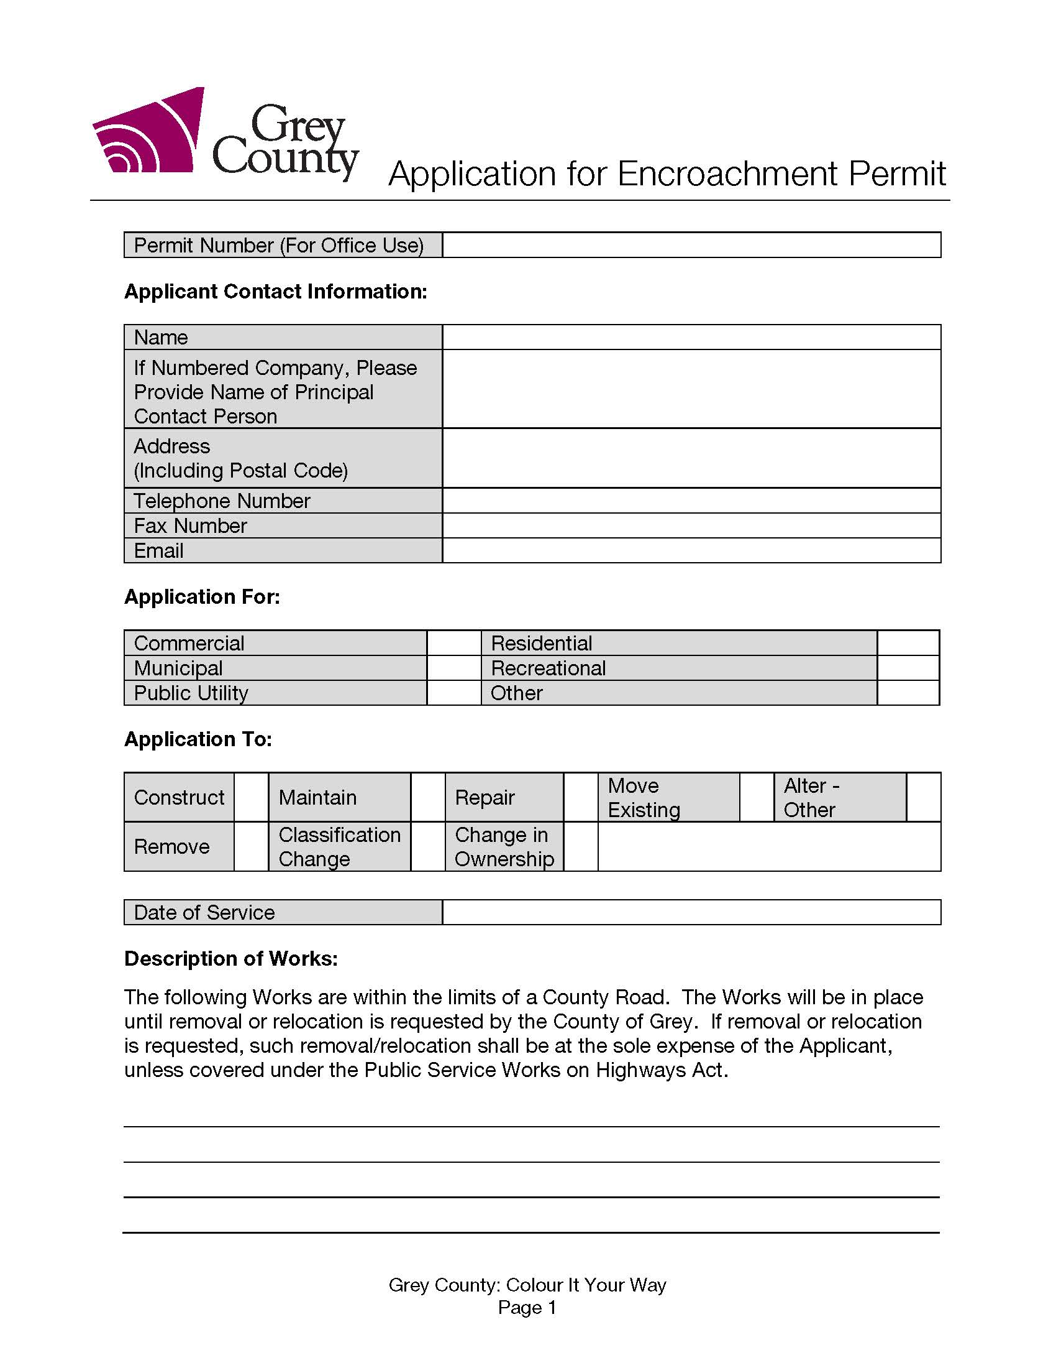

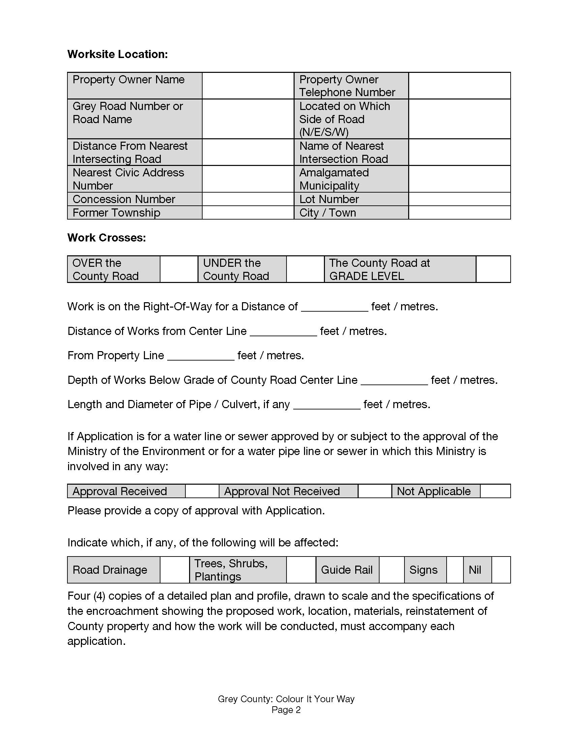

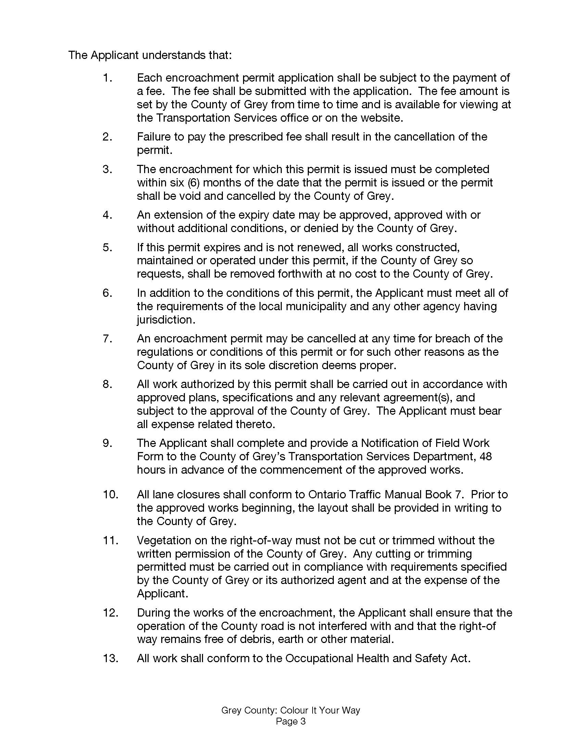

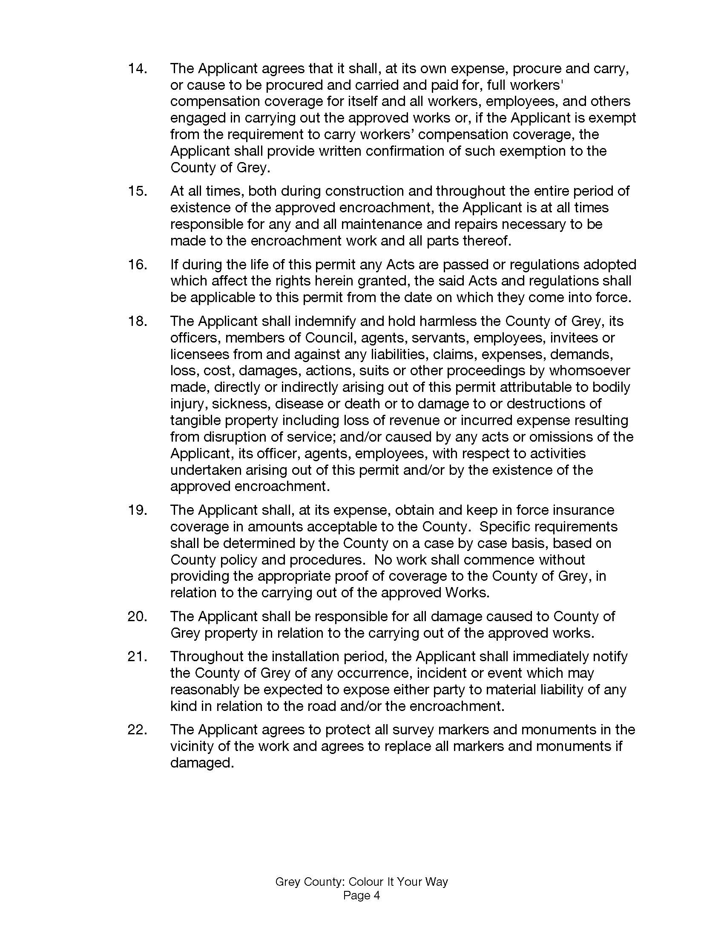

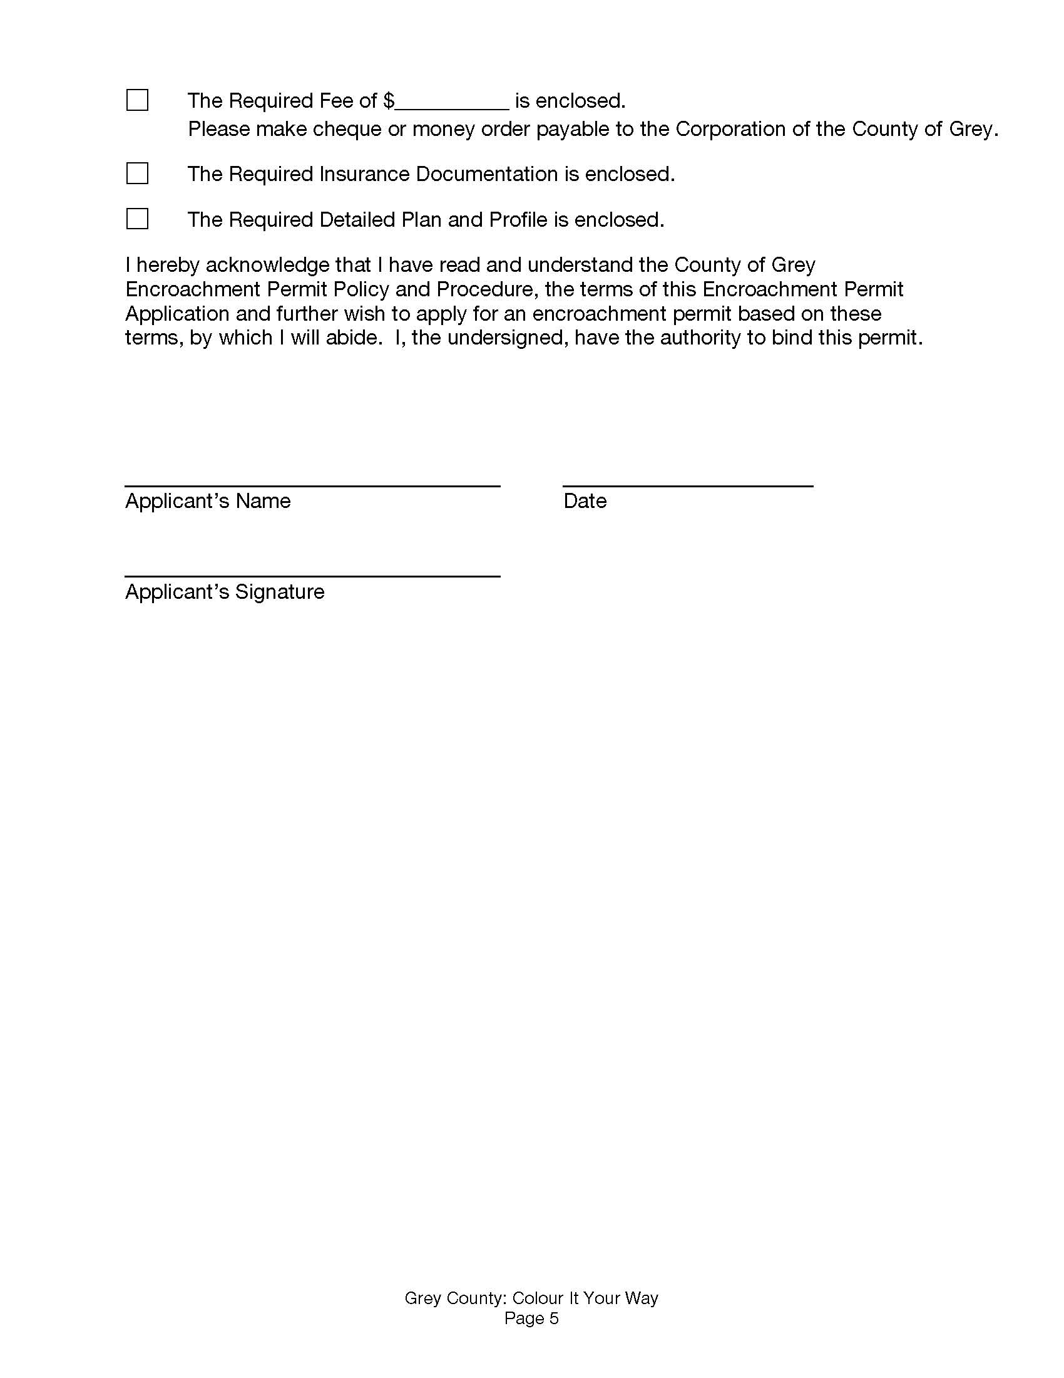

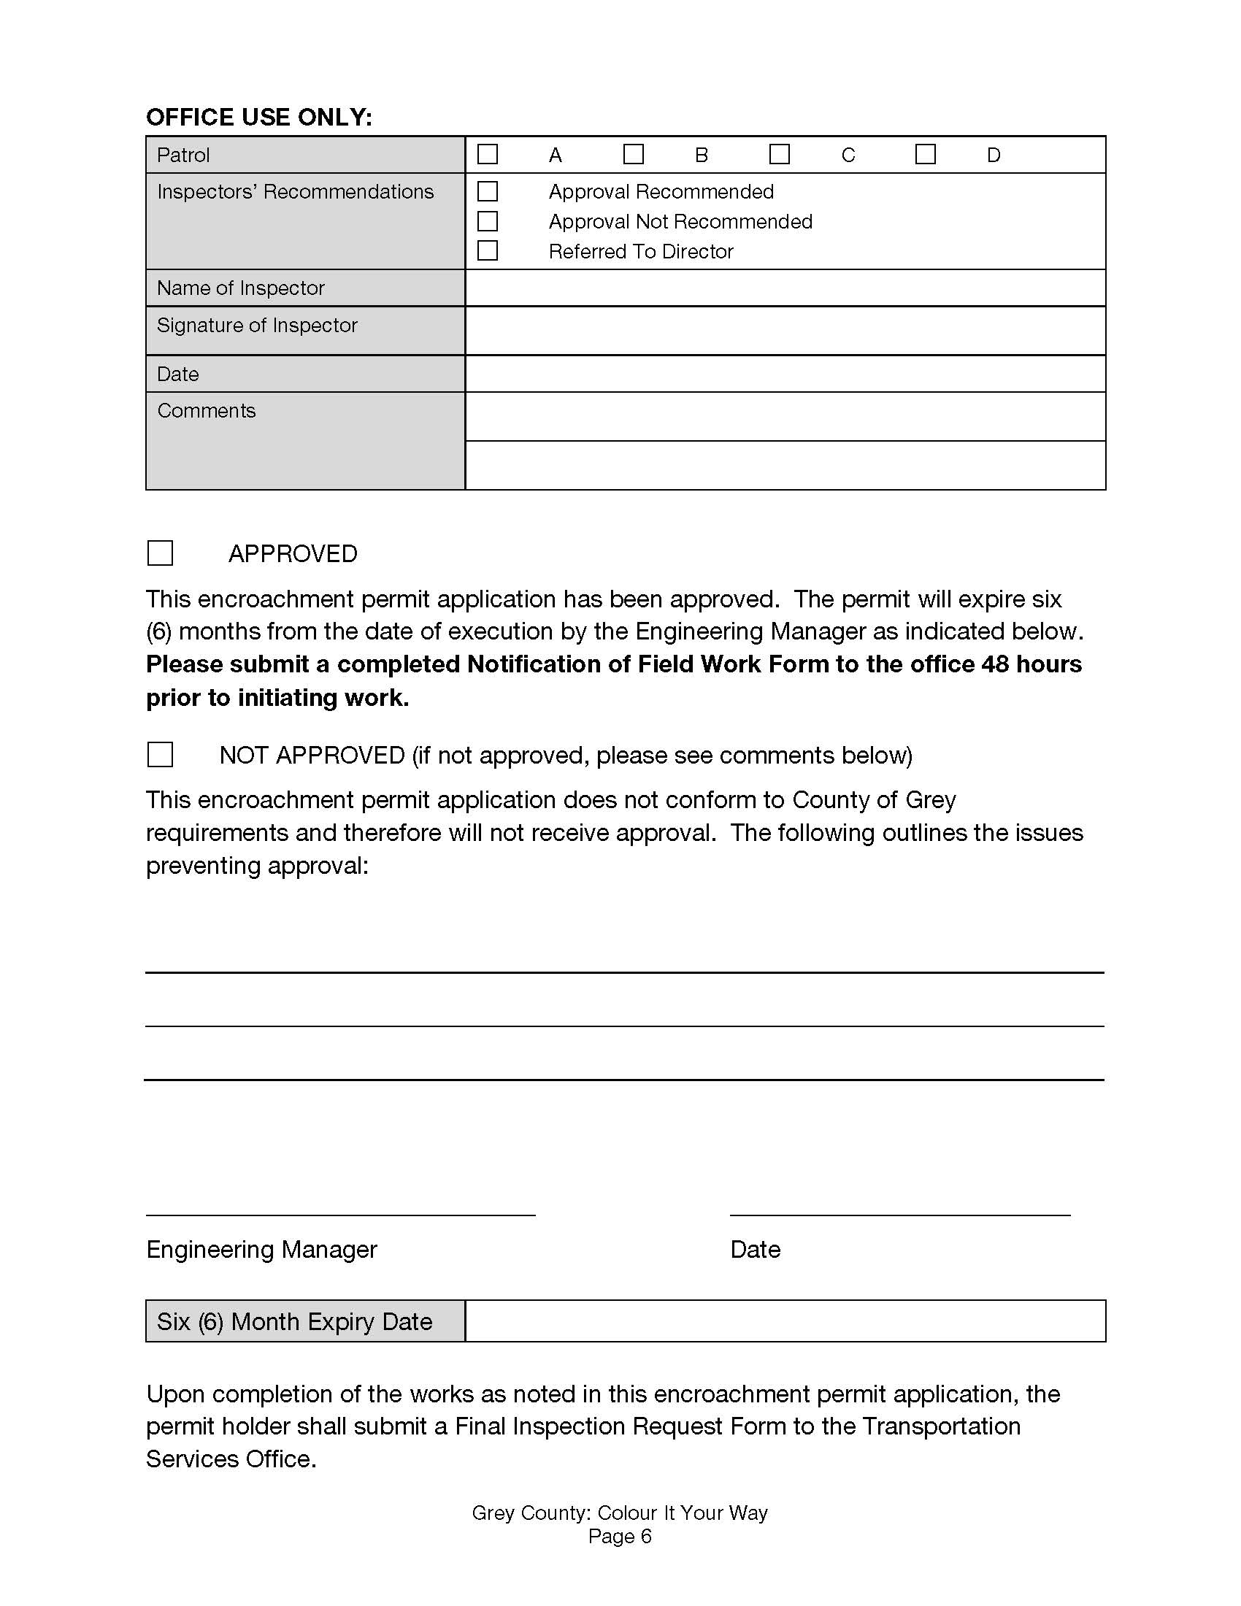

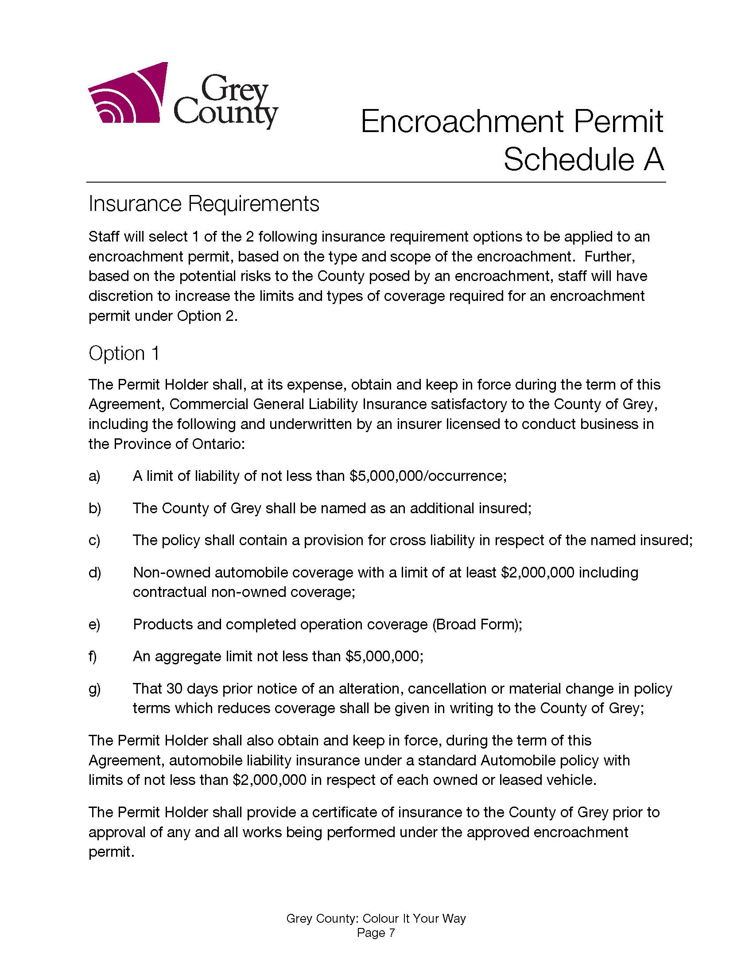

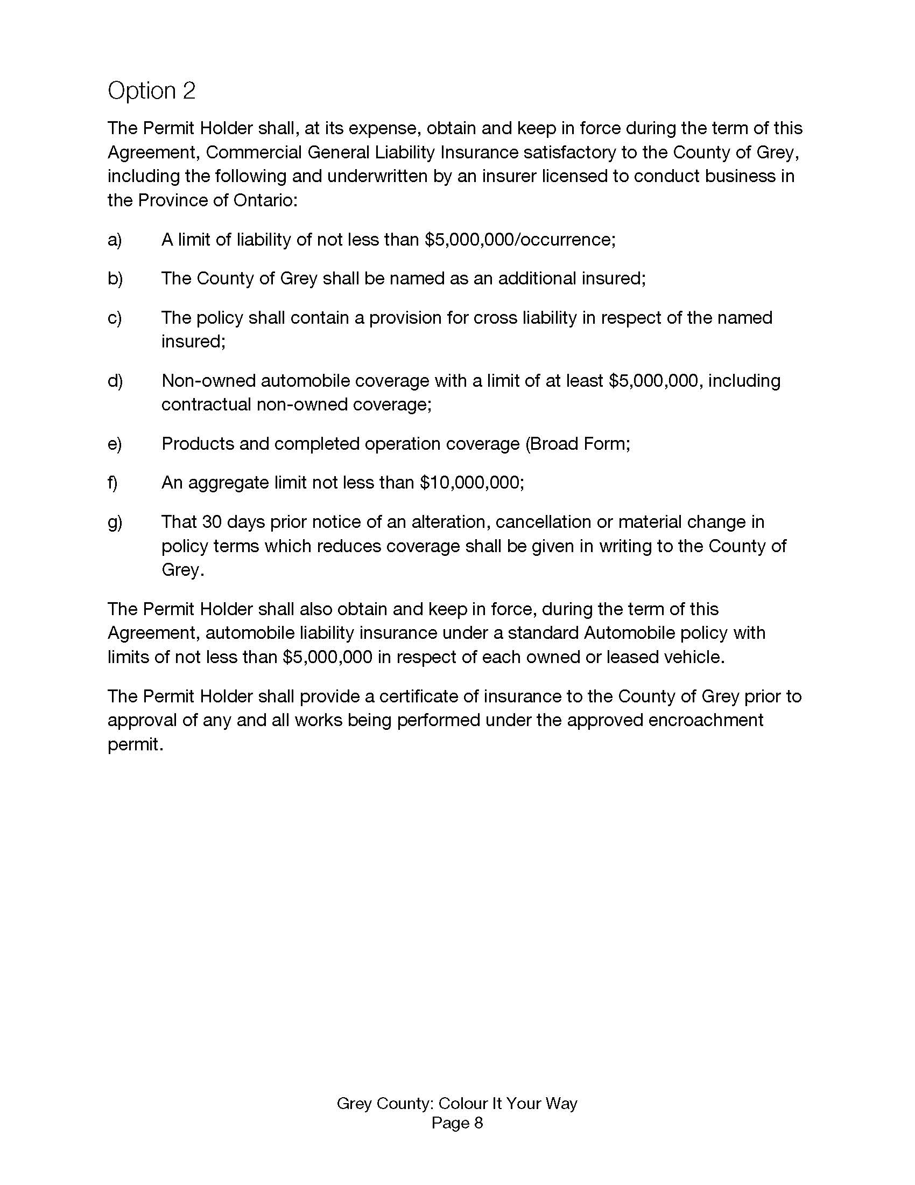

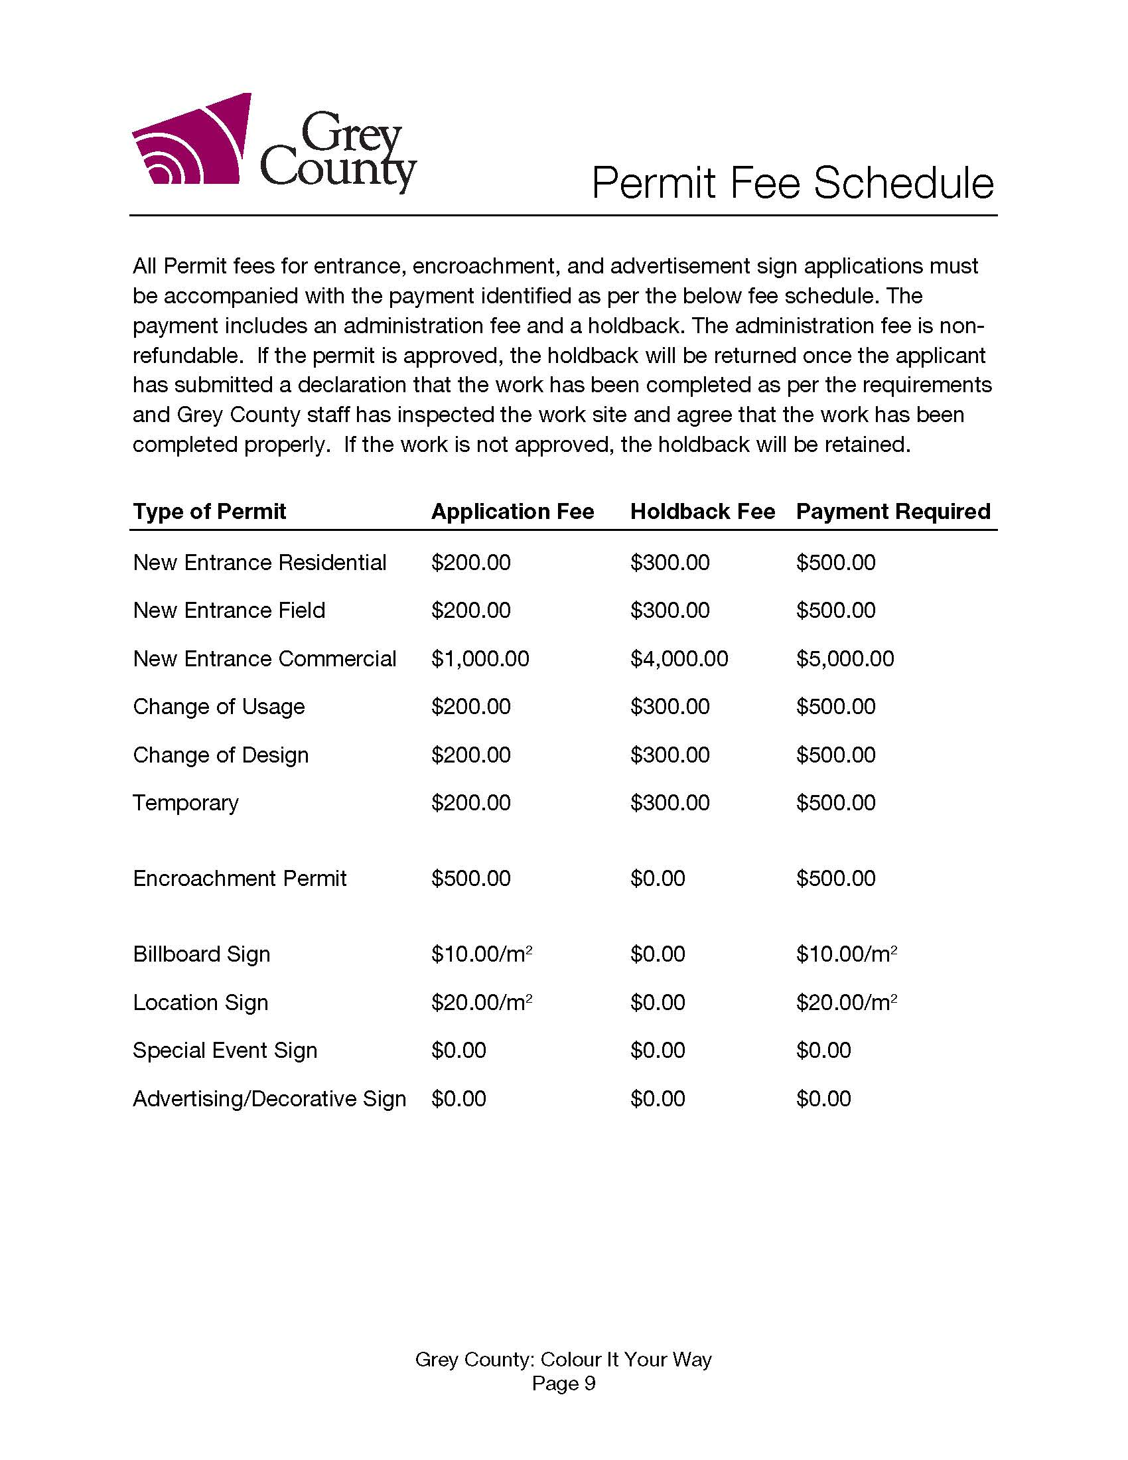

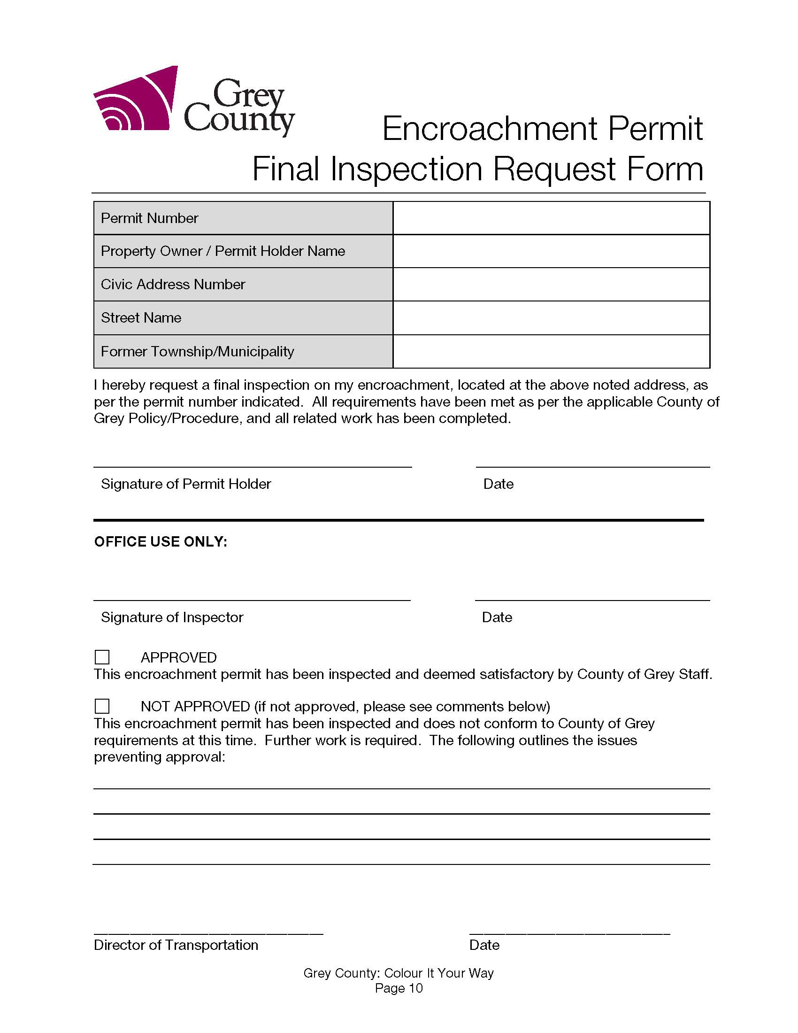

Grey County Logo Notification of Field Work

Transportation Services

595 9th Avenue East Owen Sound Ontario N4K 3E3

Phone: 519-376-7337 / Fax: 519-376-0967

This completed notification must be submitted five (5) days prior to commencing work   
on Grey County right-of-ways by either Fax: 519-376-0967 or email to [roads@grey.ca](mailto:roads@grey.ca).

Company Name:

Contractor Performing Work:

**Location of Work:** Grey County Road Number:

Closest Civic Address (if available):

Township/Municipality:

Date of Work:

Description of Work:

Duration of Work:

**Type of Operation** Road Cut

Off Road Cut

Lane Closure

Trenching

Boring

**Type of Approval** MC  Verbal  Other

**Company Authority** ______________________________________ (Signature)

_______________________________________ (Name Printed)

**Contact No.** _______________________________________

**Date** _______________________________________