Grey County Logo Colour It Connection

## Lee Manor

April 2020

# LTC Director Message

Every email I open these days talks about unprecedented times, encourages people to stay at home and reminds us that we are all in this together!  I wish to extend my gratitude to so many.  To the residents, for being understanding, flexible and staying positive!  To you, the families and friends, for all your kind words of support, for staying away when I know just how much you need to see your loved ones and for staying connected through telephone and technology.  To all the team members in the home, for your courage, your knowledge and your love for the residents.  I will continue to provide special COVID updates via MailChimp and watch for Virtual Town Hall style meetings to join and ask questions.

Stay strong and stay well.

Sincerely,

Jennifer

# Colour It Your Way

Despite the daily challenges and effects of COVID-19, Lee Manor staff continue to be committed to the well being of residents. We proudly share some of the efforts that have been implemented in the past few weeks!

* Traditional activities have been set aside until we receive notification that group programming can resume. Until then each day is filled with “Neighbourhood Time” where recreation staff walk the halls with “Colour It Carts” filled with resources that are specifically stocked to meet the needs and interests of the residents in the home area. Staff visit door to door connecting with residents, utilizing their resources and offering choice to “Colour It Their Way” in the moment. Whether it’s a chat, sharing music or a book, playing a game or enjoying a brush through their hair, we will do our best to make it happen. We even managed to satisfy some green thumbs recently!

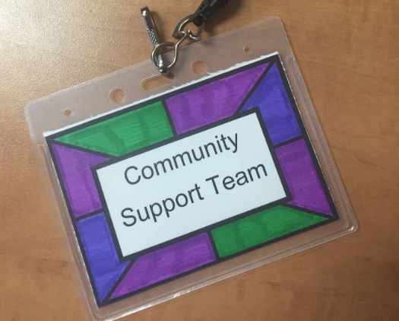

* Residents enjoyed making special name tags for the redeployed County Staff who have joined our Community Support Team. We are very grateful for their support and assistance.

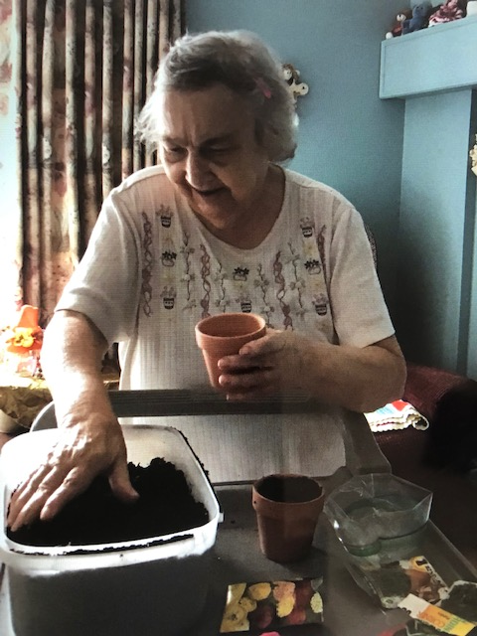

* Activity Room Service at your call! Residents are enjoying the opportunity to select different activities that can be delivered directly to their room. Residents simply check the box and place the door hanger outside of their room. Residents can choose from puzzles, colouring, assistance with contacting family/friends and even request a trip to the Ice Cream Parlour to pick up a few treats.

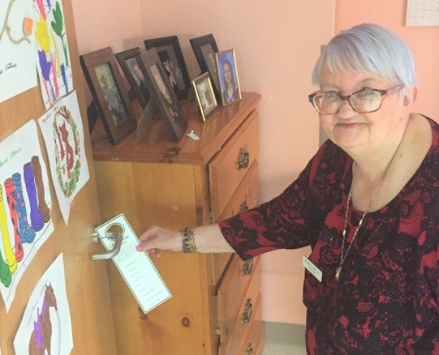

* Bingo has always been a classic activity that residents look forward to. With some innovative twists on a popular pastime we’ve managed to keep it a favourite! Activity Bingo encourages residents to complete different tasks such as write a letter to a friend, talk to someone on the phone, or share a compliment. When their card is full, they will be entered in a draw for a small prize. 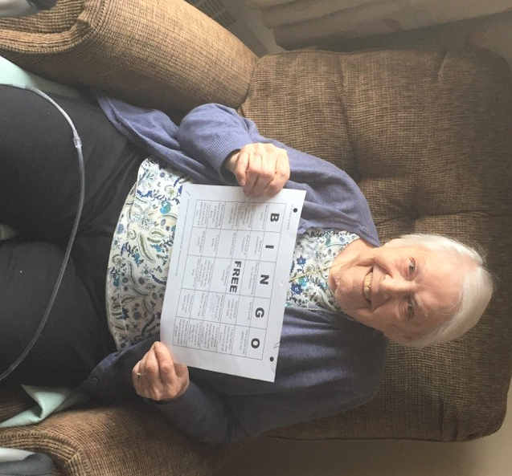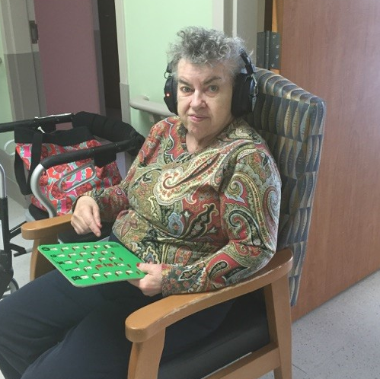We also implemented hallway bingo where residents were set-up in their doorways and provided with wireless headsets. They could hear the bingo caller at the end of the hall and play their card from a safe distance. This generated lots of enthusiasm from the group! We’ve since done hallway karaoke, which brought lots of smiles and laughter up and down the halls.

We look forward to more doorway activities in the upcoming weeks.

* Weather permitting, we have an outdoor concert lined up with Jackie Ralph later this week. Jackie reached out to offer her karaoke talents to brighten everyone’s spirits amongst so much uncertainty. She will be performing in the centre courtyard where residents will enjoy the sounds from their bedroom windows. We intend to line up additional performances like this…the next one might be in the front parking lot!

Recreation Staff have done a marvelous job thinking outside the box and residents have responded positively! We are looking forward to seeing what they come up with next.

# Stay Connected

In response to family and resident visiting restrictions, the “Colour It Connect” program was born. Connecting residents with family and friends with face to face visits has been rewarding for all parties. To date, over 50 people have signed up and interest continues to grow daily. Your patience is appreciated as we work our way through some of the challenges. If you miss your loved one’s call, we will try to send a personalized message or photo from your loved one and will attempt to connect again another day. Our hope is to make a successful connection weekly for each resident on the list.

If you receive a missed video call notification, we kindly ask that you do not attempt to return the call. To join the program, please email [lmconnect@grey.ca](mailto:lmconnect@grey.ca)

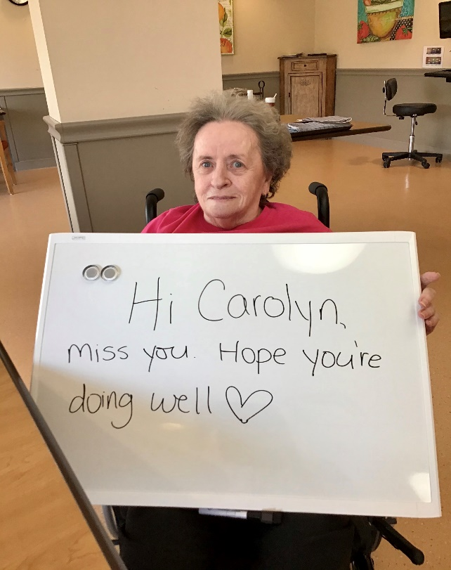

In addition to connecting via videocalls, we have supported several “through the window visits” and even a birthday celebration. Below, resident Fran McCormick celebrated her 91st with her daughter and friends, complete with balloons, banners, and the birthday song cued to a live clarinet performance.

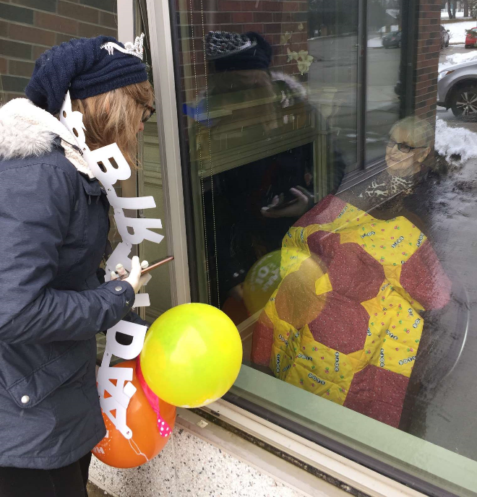

To stay connected we also invite you to continue to email your loved one a message at [leemanorresident@grey.ca](mailto:leemanorresident@grey.ca) . They are delivered to your loved one the following business day. You can also drop off or send cards and parcels with your loved one’s favourite things at the door or via email. All items will be quarantined for 24 hours before delivery.

You may notice some new faces who are connecting you with your loved one in the upcoming weeks. Members of the Community Support Team will soon be assisting with the program.

# # In This Together

We’ve received some wonderful acts of kindness from community members – thanks so much for the nice letters, artwork and painted rocks that have been dropped off. The gestures are keeping our spirits strong…keep them coming!

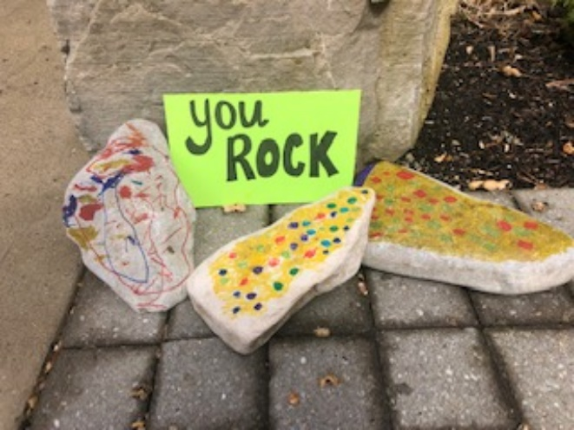

A big shout out to our staff who throughout our everchanging environment have recognized that just a little can go along way. Teams have injected some fun into the home by surprising residents with theme/costume days. We’ve had teams of cowgirls, hula dancers and most recently the M & M candies providing care to the residents. We are truly blessed with amazing staff whose spontaneity has been inspiring. We are in this together!

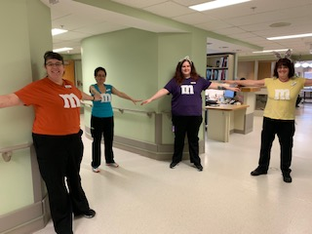

With the current restrictions in place, you might have some “me time” these days. One of our residents is an avid reader and would like to offer her recommendation. Teri gives “Matters of the Heart” by Danielle Steele 8.5/10, give it a read if you like a little romance!

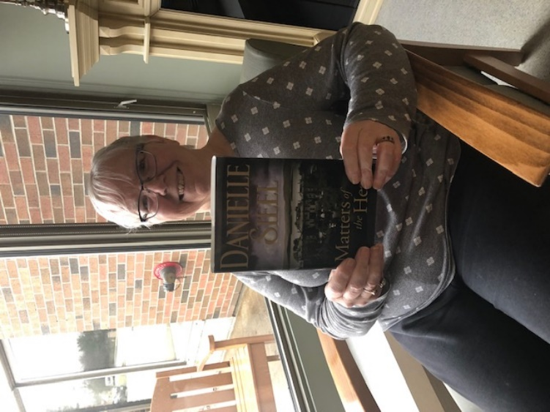

# Colour It Academy

## Your best Defense!

 You can help yourself and your loved ones stay healthy by washing your hands often. Washing your hands is easy, and it is one of the most effective ways to prevent the spread of germs.

Follow these five steps:

1. **Wet** your hands with clean, running water (warm or cold), turn off the tap, and apply soap.
2. **Lather** your hand by rubbing them together with the soap. Lather the backs of your hands, between your fingers, and under your nails.
3. **Scrub** your hands for at least 20 seconds.
4. **Rinse** your hands well under clean running water.
5. **Dry** your hands using a clean towel or air dry them.

# Leadership Team

Renate Cowan, Executive Director

Ext. 2105, [Renate.cowan@grey.ca](mailto:Renate.cowan@grey.ca)

Patti Mink, Director of Care

Ext. 2101, [Patti.mink@grey.ca](mailto:Patti.mink@grey.ca)

Susan Torrie, Associate Director of Care

Ext. 2213, [Susan.torrie@grey.ca](mailto:Susan.torrie@grey.ca)

Darlene Bowerman, PSW Coordinator

Ext. 2116, [Darlene.Bowerman@grey.ca](mailto:Darlene.Bowerman@grey.ca)

Stacey Goldie, Resident and

Family Services Manager

Ext. 2108, [Stacey.goldie@grey.ca](mailto:Stacey.goldie@grey.ca)

Paige Caswell, Nutrition Manager

Ext. 2102, [Paige.caswell@grey.ca](mailto:Paige.caswell@grey.ca)

Krista Tennant, Asst. Nutrition Manager

Ext. 2102, [Krista.Tennant@grey.ca](mailto:Krista.Tennant@grey.ca)

Tim Dean, Building Services Supervisor

Ext. 2313, [Tim.dean@grey.ca](mailto:Tim.dean@grey.ca)

Kari Tupling, Office Coordinator

Ext. 2104, [Kari.tupling@grey.ca](mailto:Kari.tupling@grey.ca)



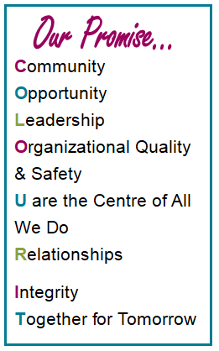

# Let’s Connect

We want to hear your **suggestions, questions, compliments or concerns**. There are lots of ways to share your feedback with us.

1. Fill out a Let’s Connect comment card and drop it in our confidential Let’s Connect box.
2. Speak directly with our Executive Director or with any manager on duty.
3. Email your feedback to the Grey County Support Services Office at [ltcfeedback@grey.ca](mailto:ltcfeedback@grey.ca).
4. For emergencies or urgent concerns, please contact any member of our team.