Grey County Logo Committee Report

# Report PDR-CW-07-17

**To**: Warden Barfoot and Members of Grey County Council

**From**: Scott Taylor

**Meeting Date:** February 9, 2017

**Subject: Plan of Subdivision 42T-2016-09 – Stan Gilas (Township of Southgate)**

**Status**: Recommendation adopted by Committee as presented per Resolution CW-25-17; Endorsed by County Council February 23, 2017 per Resolution CC09-17;

## Recommendation

1. **That Report PDR-CW-07-17 regarding an overview of proposed plan of subdivision application 42T-2016-09, to establish a plan of subdivision consisting of sixteen (16) detached dwelling lots, eight (8) semi-detached dwelling units, three (3) triplex units, thirty-two (32) fourplex units, and thirty (30) townhouse units on lands described as Part of Lot 227, Concession 2 SWTSR, (geographic Township of Proton) in the Township of Southgate, be received for information.**

## Background

The County has recently received a plan of subdivision application from **Stan Gilas** to establish;

* 16 detached dwelling lots,
* 8 semi-detached dwellings units,
* 3 triplex units,
* 32 fourplexes units, and
* 30 townhouse units.

The eastern portion of the lands (approximately 3.7 hectares), which is currently treed, and shown as ‘additional lands owned by the applicant’ is not proposed for development at this time. A copy of the draft plan of subdivision has been included as Map 2 below.

The subject lands are located in Dundalk and are legally described as Part of Lot 227, Concession 2 SWTSR, (geographic Township of Proton) in the Township of Southgate. The proposed housing units would have frontage off of a series of new roads, which would connect to Bradley Street to the south and a future road to the west.

The subject lands are designated as ‘Primary Settlement Area’ in the County Official Plan. The County Plan also incorrectly maps a ‘Wellhead Protection Area’ on the subject lands, but this mapping has been superseded. There are no buildings or structures currently located on the subject property. The subject lands are on the northern edge of Dundalk, and lands further north are in the ‘Rural’ designation.

Surrounding the proposed plan of subdivision is a mixture of residential, farmed, and forested lands. The lands immediately to the southwest of this property have been draft approved for a plan of subdivision, which would allow for a future road connection to these lands.

See Map 1 for an aerial view of the subject property and surrounding area, and Map 2 for a copy of the proposed plan of subdivision.

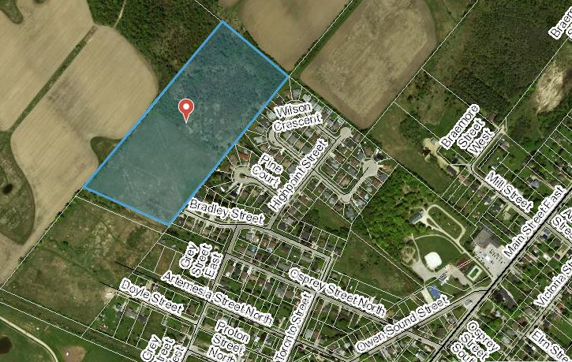

### Map 1: Airphoto of the Subject Property and Surrounding Lands

Pre-submission consultation between the proponent, the Township of Southgate and the County identified the submission requirements for the proposed plan of subdivision, which are as follows;

1. a Planning Report,
2. an Archaeological Assessment (Stage 1 – 2),
3. an Environmental Impact Study, and
4. a Pre-Servicing Report including stormwater management and functional servicing.

The Township did not request a Traffic Impact Study for this development.

Copies of all background reports and plans can be found at the below link:

[Link to Background Materials](http://www.grey.ca/services/planning-development/new-planning-applications/1786934-ontario-inc/)

#### proposed plan of subdivision

### Map 2: Proposed Draft Plan of Subdivision (Courtesy Cuesta Planning Consultants Inc.)

A zoning by-law amendment application has also been submitted to the Township of Southgate.

#### Analysis of Planning Issues

When rendering a land use planning decision, planning authorities must have regard to matters of Provincial Interest under the *Planning Act*, be consistent with the Provincial Policy Statement (PPS) 2014, and conform to any official plans that govern the subject lands. In this case both the County of Grey Official Plan and the Township of Southgate Official Plan have jurisdiction over the subject property.

#### Provincial Policy and Legislation

Both the *Planning Act* and the PPS speak to the efficient use of land within settlement areas, where hard and soft services are readily available. The proposed plan of subdivision will be within the settlement area of Southgate and will be serviced by municipal water and sewer services. When this subdivision is considered for approval servicing capacity may or may not be a limiting factor, depending on the timing of a future approval.

The supply of an adequate range of residential housing types is required in both Provincial documents. The provision of a suitable transportation network, both pedestrian and vehicular, is also noted in the Provincial legislation and policy.

Environmental features on-site have been reviewed through an Environmental Impact Study.

#### County Official Plan

The proposed plan of subdivision is designated as ‘Primary Settlement Area’ within the County Official Plan. Within the Primary Settlement Area designation the County Plan generally defers to the detailed land use policies and development standards of the municipal official plan.

Section 2.6.3(5) of the County Plan requires an overall average development density of 20 units per net hectare within Primary Settlement Areas such as Dundalk. The proposed plan of subdivision would exceed this target.

Section 5.3 of the County Plan provides a similar servicing hierarchy to that found in the PPS, which has been noted above. Elsewhere in section 5 of the Plan are policies which govern roads and transportation.

A detailed analysis of Provincial and County policy has not been offered at this stage; however, following the public and agency review processes, a comprehensive planning analysis and final recommendations will be provided.

### Township of Southgate Official Plan

The Township’s Official Plan contains many similar policies to that of the County Plan. Within the Township Plan the lands are designated as ‘Neighbourhood Area’ which provides for new residential growth.

## Financial/Staffing/Legal/Information Technology Considerations

At this point there are no financial, staffing, legal or information technology considerations beyond those normally encountered in processing a plan of subdivision application. The County has collected the required application fee and peer review deposit.

## Link to Strategic Goals/Priorities

Action 2.10, under Goal 2 of the County’s Strategic Plan, speaks to the continued management of growth, and the application of sound land use planning principles. Permitting new residential development on lands which are designated for growth could be considered sound land use planning, provided the relevant planning policies are adhered to. Following the public and agency development review processes, County staff will offer a final recommendation on the proposed plan of subdivision application with respect to;

1. regard for matters of Provincial Interest under the Planning Act,
2. consistency with the Provincial Policy Statement (PPS), and
3. conformity to the County and Township Official Plans.

## Attachments

None

Respectfully submitted by,

Scott Taylor, MCIP, RPP  
Senior Planner

Director Sign Off: Randy Scherzer