Grey County Logo Committee Report

|  |  |
| --- | --- |
| **To**: | Warden McQueen and Members of Grey County Council |
| **Committee Date**: | September 24, 2020 |
| **Subject / Report No**: | PDR-CW-36-20 |
| **Title**: | Southgate Meadows Subdivision – Redline Revision – 42T-2018-12 |
| **Prepared by**: | Randy Scherzer |
| **Reviewed by**: | Kim Wingrove |
| **Lower Tier(s) Affected**: | Township of Southgate |
| **Status**: | Recommendation adopted by Committee as presented per Resolution CW166-20; Endorsed by County Council October 8, 2020 per Resolution CC78-20; |

# Recommendation

1. **That PDR-CW-36-20 regarding the Southgate Meadows Subdivision -Redline Revision – 42T-2018-12 be received; and**
2. **That all written and oral submissions received on the proposed redline revisions to plan of subdivision 42T-2018-12 were considered which helped to make an informed recommendation and decision; and**
3. **That in consideration of the revised draft plan of subdivision 42T-2018-12, and the matters to have regard for under Subsection 51(24) of the Planning Act, the County of Grey Committee of the Whole hereby approves the revised plan of subdivision on lands described as Part of Lots 227 and 228, Concession 2, Southwest of the Toronto Sydenham Road (SWTSR), all of Lot Y and part of the unnamed street lying northeast of Part Lot 3, Block S, Plan 480, Township of Southgate, geographic Township of Proton.**

## Executive Summary

The report considers proposed revisions to draft plan of subdivision 42T-2018-12 known as Southgate Meadows. The current draft plan consists of a total of 163 residential units, consisting of 130 single detached units and 33 townhouse units. The proposed revisions would change the total residential units to 118 single detached units and 65 townhouse units, being a total increase of 20 residential units. Other proposed changes include changing some of the lot/block numbers as a result of the proposed revisions. An associated zoning by-law amendment to support the proposed subdivision changes has recently been approved by the Township of Southgate and is now in the appeal period. All comments regarding the proposed revisions have been considered and it is recommended that Committee approve the revisions to the draft plan.

## Background and Discussion

The County has received a redline revision application which proposes to revise the current draft approved plan of subdivision known as Southgate Meadows - 42T-2018-12.  The draft approved plan is in the settlement area of Dundalk on lands situated north of Glenelg Street and east of Ida Street. The lands are described as Part of Lots 227 and 228, Concession 2, Southwest of the Toronto Sydenham Road (SWTSR), all of Lot Y and part of the unnamed street lying northeast of Part Lot 3, Block S, Plan 480, Township of Southgate, geographic Township of Proton. This subdivision was originally draft approved in November 2019 and a link to the staff report recommending draft approval has been included in the Attachments section of this report. Figure 1 below shows the subject lands. Figure 2 shows the proposed revised plan of subdivision.

Figure 1: Airphoto of Subject Lands

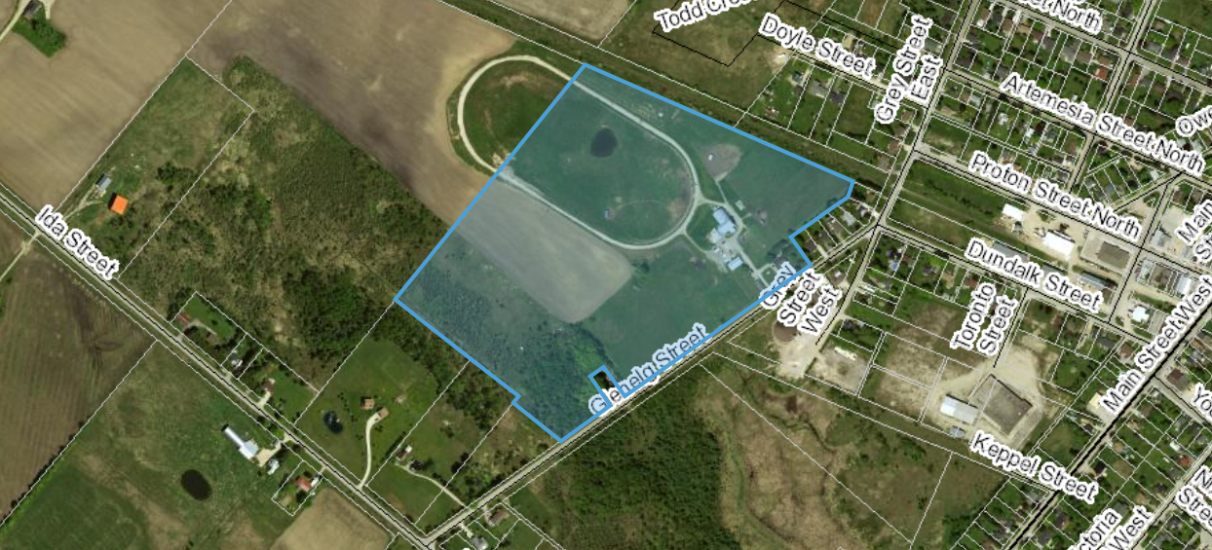

The proposed revisions would increase the total number of residential units from 163 to 183, or an increase of 20 units.  Upon further detailed review of the stormwater management by the developer’s consultant, it has been determined that the stormwater block in the current draft approved plan is larger than what will be required for the stormwater management pond.  As such, the developer is proposing to add seven residential lots on the west side of the stormwater management block (Block 146).  The proposed revisions also propose to convert some of the single detached units to townhouse units.  Lots 70 to 78 and Lots 108 to 117 are proposed to be converted to townhouse blocks.  This would essentially convert 19 single detached lots to six townhouse blocks which would contain a total of 32 townhouse units.  The proposed changes would change the current draft approved plan from 130 single detached units and 33 townhouse units to 118 single detached units and 65 townhouse units.  Other changes include changing some of the lot/block numbers as a result of the proposed revisions.

Updated studies have been submitted with the proposed redline revision application. Copies of all background reports and plans can be found at [this link.](https://www.grey.ca/planning-development/planning-applications)

### Figure 2: Proposed Revised Plan of Subdivision

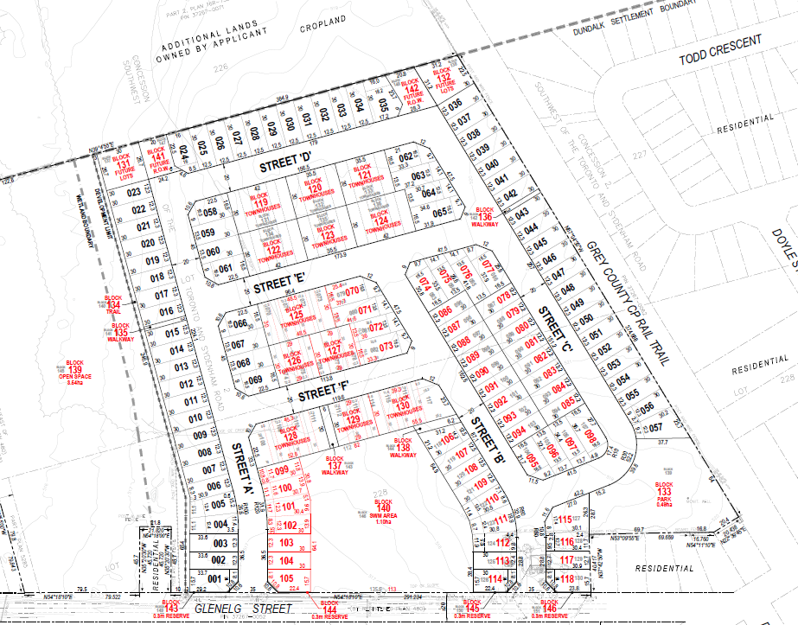

An associated zoning by-law amendment to support the proposed subdivision changes has recently been approved by the Township of Southgate and is now in the appeal period.

### Public and Agency Comments Received

#### Public Comments

The Township of Southgate held a public meeting for the proposed zoning by-law amendment and the associated proposed redline revision on June 12, 2020. No public comments were received as part of the public meeting or in writing.

#### Agency Comments

As part of the planning application process, comments were received by the following groups, agencies and public bodies.

##### Bell Canada

In correspondence dated April 28, 2020, Bell Canada requests that a condition of draft approval be included to grant easements for the installation of services. A condition of draft approval was included previously regarding the provision of easements for utilities.

##### Bruce Telecom

In correspondence dated April 24, 2020, Bruce Telecom notes that they will not have any involvement with the proposal in this location.

##### Canada Post

In comments dated April 24, 2020, Canada Post notes there are no changes to the previous comments they provided as part of the original plan of subdivision application. They note that mail delivery will be done through community mailboxes and they will work with the developer once site plans are created to decide on suitable locations for the mailboxes.

##### Eastlink

In comments dated April 24, 2020, Eastlink indicates that they have no concerns.

##### Enbridge Gas Inc.

In correspondence dated April 27, 2020, Enbridge Gas Inc. requires that as a condition of draft approval that the developer provide to Union Gas/Enbridge the necessary easements and/or agreements required by Union Gas/Enbridge. As noted, an existing condition of draft approval exists to address these comments.

##### Grand River Conservation Authority (GRCA)

In previous comments, GRCA requested additional information which was provided by the developer’s engineering consultant. In the most recent comments from GRCA dated June 30, 2020, GRCA notes that it has been confirmed that the proposed stormwater management facility has extra capacity and therefore GRCA can support the redline revision at this time. GRCA notes that they have no objections to the approval of the redline revision and the zoning by-law amendment.

##### Grey County Transportation Services

In correspondence dated May 1, 2020, Transportation Services has no concerns.

##### Hydro One

In correspondence dated April 23, 2020, Hydro One has no comments or concerns.

##### Township of Southgate

In Township Staff Report PL2020-035, the Township Staff recommended that the associated zoning by-law amendment be approved. Township staff have noted that the zoning by-law amendment application C9-20 (By-law 2020-093) has been passed by Township Council and therefore have no concerns with the proposed redline revisions.

## Analysis of Planning Issues

When rendering a land use planning decision, planning authorities must have regard to matters of Provincial Interest under the *Planning Act*, be consistent with the Provincial Policy Statement (PPS) 2020, and conform to any official plans or provincial plans that govern the subject lands. In this case, the County of Grey Official Plan and the Township of Southgate Official Plan have jurisdiction over the subject property.

A fulsome planning analysis was completed prior to the original draft plan approval in staff report Addendum to PDR-CW-07-19 (linked to in the Attachments section of this report). An abbreviated planning analysis will be provided below, building off the analysis done in the earlier report.

### The Planning Act

Section 1.1 of the *Planning Act* outlines the purposes of the Act. The purposes of the Act promote sustainable economic development, in a healthy natural environment, within a land use planning system led by provincial policy and matters of provincial interest. Section 2 of the *Planning Act* outlines matters of Provincial Interest, which decision makers must be consistent with when carrying out their responsibilities under the Act. Although the proposed revisions will add 20 residential units, the changes will not develop any further lands than were contemplated through the original draft approval. The proponent’s engineer has confirmed that the stormwater management and servicing of the additional units can be accommodated. The subject redline revision application, with the attached revised conditions of draft approval, has regard for matters of Provincial Interest under the *Planning Act* including Section 51(24).

### Provincial Policy Statement (PPS) 2020

A key goal of the PPS is directing new growth to serviced settlement areas, and promoting the vitality of such settlement areas through re-development, infill and intensification. The subject lands have been designated for residential growth and are within a settlement area. The proposed redline revision would have the effect of adding additional residential units, thereby intensifying this development.

Section 1.6.6.1 of the PPS outlines the servicing hierarchy to be utilized in the Province of Ontario. At the top of the hierarchy are municipal water and sewer services. The proposed development will be serviced by municipal water and sewer services.

The proposed redline revisions, with the attached revised conditions of draft approval, are consistent with the PPS.

### County Official Plan

The proposed plan of subdivision is designated as ‘Primary Settlement Area’ and ‘Hazard Lands’ within the County’s Recolour Grey Official Plan. Increasing the density in this subdivision is supported in the policies contained in the County Official Plan. The proposed subdivision also provides a good mix of singles and townhouse dwellings.

These lands are fully serviced by municipal water and sewer services and therefore conform to section 8.9 of the County Plan.

Subject to the revised conditions of draft approval attached to this report, the application conforms to the goals and objectives of the County of Grey Official Plan.

### Township of Southgate Official Plan

The subject lands are designated ‘Neighbourhood Area’ and ‘Hazard Lands’ in the Township of Southgate Official Plan. Township staff have not flagged any conformity issues with the proposed redline revision. As noted earlier in this report, the Township has approved a zoning amendment to support this redline revision.

With the attached recommended revised draft plan conditions, County staff are of the opinion that the proposed redline revision:

1. has regard for matters of Provincial interest under the *Planning Act*;
2. is consistent with the Provincial Policy Statement;
3. conforms to the County of Grey Official Plan; and
4. conforms to the Township of Southgate Official Plan.

## Legal and Legislated Requirements

The application was processed in accordance with the *Planning Act.*

## Financial and Resource Implications

There are no anticipated financial, staffing or legal considerations associated with the proposed redline revisions, beyond those normally encountered in processing the application. The County has collected the requisite fee for this application.

# Relevant Consultation

Internal (Planning Staff, Transportation Services)

External (Township of Southgate, agencies under the Planning Act)

### Appendices and Attachments

[Addendum to PDR-CW-07-19 Southgate Meadows Final Report](https://docs.grey.ca/share/public?nodeRef=workspace://SpacesStore/af978650-441c-46ae-8299-c10977945b6f)

*Revised Conditions of Draft Approval (attached)*

# **NOTICE OF DECISION**

**On Application for Revision to Approval of Draft Plan of Subdivision**

**under Subsection 51(45) of the Planning Act**

Draft Plan Approval was originally given by the County to Plan of Subdivision 42T-2018-12 on November 28, 2019. Revised Draft Plan Approval is hereby given by the County of Grey for the application regarding the above noted lands. A copy of the Decision is attached.

**PUBLIC AND AGENCY COMMENTS RECEIVED ON THE FILE**

All written and oral submissions received on the application were considered; the effect of which helped to make an informed recommendation and decision.

**WHEN AND HOW TO FILE A NOTICE OF APPEAL**

Notice to appeal the decision to the Local Planning Appeals Tribunal must be filed with the County of Grey no later than 20 days from the date of this notice, as shown above.

The notice of appeal should be sent to the attention of the Director of Planning and Development of the County, at the address shown below and it must,

(1) set out the reasons for the appeal,

(2) be accompanied by the fee prescribed under the Local Planning Appeals Tribunal Act, and

(3) Include the completed appeal form from the LPAT’s website.

**WHO CAN FILE A NOTICE OF APPEAL**

Only individuals, corporations or public bodies may appeal decisions in respect of a proposed plan of subdivision to the Local Planning Appeal Tribunal. A notice of appeal may not be filed by an unincorporated association or group. However, a notice of appeal may be filed in the name of an individual who is a member of the association or group on its behalf.

No person**\*** or public body shall be added as a party to the hearing of the appeal of the decision of the approval authority, including the lapsing provisions of the conditions, unless the person or public body, before the decision of the approval authority, made oral submissions at a public meeting or written submissions to the council, or made a written request to be notified of changes to the conditions or, in the Local Planning Appeal Tribunal’s opinion, there are reasonable grounds to add the person or public body as a party.

**\***Notwithstanding the above, only a ‘person’ listed in subsection 51(48.3) of the Planning Act may appeal the decision of the County of Grey to the Local Planning Appeal Tribunal (LPAT) as it relates to the proposed plan of subdivision. Below is the prescribed list of ‘persons’ eligible to appeal a decision of the County of Grey related to the proposed plan of subdivision as per subsection 51(48.3) of the Planning Act.  These are recent changes that have been made to the Planning Act by the province. A link to the revised Planning Act can be found here - <https://www.ontario.ca/laws/statute/90p13>. For more information about these recent changes, please visit the LPAT website or contact LPAT - <https://elto.gov.on.ca/tribunals/lpat/about-lpat/>.

The prescribed list of ‘persons’ eligible to appeal a decision of the County on the proposed plan of subdivision as per subsection 51(48.3) of the Planning Act is as follows:

1. A corporation operating an electric utility in the local municipality or planning area to which the plan of subdivision would apply.
2. Ontario Power Generation Inc.
3. Hydro One Inc.
4. A company operating a natural gas utility in the local municipality or planning area to which the plan of subdivision would apply.
5. A company operating an oil or natural gas pipeline in the local municipality or planning area to which the plan of subdivision would apply.
6. A person required to prepare a risk and safety management plan in respect of an operation under Ontario Regulation 211/01 (Propane Storage and Handling) made under the Technical Standards and Safety Act, 2000, if any part of the distance established as the hazard distance applicable to the operation and referenced in the risk and safety management plan is within the area to which the plan of subdivision would apply.
7. A company operating a railway line any part of which is located within 300 metres of any part of the area to which the plan of subdivision would apply.
8. A company operating as a telecommunication infrastructure provider in the area to which the plan of subdivision would apply.

**RIGHT OF APPLICANT OR PUBLIC BODY TO APPEAL CONDITIONS**

The following may, at any time before the approval of the final plan of subdivision, appeal any of the conditions imposed by the approval authority to the Tribunal by filing a notice of appeal with the approval authority: the applicant; any public body that, before the approval authority made its decision, made oral submissions at a public meeting or written submissions to the approval authority; the Minister; or the municipality in which the subject land is located.

**HOW TO RECEIVE NOTICE OF CHANGED CONDITIONS**

The conditions of an approval of draft plan of subdivision may be changed at any time before the final approval is given.

You will be entitled to receive notice of any changes to the conditions of the approval of draft plan of subdivision if you have made a written request to be notified of changes to the conditions.

**RELATED APPLICATIONS**

Township of Southgate Zoning By-law Amendment 2020-093 (ZBA C9-20).

**GETTING ADDITIONAL INFORMATION**

Additional information about the application is available for public inspection during regular office hours in the Planning & Development Office at the address noted below or by calling 519-376-2205 or 1-800-567-GREY.

**ADDRESS FOR NOTICE OF APPEAL**

**County of Grey**

**595-9th Avenue East**

**OWEN SOUND, Ontario N4K 3E3**

**Attention: Mr. Randy Scherzer, MCIP RPP**

**Director of Planning & Development**

Plan of Subdivision File No. 42T-2018-12 has been revised and granted draft approval. The draft plan is hereby revised. The County’s conditions of final plan approval for this draft Plan of Subdivision are amended as follows:

No. Conditions

1. Condition 1 of the draft plan conditions approved on November 28, 2019 is hereby deleted and replaced with the following:

That the final plan shall conform to the Draft Plan of Subdivision File No. 42T-2018-12 prepared by MHBC Planning and surveyed by Schaeffer Dzaldov Bennett Ltd. dated September 25, 2018 and revised on March 24, 2020 showing:

* 1. 118 single detached lots (Lots 1 to 118)
  2. 65 townhouse units located within Blocks 119 to 130
  3. 2 blocks for future lots (Blocks 131 and 132)
  4. Park block (Block 133)
  5. Walkway/trail blocks (Blocks 134 to 138)
  6. Open space block (Block 139)
  7. Stormwater block (Block 140)
  8. Future right of way blocks (Blocks 141 and 142)
  9. 0.3 metre reserves (Blocks 143 to 146)

The legal description of the subject lands is Part of Lots 227 and 228, Concession 2, Southwest of the Toronto Sydenham Road (SWTSR), all of Lot Y and part of the unnamed street lying northeast of Part Lot 3, Block S, Plan 480, Township of Southgate, geographic Township of Proton, County of Grey.

1. Condition 3 of the draft plan conditions approved on November 28, 2019 is hereby deleted and replaced with the following:

That Blocks 133 to 140 (Open Space, Park, Walkways, Trail, and SWM Pond), Blocks 141 & 142 (Future Right of Way blocks) and Blocks 143 to 146 (0.3m reserve) be deeded to the Township of Southgate.

1. That all other conditions of draft approval as granted on November 28, 2019 remain in effect.