Grey County Logo Committee Report

# Report PDR-PCD-06-14

**To**: Chair Wright and Members of the Planning and Community Development Committee

**From**: Randy Scherzer, Director of Planning

**Meeting Date:** January 21, 2014

**Subject: 42-CDM-2007-09 (Gates of Kent) – Three Year Draft Approval Extension Request**

**Status**: Recommendation adopted by Committee as presented per Resolution PCD23-14 January 21, 2014; Endorsed by County Council February 4, 2014 per Resolution CC23-14;

## Recommendation(s)

**WHEREAS draft plan approval was granted for Plan of Condominium File 42-CDM-2007-09 by the County of Grey on May 15th, 2008;**

**AND WHEREAS extensions of draft approval have been granted over the years including a three year extension granted by the Planning and Community Development Committee in March 2011;**

**AND WHEREAS a request has been received from the applicant requesting an additional three year draft approval extension;**

**AND WHEREAS the Municipality of Meaford supports the request for an additional three year extension;**

**NOW THEREFORE BE IT RESOLVED THAT Report PDR-PCD-06-14 be received and that under the authority delegated to it by Grey County Council, the Planning and Community Development Committee hereby grants an extension of draft approval for condominium file no. 42-CDM-2007-09 to May 15th, 2017 under Section 51(33) of The Planning Act, RSO 1990, as amended.**

## Background

Plan of Condominium Application 42-CDM-2007-09 received draft approval on May 15th, 2008. The draft approved condominium includes a total of 82 residential units to be registered in multiple phases on lands described as Lots 416, 418 and 419, and Part of Lot 417, R.P. 309, geographic Town of Meaford, Municipality of Meaford. The subject lands are located between Centre Street and Union Street in the Town of Meaford (see map below). The total number of condominium townhouses that have been registered is 20 units. The developer is currently constructing another 4 units which will be registered in the near future.

### MAP 1: Gates of Kent Subject Lands

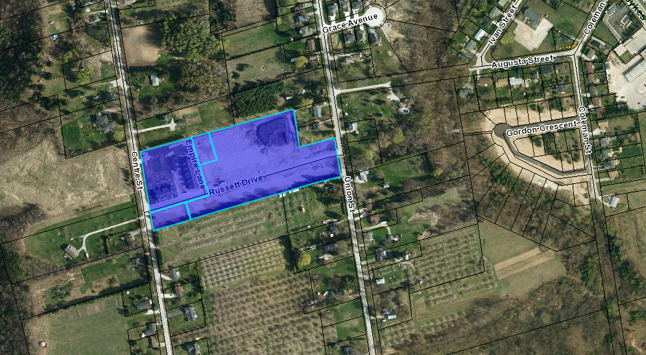

Several extensions of draft plan approval have been granted for Condominium File 42-CDM-2007-09 over the past few years, including a three year extension that was approved by the Planning and Community Development Committee in March 2011 which extended draft approval to May 15, 2014. The County has received a request from the applicant requesting an additional three year draft approval extension. The main reason for the request is that the market demand has been slower than anticipated.

In correspondence dated December 13, 2013, the Municipality of Meaford indicates that they support a three year extension given the scale of the project and given that the current zoning and the existing Development Agreement protects the interests of the Municipality.

The standard period of time for extensions of draft approval is one year. The granting of one year extensions has been delegated to the Director of Planning. Extension requests beyond one year are required to be approved by the Planning and Community Development Committee. County staff typically recommends that extensions to draft approval only be for a one year period to ensure that the proponent is continuing to move forward with fulfilling the conditions and to allow local municipalities to have the option of not extending draft approval if the municipality is experiencing servicing capacity issues.

Based on the reasons for the extension request identified in the letter from the Applicant’s agent, and based on the Municipality of Meaford supporting the request for a three year extension, County staff recommends an additional three (3) year draft approval extension be granted.

## Financial / Staffing / Legal / Information Technology Considerations

At this point there are no financial, staffing, legal or IT considerations. The County has collected a fee for the extension of draft approval.

## Link to Strategic Goals / Priorities

Action 2.10, under Goal 2 of the County’s Strategic Plan requires the continued management of growth and the application of sound land use planning principles. Permitting an extension to draft approval for a previously draft approved subdivision would be considered sound land use planning, given the specific circumstances.

Respectfully submitted by,

Randy Scherzer  
Director of Planning