Grey County Logo Committee Report

# Report PDR-PCD-13-16

**To**: Chair McQueen and Members of the Planning and Community Development Committee

**From**: Sarah Morrison, Intermediate Planner

**Meeting Date:** March 15, 2016

**Subject: Request to Change Culvert Project for 2016 from Culvert 16 to Culvert 74**

**Status**: Recommendation adopted by Committee as presented per Resolution PCD55-16; Endorsed by County Council April 5, 2016 per Resolution CC46-16;

## Recommendation(s)

**WHEREAS Culvert#16 on the CP Rail Trail was slated for replacement by the County of Grey in 2016;**

**AND WHEREAS after further site investigation it is was determined that the structure that exists at this location is not a culvert, but what is believed to be an old water refill station which is located approximately 1km south of Massie Road on the CP Rail Trail;**

**NOW THEREFORE BE IT RESOLVED THAT Report PDR-PCD-13-16 be received;**

**AND THAT based on the AECOM report the next culvert with highest need for replacement is Culvert 74 which is approximately 0.5 km north of Southgate Road 24 on the CP Rail Trail;**

**AND FURTHER THAT the 2016 approved budget reserve funding of $60,000 for Culvert 16 be utilized to fund the replacement/rehabilitation of Culvert 74 in 2016.**

## Background

Each year based on the AECOM report that was completed in 2011, a culvert is slated for repair or replacement. The current year, 2016, Culvert 16 was slated for replacement.

As part of preparation for the annual project staff performed a detailed site visit to determine the scope of work required. This year when the site inspection occurred it was determined that the culvert was not a culvert, instead it is believed to be an old water refill station beside the track which is located approximately 1km south of Massie Road on the CP Rail Trail (see Map 1 below). As a result of this discovery staff have recommended that we move forward with the next culvert slated for repair or replacement in the AECOM report, being Culvert 74. Culvert 74 is located approximately 0.5 km north of Southgate Road 24 on the CP Rail Trail (See Map 2 below).

### Map 1: Possible Water Refill Station Location (Former Culvert 16)

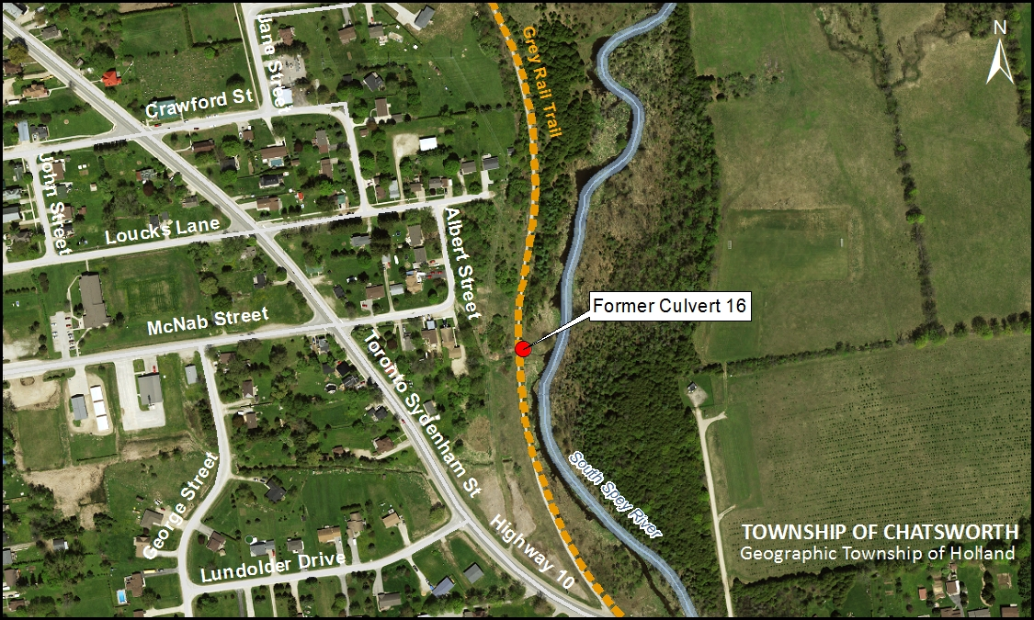

### Map 2: Location of Culvert 74

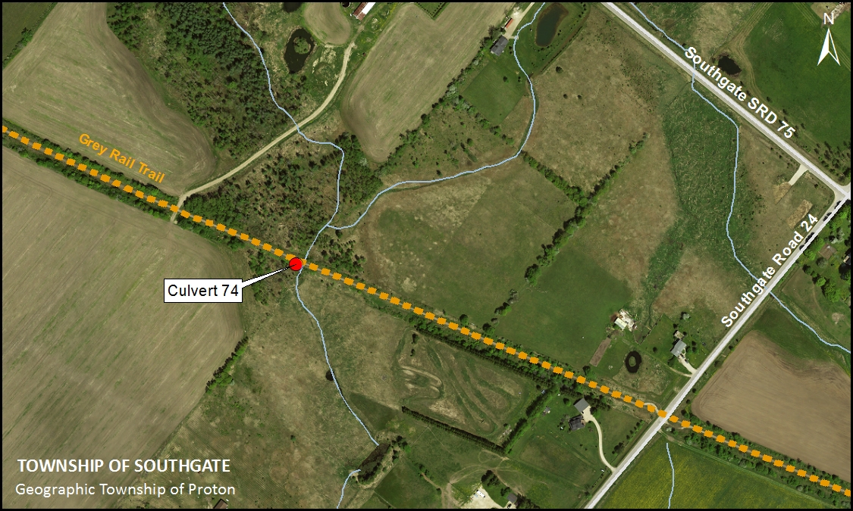

## Financial / Staffing / Legal / Information Technology Considerations

There are no anticipated increased costs for this project, as the allotted budget for Culvert 16 will now be used for Culvert 74; early estimates indicate that the project will be well within the existing budgeted amount. The preliminary estimate to replace Culvert 74 is $30,000 and the 2016 approved budget reserve funding for Culvert 16 is $60,000.

## Link to Strategic Goals / Priorities

Action Item 3.7 of the Corporate Strategic Plan calls for the continued implementation of the Grey County Recreational Trails Strategy. The CP Rail Trail is the major trail linkage in Grey County providing access to several arterial trails in the region. Maintaining the CP Trail and keeping the trail safe for recreational users will assist in achieving Action Item 3.7.

## Attachments

[AECOM Culvert Improvement Needs Updated Priority List - June 3, 2013](https://greydocs.ca/urm/idcplg?IdcService=GET_FILE&dDocName=GC_203288&RevisionSelectionMethod=LatestReleased)[AECOM Culvert Inspection Report 2011 - Final Report](https://greydocs.ca/urm/idcplg?IdcService=GET_FILE&dDocName=GC_203284&RevisionSelectionMethod=LatestReleased&allowInterrupt=1)

Respectfully submitted by,

Sarah Morrison, Hons. BA, MCIP, RPP  
Intermediate Planner

Director Sign Off: Randy Scherzer